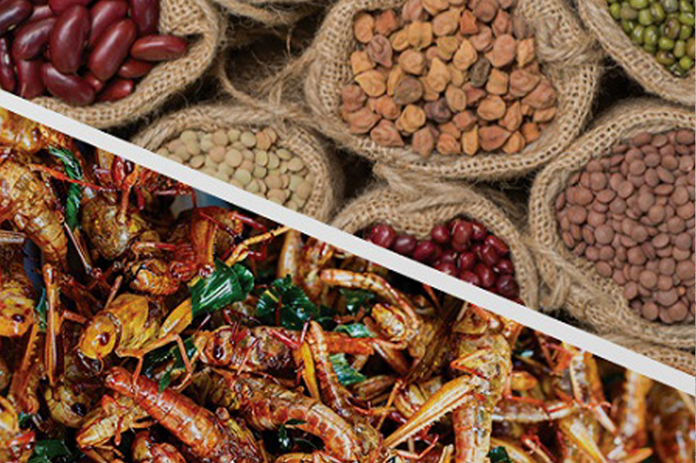 Sustainable Proteins

Design Brief
You are required to develop 4 serves of a dish that showcases an easily sourced alternative protein. The dish must be original/creative, consider sustainable practices including the reduction of food waste, and be plated in a contemporary manner.
You will be required to produce and present your chosen dish in groups of 4.
The product you decide to make will need to be made in a 90 minute lesson and you should attempt to challenge your skill level, whilst working safely and hygienically with the appropriate tools and equipment.

1. Criteria for Success
List specific factors that need to be considered to make this task successful in the table below:
Considerations (flexible factors that allow the product to be changed/modified) | Constraints (inflexible factors that must comply to the design brief)

Develop a set of CRITERIA FOR EVALUATION from the table. That is, put the criteria into question format to ask yourself when you evaluate the process at the end of the project (i.e., Did I use my time efficiently during the lesson?).

2. RESEARCH (500 words)
As the global population is expected to reach 9 billion by 2037, designing, producing, and consuming new types of food may be key to food sustainability and security. Use the following questions to guide your investigation, make sure you use in-text referencing and a reference list.

1. What are the key challenges to food security on a global scale?

2. List 4 examples of alternative proteins – what are the environmental impacts of producing different types of protein?

3. Choose one of the alternative proteins discussed in point 2. Find and briefly describe 2-3 recipes which utilise the ingredients in different forms. Explore sweet/savoury options.

4. Explore some opportunities and barriers to increasing the incorporation of alternative proteins in Westernised diets.

5. How could you adapt your eating habits towards a more sustainable diet?

3. Final Product Design
Based on your research, create your final recipe and sketch and label your plating.

4. Justification (200 words)
Justify how your design solution meets the task, you should consider the criteria that you identified in part 1 of this assignment.

5. Practical
You are to make your final practical product and present at the end of the double lesson (90minutes)
Complete a food order, time plan to be handed up with your recipe 1 week before the practical application.

6. Evaluation (500 words)
Use the following questions to guide your evaluation of the assignment:

- Did your product meet the criteria that you identified in your criteria for success? Why/Why not?
- What did you do well in the practical and why?
- What didn’t go so well for you in the practical and why?
- Was your planning sufficient? Were you able to follow your steps easily or did you have difficulty following them? Explain.
- If you were to make this again what changes would you recommend and why?

Year 9/10 Sustainable Proteins Criteria
 |  | WA | AE | E | BE | WB
Technologies and society | Investigation | comprehensive explanation of how people working in design and technologies occupations consider:  - factors that impact on design decisions  - the technologies used to produce products, services and environments | detailed explanation of how people working in design and technologies occupations consider:  - factors that impact on design decisions  - the technologies used to produce products, services and environments | explanation of how people working in design and technologies occupations consider:  - factors that impact on design decisions  - the technologies used to produce products, services and environments | description of how people working in design and technologies occupations consider:  - factors that impact on design decisions  - the technologies used to produce products, services and environments | statements about how people working in design and technologies occupations consider:  - design decisions  - the technologies used to produce products, services and environments
Generating and designing | Designing | - purposeful creation and connection of design ideas and processes of increasing complexity | - effective creation and connection of design ideas and processes of increasing complexity | - creation and connection of design ideas and processes of increasing complexity | - partial creation and connection of design ideas and processes | - fragmented creation of design ideas and processes
 | Justification | - discerning justification of decisions | - informed justification of decisions | - justification of decisions | - explanation of decisions | - statement of decisions
Producing and implementing | Practical (Techniques) | proficient production of high quality designed solutions suitable for the intended purpose by selecting and using appropriate technologies skilfully and safely | effective production of high quality designed solutions suitable for the intended purpose by selecting and using appropriate technologies skilfully and safely | production of high quality designed solutions suitable for the intended purpose by selecting and using appropriate technologies skilfully and safely | guided production of designed solutions for the intended purpose by selecting and using technologies safely | guided production of designed solutions for a purpose by using technologies safely
 | Practical/Time plan (Management) | application of sequenced production and management plans when producing designed solutions:  - making discerning adjustments to plans when necessary  working independently and collaboratively | application of sequenced production and management plans when producing designed solutions:  - making informed adjustments to plans when necessary  working independently and collaboratively | application of sequenced production and management plans when producing designed solutions:  - making adjustments to plans when necessary  working independently and collaboratively | use of production and management plans when producing designed solutions:  - making adjustments to plans  working collaboratively | use of plans when producing designed solutions
Evaluating | Evaluation | use of detailed criteria for success to make a discerning evaluation of:  - their ideas  - designed solutions  processes | use of detailed criteria for success to make an informed evaluation of:  - their ideas  - designed solutions  processes | use of detailed criteria for success to make an evaluation of:  - their ideas  - designed solutions  processes | use of detailed criteria for success to make a partial evaluation of:  - their ideas  - designed solutions  processes | use of detailed criteria for success to make a fragmented evaluation of:  - their ideas  - designed solutions  processes

