Year 7 Food Technology Name:

Nourish Bowls
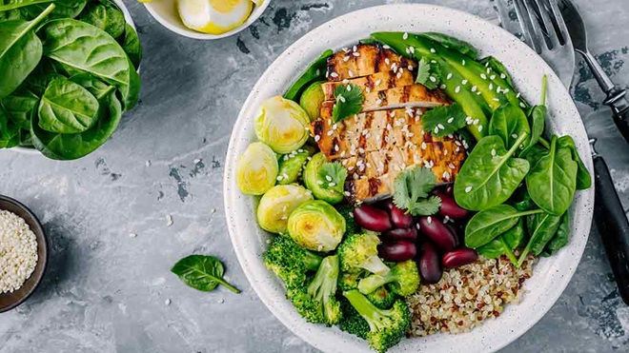

Design Brief

You are required to develop two Nourish Bowls, suitable for a trendy café menu.

The dish must incorporate all five food groups from the Australian Guide to Healthy Eating, and be presented in colourful segments of vegetables, grains, proteins, and dressings. Nuts are not permitted.

You will be required to produce and present your chosen dish in pairs.

The product you decide to make will need to be made in a 90 minute lesson and you should consider your skill level, whilst working safely with the appropriate tools and equipment.

1. Criteria for Success
List specific factors that need to be considered to make this task successful in the table below:
Considerations (flexible factors that allow the product to be changed/modified) | Constraints (inflexible factors that must be completed, based on the design brief)

Develop a set of CRITERIA FOR EVALUATION from the table. That is, put the criteria into question format to ask yourself when you evaluate the process at the end of the project (ie Did I use my time efficiently during the lesson?)

YES | NO | Questions

2. RESEARCH (400 words)
In order to create a visually appealing Nourish Bowl which incorporates the five food groups, it is important to understand what this involves. Use the following questions to guide your investigation.

1. What is a Nourish Bowl?

3. Research three examples of Nourish Bowl recipes and list their main ingredients.

3. Choose one of the examples and explain which food groups are represented by each ingredient.

4. What makes Nourish Bowls visually appealing?

5. In what ways can Nourish Bowls be sustainably produced?

6. What do people working in the food industry need to consider when creating foods to sell?

3. Generating Ideas
Using the diagram below, brainstorm possible ideas that could be considered for your Nourish Bowl.

 |  |  | Presentation | Time | Tools and equipment
 |  |  | Seasonal Vegetable/Legumes Options | Nourish Bowl | Dairy Options |  | Dairy Options
 |  |  | Seasonal Fruit Options | Grain Options | Protein Options
 |  |  |  |  |  |  | Protein Options

4. Final Product Design
Based on your research and idea generation, create and name your final recipe. Provide a labelled diagram of your plating vision, detailing the ingredients and food groups utilised.

5. Final Recipe
Name of Recipe
Ingredients

Quantity | Ingredient | Preparation Technique

Method

6. Justification (200 words)
Justify (give reasons for) how your final recipe meets the task, you should consider the criteria that you identified in part 1 of this assignment.

7. Practical
You are to make your final practical product and present it at the end of the double lesson (90minutes)
Complete a food order, time plan to be handed up with your recipe 1 week before the practical application.

8. Evaluation (300-400 words)
Use the following questions to guide your evaluation of the assignment:

- Did your product meet the criteria that you identified in your criteria for success? Why/Why not?
- How does your product compare to a commercially produced equivalent?
- What did your do well in the practical and why?
- What didn’t go so well for you in the practical and why?
- Was your planning sufficient? Were you able to follow your steps easily or did you have difficulty following them? Explain.
- If you were to make this again, what changes would you recommend and why?

Year 7 Buddha Bowl Assessment Criteria
 |  | WA | AE | E | BE | WB
Knowledge and Understanding | Research | comprehensive explanation of factors that influence the design of products, services and environments to meet present and future needs | detailed explanation of factors that influence the design of products, services and environments to meet present and future needs | explanation of factors that influence the design of products, services and environments to meet present and future needs | basic statements of factors that influence the design of products, services and environments to meet present and future needs | limited statements of factors that influence the design of products, services and environments to meet present and future needs
Processes and Production Skills | Designing | purposeful creation and adaptation of design ideas, making well-considered decisions | effective creation and adaptation of design ideas, making considered decisions | creation and adaptation of design ideas, making considered decisions | partial creation and adaptation of design ideas, making decisions | fragmented creation and adaptation of design ideas
 | Justification | Comprehensive justification needs in relation to the prescribed task. | detailed justification of needs in relation to the prescribed task. | justification of needs in relation to the prescribed task | Basic explanations of the needs in relation to the prescribed task. | limited statements about the needs in relation to some of the prescribed task.
 | Practical (Techniques) | proficient and consistent production of effective designed solutions for the intended purpose independently and safely | consistent production of effective designed solutions for the intended purpose independently and safely | production of effective designed solutions for the intended purpose independently and safely | guided production of designed solutions for the intended purpose safely | guided production of designed solutions safely
 | Practical (Management/Planning/ Recipe)) | application of project management skills, including comprehensive documentation and discerning use of project plans, to manage production processes | application of project management skills, including detailed documentation and informed use of project plans, to manage production processes | application of project management skills, including documentation and use of project plans, to manage production processes | application of project management skills, including partial documentation and use of project plans, and use of production processes | use of project management skills, including partial documentation of aspects of project plans, and use of aspects of production processes
 | Evaluation | discerning use of developed criteria for success (including sustainability considerations) to judge the suitability of their ideas, designed solutions and processes | informed use developed of criteria for success (including sustainability considerations) to judge the suitability of their ideas, designed solutions and processes | use of developed criteria for success (including sustainability considerations) to judge the suitability of their ideas, designed solutions and processes | partial use of developed criteria for success (including sustainability considerations) to describe the suitability of their ideas, designed solutions and processes | fragmented use of developed criteria for success to make statements about their ideas, designed solutions and processes

