Year 8 Food Technology Name:

Wok in a box
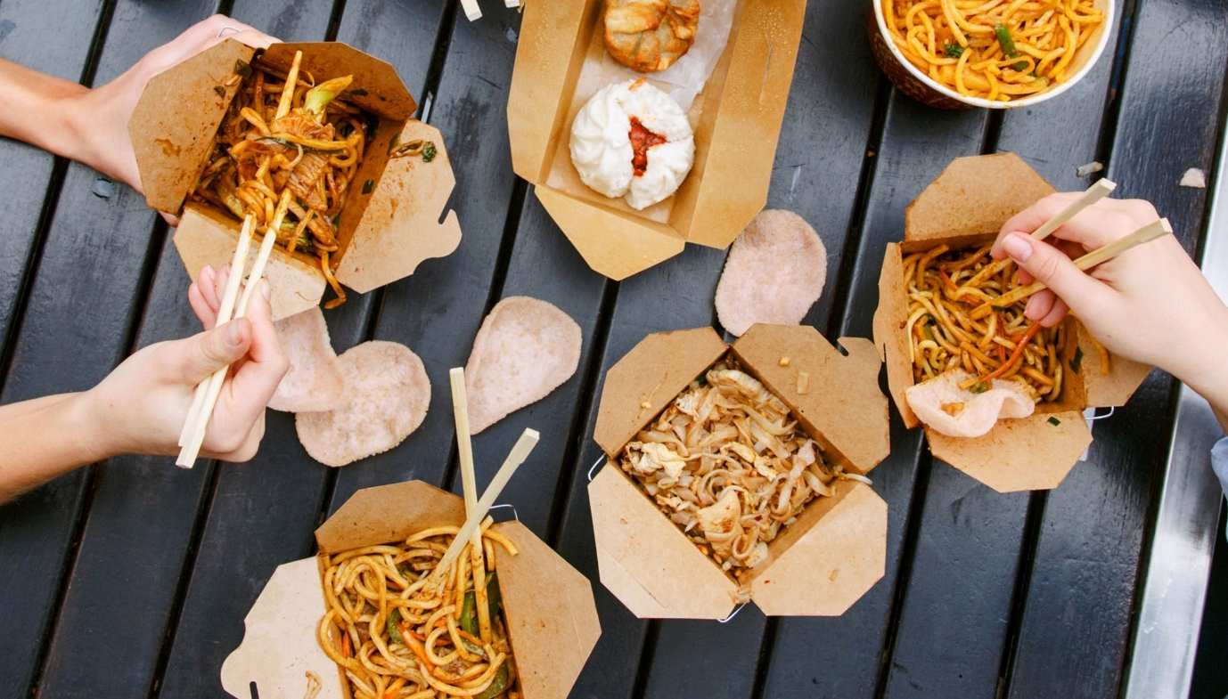

Design Brief
You are required to develop 2 serves of a stir fry dish, suitable to sell at a stir fry fast food chain such as Wok in a Box.

The dish must be healthy, including at least 4 different vegetables (besides onion and garlic), utilise seasonal produce, and be appropriately packaged and labelled. Each pair must only use 200 grams of protein and the dish must contain a member of the grain and cereals food group.

You will be required to produce and present your chosen dish in pairs.

The product you decide to make will need to be made in a 90 minute lesson and you should consider your skill level, whilst working safely with the appropriate tools and equipment.

1. Criteria for Success
List specific factors that need to be considered to make this task successful in the table below:
Considerations (flexible factors that allow the product to be changed/modified) | Constraints (inflexible factors that must that must be completed, based on the design brief)

Develop a set of CRITERIA FOR EVALUATION from the table. That is, put the criteria into question format to ask yourself when you evaluate the process at the end of the project (ie Did I use my time efficiently during the lesson?)

YES | NO | Questions

2. RESEARCH (400 words)
In order to create a stir fry suitable to sell at a takeaway restaurant it is important to understand what this involves. Use the following questions to guide your investigation, make sure you use reference list.

1. What types of meals/ food combinations/ flavours/ noodles found at Wok in a box Noodle box etc.

3.What information is legally required to be on a food label in Australia?

3. What makes a good stir fry?

4. What types of vegetables are suitable to use in a stir fry and are in season in South Australia in Term 3?

5. What do people working in the food industry need to consider when creating foods to sell?

3. Generating Ideas
Using the diagram below, brainstorm possible ideas that could be considered for your noodle box.

 |  |  | Presentation | _______ | _______
 |  |  | Carbohydrate Options | Noodle  Box | Packaging Design |  | Packaging Design
 |  |  | Suitable Proteins | Seasonal Vegetables (sustainability) | Packaging Requirements
 |  |  |  |  |  |  | Packaging Functionality

4. Final Product Packaging
Based on your, research, brainstorming create your final recipe and packaging; sketch and label your plating vision.
Make sure to include the following: Nutritional panel, name of food, ingredients list, identification of allergies, date, direction of use and storage, country of origin.

Front Back

Side Side

5. Final Recipe
Name of Recipe
Ingredients
Your chosen vegetables (How are they going to be cut? Try and use different ways)

Vegetable | Preparation Technique

200 grams ____________________Noodles or ½ Cup ____________________Rice

200 grams____________________Protein

Other Ingredients

Method

- Prepare noodles or rice

- Collect all ingredients and equipment. Marinade meat? Mix sauces together
- Prepare all vegetables
- Heat oil in wok. Add flavouring (ginger and/or garlic).
- Add meat/chicken. Cook until brown. Remove
- Add hard vegetables first. (List in order) Fry for a few minutes, then add softer vegetables. (List in order). Return meat to pan
- Add sauce. Bring stir-fry to the boil. Stir in noodles
- Serve

6. Justification (200 words)
Justify (give reasons for) how your final packaging and recipe meet the task, you should consider the criteria that you identified in part 1 of this assignment.

7. Practical
You are to make your final practical product and present it at the end of the double lesson (90minutes)
Complete a food order, time plan to be handed up with your recipe 1 week before the practical application.

8. Evaluation (300-400 words)
Use the following questions to guide your evaluation of the assignment:

- Did your product meet the criteria that you identified in your criteria for success? Why/Why not?
- How does your product compare to a commercially produced equivalent?
- What did your do well in the practical and why?
- What didn’t go so well for you in the practical and why?
- Was your planning sufficient? Were you able to follow your steps easily or did you have difficulty following them? Explain.
- If you were to make this again what changes would you recommend and why?

Year 8 Wok in a Box Assessment Criteria
 |  | WA | AE | E | BE | WB
Knowledge and Understanding | Research | comprehensive explanation of factors that influence the design of products, services and environments to meet present and future needs | detailed explanation of factors that influence the design of products, services and environments to meet present and future needs | explanation of factors that influence the design of products, services and environments to meet present and future needs | basic statements of factors that influence the design of products, services and environments to meet present and future needs | limited statements of factors that influence the design of products, services and environments to meet present and future needs
Processes and Production Skills | Designing | purposeful creation and adaptation of design ideas, making well-considered decisions | effective creation and adaptation of design ideas, making considered decisions | creation and adaptation of design ideas, making considered decisions | partial creation and adaptation of design ideas, making decisions | fragmented creation and adaptation of design ideas
 | Packaging | comprehensive and effective communication to different audiences:  appropriate technical terms  a range of technologies and graphical representation techniques | effective communication to different audiences:  appropriate technical terms  a range of technologies and graphical representation techniques | communication to different audiences using:  appropriate technical terms  a range of technologies and graphical representation techniques | partial communication to audiences using some labelling, technologies and graphical representation techniques | fragmented communication to audiences using casual language with no labelling and minimal graphical representation techniques
 | Justification | Comprehensive justification needs in relation to the prescribed task. | detailed justification of needs in relation to the prescribed task. | justification of needs in relation to the prescribed task | Basic explanations of the needs in relation to the prescribed task. | limited statements about the needs in relation to some of the prescribed task.
 | Practical (Techniques) | proficient and consistent production of effective designed solutions for the intended purpose independently and safely | consistent production of effective designed solutions for the intended purpose independently and safely | production of effective designed solutions for the intended purpose independently and safely | guided production of designed solutions for the intended purpose safely | guided production of designed solutions safely
 | Practical (Management/Planning/ Recipe)) | application of project management skills, including comprehensive documentation and discerning use of project plans, to manage production processes | application of project management skills, including detailed documentation and informed use of project plans, to manage production processes | application of project management skills, including documentation and use of project plans, to manage production processes | application of project management skills, including partial documentation and use of project plans, and use of production processes | use of project management skills, including partial documentation of aspects of project plans, and use of aspects of production processes
 | Evaluation | discerning use of developed criteria for success (including sustainability considerations) to judge the suitability of their ideas, designed solutions and processes | informed use developed of criteria for success (including sustainability considerations) to judge the suitability of their ideas, designed solutions and processes | use of developed criteria for success (including sustainability considerations) to judge the suitability of their ideas, designed solutions and processes | partial use of developed criteria for success (including sustainability considerations) to describe the suitability of their ideas, designed solutions and processes | fragmented use of developed criteria for success to make statements about their ideas, designed solutions and processes

