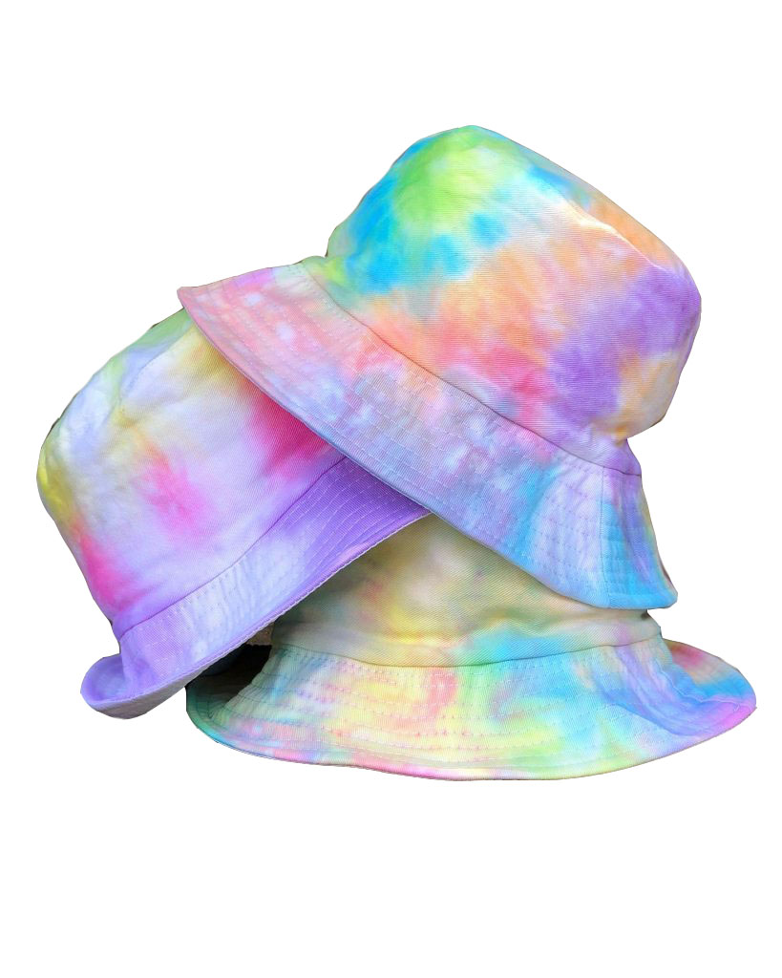
Bucket Hat
Construction, Design and Sustainability
Year 7 Textiles Technology

The life cycle of a piece of clothing – Sustainable Textiles

What is Sustainability?

How can we make the textile production process more sustainable?
The main stages of the textile production process include growing, spinning growing, spinning, dyeing, sewing, transporting, selling, owning.

Below research each process and suggest how the world and/or you personally could make this process more sustainable.
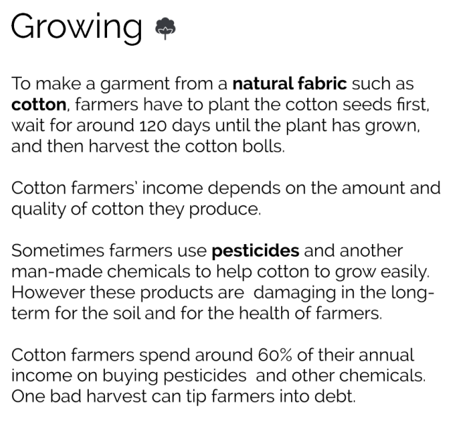
What can be done to make the growing process more sustainable?

What can be done to make the spinning process more sustainable?

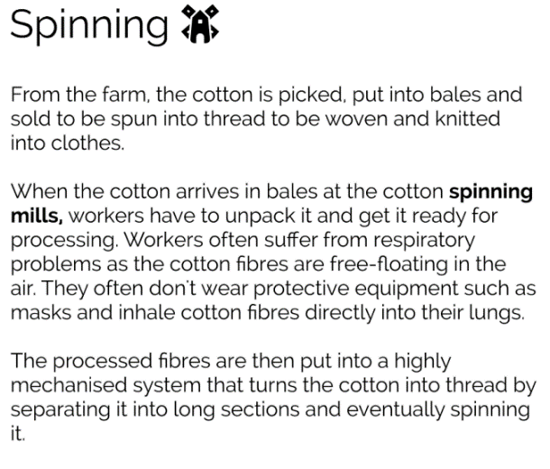

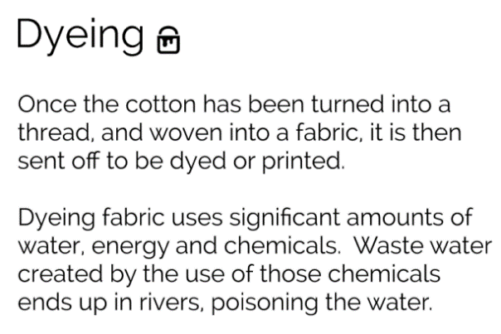
What can be done to make the dying process more sustainable?

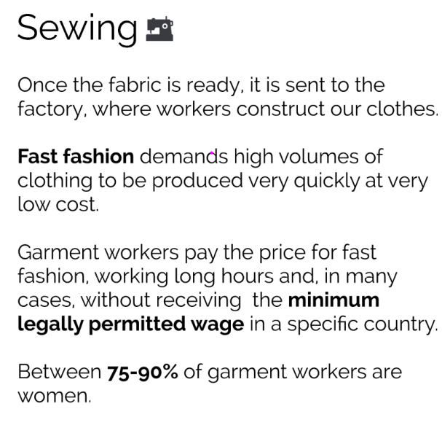
What can be done to make the sewing process more sustainable?

What can be done to make the transport process more sustainable?

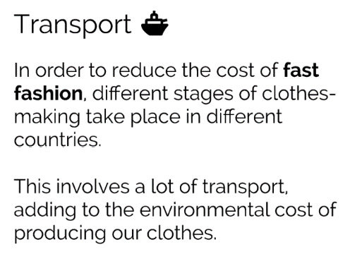

What can be done to make the selling process more sustainable?

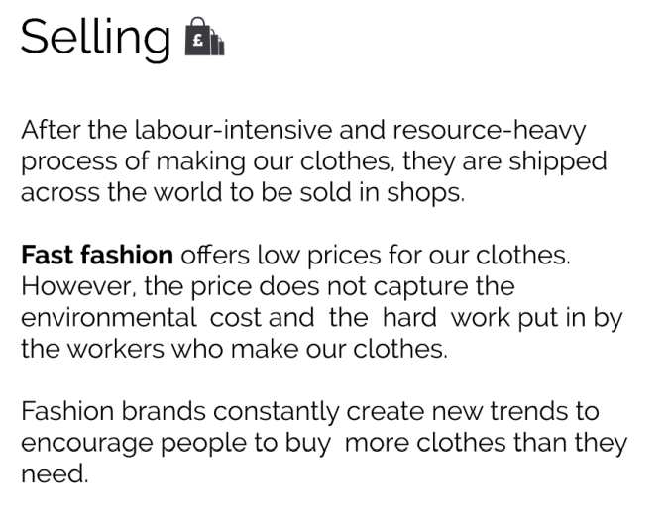

Tie Dying – What colour and pattern?
Using a minimum of 2 colours for each, design 3 colour scheme/pattern ideas you might like create on your hat.
Label the colours and draw what pattern you are hoping to achieve for each design option.
Design 1: Design 2: Design 3:

Which of the above designs you going to use for your tie dying?

Explain, in full sentences, why you chose these colours and patterns:
____________________________________________________________________________________________________________________________________________________________________________________________________________________________________________________________________________________________________________________________________________________________________________________________________________________________________________________________________________________________________________________________________________________________________________________________________________________________________________________________________________________________________________________________________________________________________________________________________________
Step by Step
Research what pattern you want to make with your tie dye colours.
Create detailed step by step instructions (with pictures) of how to create your pattern on your fabric.
STEPS | IMAGE/DIAGRAM
STEPS | IMAGE/DIAGRAM

Evaluation
Evaluate your work process and the quality of the construction techniques you have used
Answer the following questions:

Describe your task:
............................................................................................................................................................................................................................................................................................................................................................................................................................................................................................................................................................................................................................................................................

Did you use your class time effectively? (explain how you specifically did this)
.....................................................................................................................................................................................................................................................................................................................................................................................................................................................................................................................................................................................................................................................................................................................................................................................................................................................................................................................................................................................................................................................................................................................................................................................
Did you construct your hat well? (explain how you specifically did this using specific examples)
.....................................................................................................................................................................................................................................................................................................................................................................................................................................................................................................................................................................................................................................................................................................................................................................................................................................................................................................................................................................................................................................................................................................................................................................................
Did you have any problems or issues when sewing your hat? Explain.
.....................................................................................................................................................................................................................................................................................................................................................................................................................................................................................................................................................................................................................................................................................................................................................................................................................................................................................................................................................................................................................................................................................................................................................................................

How have your sewing skills developed while creating your hat? What new techniques and skills have you learnt?
........................................................................................................................................................................................................................................................................................................................................................................................................................................................................................................................................................................................................................................................................................................................................................................................................................................................................................................................................................................................................................................................................................................................................................................................................................................................................................................................................................
Did your hat turn out how you originally imagined? Why/why not?
...............................................................................................................................................................................................................................................................................................................................................................................................................................................................................................................................................................................................................................................................................................................................................................................................................................................

What would you change about the design of your hat if you did the task again?
.....................................................................................................................................................................................................................................................................................................................................................................................................................................................................................................................................................................................................................................................................................................................................................................................................................................................................................................................................................................................................................................................................................................................................................................................

Sustainability
Definition - This is about doing things in a way that keeps our living planet healthy and sustaining its natural balance. Sustainability is also about not taking more resources from the living planet than are available during a certain time period. When we do things sustainably, everyone can meet their needs and fulfil their potential.

Do you think that the process of tie dying and making a hat was sustainable? Why/Why not?
........................................................................................................................................................................................................................................................................................................................................................................................................................................................................................................................................................................................................................................................................................................................................................................................................................................................................................................................................................................................................................................................................................................................................................................................................................................................................................................................................................
What could we do to make the project more sustainable? (i.e. use more sustainable materials)
........................................................................................................................................................................................................................................................................................................................................................................................................................................................................................................................................................................................................................................................................................................................................................................................................................................................................................................................................................................................................................................................................................................................................................................................................................................................................................................................................................

Self-assessment:
On a scale of poor – excellent how well would you rate yourself on the following:

Constructive use of lesson time:

Poor Satisfactory Good Excellent

Straight machine stitching:

Poor Satisfactory Good Excellent

Neat appropriate sized seams:

Poor Satisfactory Good Excellent

Effectiveness of design:

Poor Satisfactory Good Excellent

Overall final product neatness:

Poor Satisfactory Good Excellent

Year 7 Bucket Hat Assessment Rubric
 | A | B | C | D | E
Sustainability | comprehensive explanation of:  - factors that influence the design of products, services and environments to meet present and future needs | detailed explanation of:  - factors that influence the design of products, services and environments to meet present and future needs | explanation of:  - factors that influence the design of products, services and environments to meet present and future needs | description of:  - factors that influence the design of products, services and environments to meet present and future needs | statements about:  - factors that influence the design of products, services and environments to meet present and future needs
Design | Purposeful creation and adaptation of design ideas, making well-considered decisions | Effective creation and adaptation of design ideas, making considered decisions | Creation and adaptation of design ideas, making considered decisions | Partial creation and adaptation of design ideas, making decisions | Fragmented creation and adaptation of design ideas
Step by Step | application of project management skills, including comprehensive documentation and discerning use of project plans, to manage production processes | application of project management skills, including detailed documentation and informed use of project plans, to manage production processes | application of project management skills, including documentation and use of project plans, to manage production processes | application of project management skills, including partial documentation and use of project plans, and use of production processes | use of project management skills, including partial documentation of aspects of project plans, and use of aspects of production processes
Producing and Implementing  (creation of the bag) | Proficient and consistent production of effective designed solutions for the intended purpose independently and safely | Consistent production of effective designed solutions for the intended purpose independently and safely | Production of effective designed solutions for the intended purpose independently and safely | Guided production of designed solutions for the intended purpose safely | Guided production of designed solutions safely
Evaluation | Discerning use of developed criteria for success (including sustainability considerations) to judge the suitability of:  - their ideas  - designed solutions and processes | Informed use developed of criteria for success (including sustainability considerations) to judge the suitability of:  - their ideas  - designed solutions and processes | Use of developed criteria for success (including sustainability considerations) to judge the suitability of:  - their ideas  - designed solutions and processes | Partial use of developed criteria for success (including sustainability considerations) to describe the suitability of:  - their ideas  - designed solutions and processes | Fragmented use of developed criteria for success to make statements about:  - their ideas  - designed solutions and processes

