Who Am I?

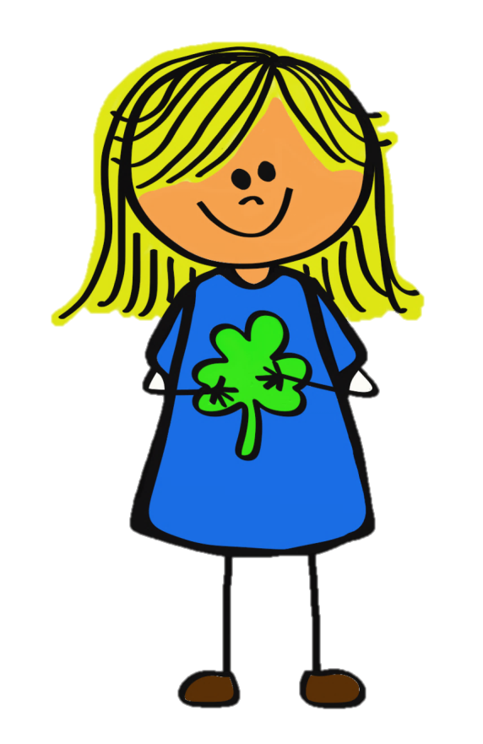

Strengths and Weaknesses:

Words that describe me

What I Value