The I Have A Dream Speech Worksheet

A Knowledge and Understanding

- Find out when the speech was given and what events occurred around that time in America.
- Where was the speech held and why was the setting significant?
- What was the purpose of the speech?
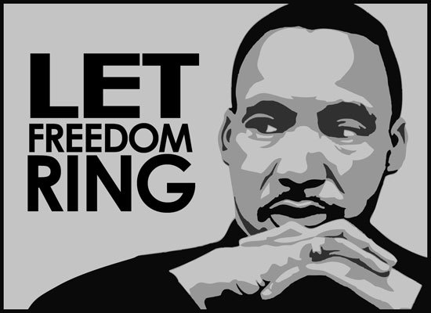
- Who were the audience?
- Identify and colour code the following language techniques:
  - repeated phrases and anaphora (look it up)
  - metaphors, similes and personifications
  - emotive words, adjectives and adverbs
  - inclusive language (“we”/ “our”) and personal language (“I”)
  - alliteration
  - quotes and allusions

B Analysis and Evaluation: use examples to discuss

- Comment on writing style, structure of the speech, use of long or short sentences and King’s presentation style (all form issues) – for the last 3 only, how do they appeal to the audience?
- How do the quotes and allusions used help to reinforce the message of King’s speech?
- Decide what effect on the audience 4 of the other language techniques in Part A have.
- Which is the most effective of the techniques above for you and why?
- How has King used the 3 pillars of persuasion?

C Reflection and Metacognition

- Killing 2 birds with one stone: choose a topic and then summarize what you have learned from Parts A and B about how to write a persuasive speech, making it specific to your speech. Discuss under the headings: purpose (Always know why you are doing something so you can make it powerful. My topic is… and my aim is to persuade that…), audience (Always be aware of the understanding and ideas of the audience so you can target them effectively. My audience is… and they have specific ideas and understandings such as…), context, language techniques, form conventions. This is your plan. Also refer to RAFT and Expectations for Speech below to make sure you have thought things through enough. Those who want an A should also consider the Adding Depth and Complexity ideas below.

D Applying and Creating

- Write your persuasive speech of no more than 5 minutes, using the language techniques and form conventions examined in Parts A to C.

Expectations for Speech:
- A counter argument if necessary
- Sophisticated ‘extra’ techniques such as anaphora or anti-metabole. Also ‘fruitcake’
- Consideration of modality and objectivity vs subjectivity
- Use of connectives to structure (ie start paragraphs) and sound sophisticated throughout
- Hooks – as start and throughout
- End with a call to action
- 3 pillars of persuasion – ethos, pathos and logos included
- Speak with the eyes (expression)
- Emphasise at least one word per sentence (emphasis). Highlight on script.
- Project to back of room to the picture of the old person with hard hearing (volume). Choose your picture for your speech and practise with them. Use music signs to show louds and softs on your script.
- Pronounce ‘t’ and ‘d’ sounds/ends of words (diction). Focus during practise.
- Practise speech by reading from end. Last sentence then 2nd last and last, then 3rd last, 2nd last and last etc (fluency).
- Vary pitch (pitch/timbre). Practise reading in high and low voice. Mark places to raise tone or lower tone on script.
- Vary pace (pace). Mark where you will slow down on your script.

RAFT Method for Creating Speech:
Role – choose a character for yourself – who are you and why would you be persuading on your topic
Audience – choose an audience – who would you be talking to and why?
Format – is a persuasive speech – what style would suit your topic and audience? (a political rally, a Christadelphian lecture, a radio show, a vlog)
Topic – choose a topic that you are interested in/feel some passion about and can argue strongly.

Adding Depth and Complexity:

Details: What are the main ideas or areas of your topic? Find examples and evidence to support your opinions and ideas

Big Ideas: Draw conclusions based on the evidence of your research on this topic. Make generalisations from your research to work out the main ideas and areas of the topic.

Ethics: What moral principles are involved in this topic? What controversies exist? What biases or wisdom emerge from a study of this topic?

Changes over Time: Has your topic changed over time? Why and how did things change? What hasn’t changed?

Different Perspectives: How would others see the topic differently?

