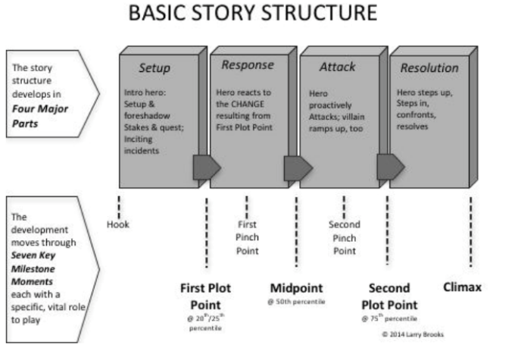**Three Act Structure**

**Four Act Structure**

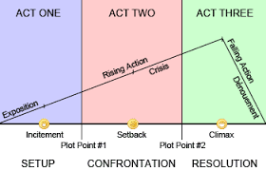

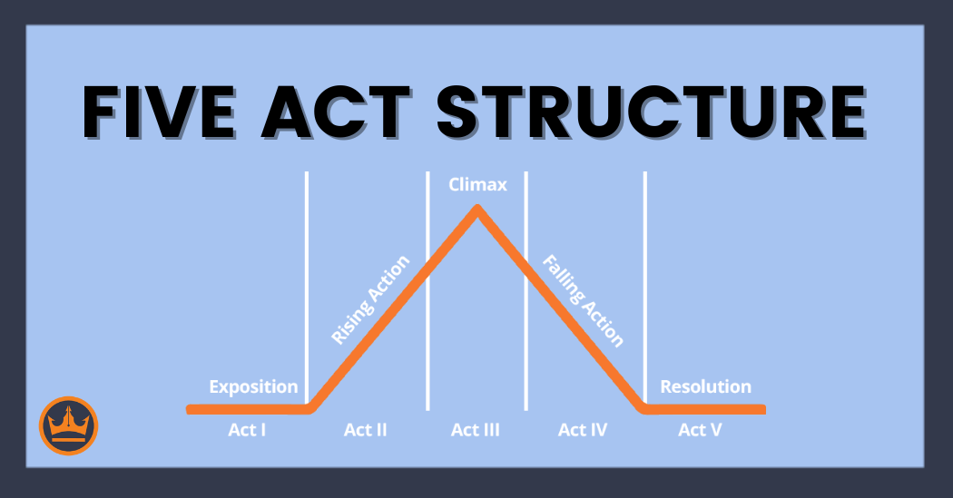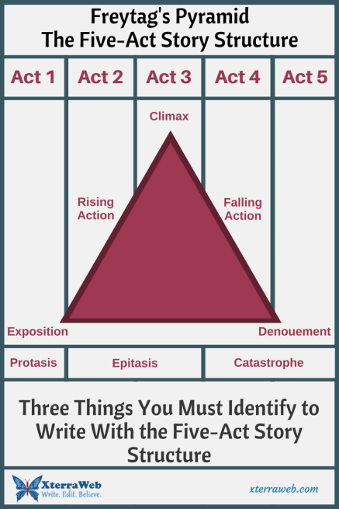

Research:

Who invented the 3 Act structure? Who used the 5 Act structure a lot?

What is meant by protasis, epitasis and catastrophe?

How do you pronounce denouement?

What does denouement mean?

Who is this Freytag anyway?

Compare all the diagrams.

What different names can you find for the first Act?

What different names can you find for the last Act?

What is the correlation between the 3, 4 and 5 Act structures (could it be argued that they all have the same information in them?)?