Intertextual Study 2: Paul’s Use of the Old Testament in the New Testament

This task is about recognising the way texts can be compared to each other to add meaning that one text alone doesn’t have. For example, if an author used ideas about Superman in their novel, we would have an understanding of what kind of person or situation was meant from the film or comic book we had seen. Another example is how Shrek relies on the audience’s understanding of fairy tales to create its humour and meaning.

In this version of intertextuality, you are to look at how your understanding of biblical concepts or New Testament quotes is shaped or added to by comparing Old Testament cross quotes. You have a maximum of 1000 words.

Question: How does the Paul use intertextuality by quoting the Old and in his New Testament letters to create understanding and explain ideas? (Think: why does Paul use this OT quote in this context?)

Resources:
- e-sword/Bible Hub
- Specific works on chosen topics
- All Paul’s OT quotes (and allusions): https://www.wednesdayintheword.com/paul-oldtestament/
- Hebrews too: https://www.wednesdayintheword.com/hebrews-ot-quotations/

Choices:
You need to choose from one or more of the class examples:

Rom 8:36 – As it is written, “For your sake we are being killed all the day long; we are regarded as sheep to be slaughtered” (Ps 44:22).
Heb 10: 5-9 – “I come to do they will O God…” (Ps 40:6-8).
Gal 4: 27 - For it is written: “Be glad, barren woman, you who never bore a child; shout for joy and cry aloud, you who were never in labour; because more are the children of the desolate woman than of her who has a husband” (Isa 54:1).
OR

Come and discuss another Paul OT and NT connection of your own with me. It must be vetted by me and not everyone will be able to work by themselves.

Structure of your writing:
- Main heading: Old Testament – under heading quote the relevant verses and give a reference
- Subheadings: Context/Author, Audience and Purpose. Under each heading explain this aspect of the Old Testament quote. Make sure you veer the information toward the KU3. In other words, show you can see the significance of the concepts under discussion.
- Subheading: Meaning in Context. Under the heading, using the whole section/Psalm explain the meaning of passage and particularly the meaning of the quote in question within this context. Use quotes (KU1, Ap3).
- Main heading: New Testament – under heading quote the relevant verses and give a reference
- Subheadings: Context/Author, Audience and Purpose. Under each heading explain this aspect of the New Testament quote. Make sure you veer the information toward KU3. In other words, show you can see the significance of the concepts under discussion.
- Subheading: Meaning in Context. Under the heading, using the whole section explain the meaning of passage and particularly the meaning of the quote in question within this context. Use quotes (KU1, Ap3).
- Main heading: Conclusion on Why Paul Used this Quote. Part 1 – explain how Paul used the quote from the Old Testament to make meaning in a new context – quote the relevant verse (KU1, An3, Ap3).

Part 2 – explain how context, audience and purpose of the Old Testament quote might encourage or have meaning for the New Testament audience in their context (An1, An3).

Performance Standards:
- KU1 Depth of knowledge and understanding about ideas and perspectives in quotes you explore.
- KU 3 Knowledge and understanding of ways in which texts are created for a range of purposes
and audiences.
- An1 Analysis of the relationship between purpose, audience, and context, and how they shape
meaning.
- An3 Detailed analysis of intertextual connections
- Ap3 Use of evidence such as quotes to support conclusions, with quotes and references
incorporated smoothly into writing.
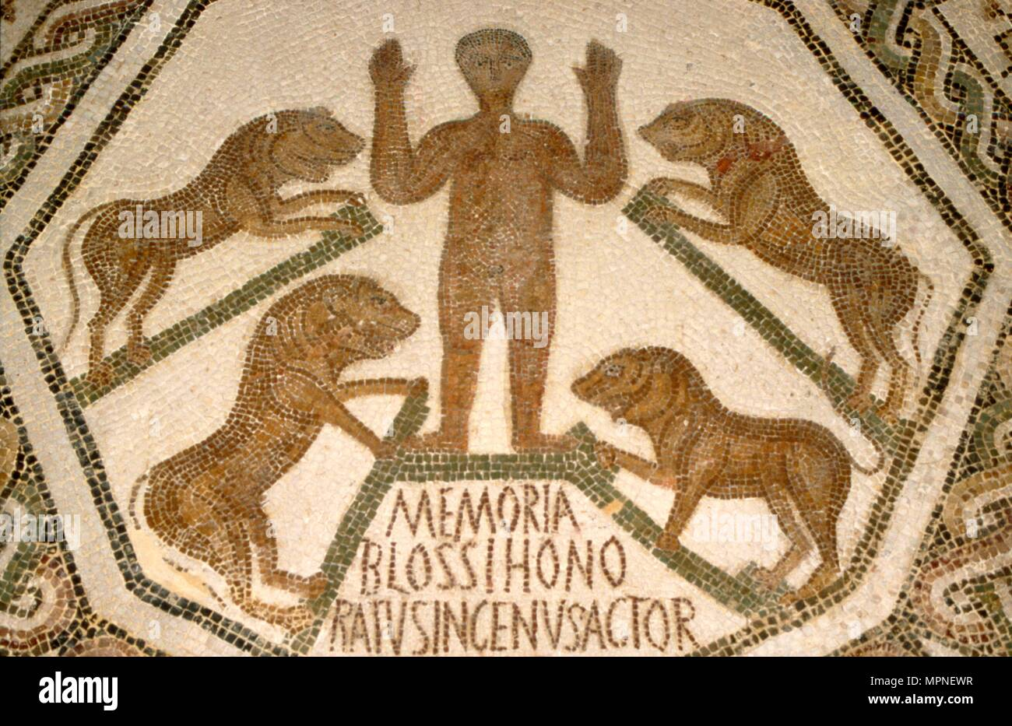
- Ap1 Precise, fluent, and coherent writing.

