Reading Skills Practise:

Film Techniques

Skwirk Online Education, inactive link
Film techniques is the term used to describe the ways that meaning is created in film.

Camera Shots
A camera shot is the amount of space that is seen in one shot or frame. Camera shots are used to demonstrate different aspects of a film's setting, characters and themes. As a result, camera shots are very important in shaping meaning in a film. Reviewing the examples on the right hand side of this page should make the different camera shots clearer.
An extreme long shot (animation on right) contains a large amount of landscape. It is often used at the beginning of a scene or a film to establish general location (setting). This is also known as an establishing shot.
A long shot (animation on right) contains landscape but gives the viewer a more specific idea of setting. A long shot may show the viewers the building where the action will take place.
A full shot (animation on right) contains a complete view of the characters. From this shot, viewers can take in the costumes of characters and may also help to demonstrate the relationships between characters. For more information on costumes and acting refer to Chapter 4.
A mid shot (animation on right) contains the characters or a character from the waist up. From this shot, viewers can see the characters' faces more clearly as well as their interaction with other characters. This is also known as a social shot
A close-up (animation on right) contains just one character's face. This enables viewers to understand the actor's emotions and also allows them to feel empathy for the character. This is also known as a personal shot.
An extreme close-up (animation on right) contains one part of a character's face or other object. This technique is quite common in horror films, particularly the example above. This type of shot creates an intense mood and provides interaction between the audience and the viewer.
When analysing a film you should always think about the different camera shots and why they are being used. The next time that you are at the cinema or watching television see what camera shots are being used.
Important: These camera shots are used in all forms of visual texts including postcards, posters and print advertisements.

Camera angles
It is important that you do not confuse camera angles and camera shots. Camera shots are used to demonstrate different aspects of setting, themes and characters. Camera angles are used to position the viewer so that they can understand the relationships between the characters. These are very important for shaping meaning in film as well as in other visual texts.
The following examples will help you to understand the differences between the different camera angles
A bird's eye angle (animation on right) is an angle that looks directly down upon a scene. This angle is often used as an establishing angle, along with an extreme long shot, to establish setting.
A high angle (animation on right) is a camera angle that looks down upon a subject. A character shot with a high angle will look vulnerable or small. These angles are often used to demonstrate to the audience a perspective of a particular character. The example above demonstrates to us the perspective or point of view of a vampire. As a viewer we can understand that the vampire feels powerful.
An eye-level angle (animation on right) puts the audience on an equal footing with the character/s. This is the most commonly used angle in most films as it allows the viewers to feel comfortable with the characters.
A low angle (animation on right) is a camera angle that looks up at a character. This is the opposite of a high angle and makes a character look more powerful. This can make the audience feel vulnerable and small by looking up at the character. This can help the responder feel empathy if they are viewing the frame from another character's point of view.
As with camera shots, you will be able to see many examples of camera angles in any film or visual text that you view. The next time that you watch television or see a film, take note of the camera angles and think of how they affect your perception (idea) of different characters.
Another camera angle that you might come across is a Dutch angle.
A Dutch angle (animation on right) is used to demonstrate the confusion of a character. The example above should disorientate you.

Camera movement
Composers of films also use camera movement to shape meaning. The following are some examples of common camera movements and how they can be used to shape meaning in films.
A crane shot (animation on right) is often used by composers of films to signify the end of a film or scene. The effect is achieved by the camera being put on a crane that can move upwards
A tracking shot and a dolly shot (animation on right) have the same effect. A tracking shot moves on tracks and a dolly shot is mounted on a trolley to achieve the effect in the example above. This camera movement is used in a number of ways but is most commonly used to explore a room such as a restaurant. By using a tracking shot or a dolly shot the composer of a film gives the viewer a detailed tour of a situation. It can also be used to follow a character.
Panning (animation on right) is used to give the viewer a panoramic view of a set or setting. This can be used to establish a scene

Others
An Evangelion shot (animation on right) is derived from the popular anime series 'Neon Genesis Evangelion'. This camera movement begins as an extreme close-up and zooms out abruptly, creating a blurring effect to emphasise the speed and size of the object

Lighting
Lighting is a very important aspect for shaping meaning in films. What kind of atmosphere is created in a room lit by candles? Have you ever heard of mood lighting? A room that is brightly lit by neon lights might seem to be sterile or a shadowy room might be eerie or scary. The lighting technicians in a film crew have the task of creating lighting to suit the mood and atmosphere of each scene in a film.
Consider the animations Lighting example one, Lighting example two, Lighting example three and think about what type of atmosphere is created in each.
For each example, do you think the lighting suits the characters in the frames? For instance, in Example Three the two people are very happy and the scene is lit brightly. What would be the effect on the atmosphere if the lighting were dark and shadowy, similar to Example Two?
Remember that lighting is used in still image visual texts as well as in films.

Cinematography
Cinematography is the combination of the techniques described in this chapter. This includes camera shots, camera angles, camera movement and lighting. Use the term cinematography to group all of these together, for example, 'The cinematography in that film was exceptional.'

Mise en Scene
Mise en scene refers to all the objects and characters in a particular frame. More specifically, it refers to the composition of the frame. When you use the term mise en scene, you are discussing where the composer or director has placed all the elements of the scene within the frame.

Examples of Techniques

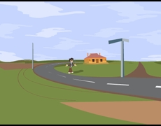Image 1 - Extreme Long Shot
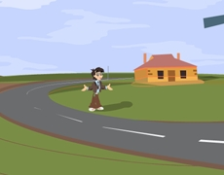Image 2 - Long shot
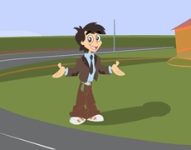Image 3 - Full shot
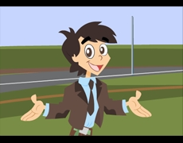Image 4 - Mid shot
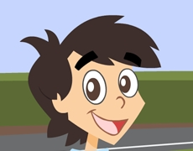Image 5 - Close up
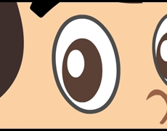Image 6 - Extreme close up
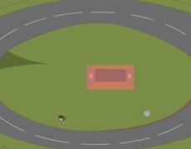Image 7 - Bird's-eye angle
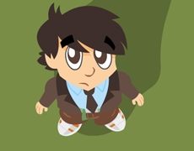Image 8 - High Angle
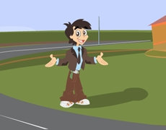Image 9 - Eye-level angle
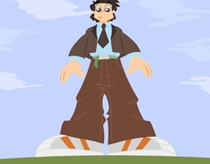Image 10 - Low angle
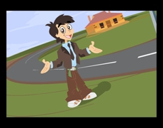Image 11 - Dutch angle
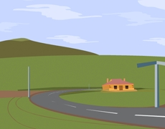Animation - Crane Shot
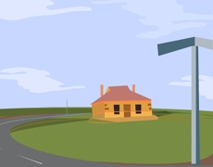Animation - Tracking Shot
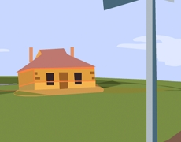Animation - Panning
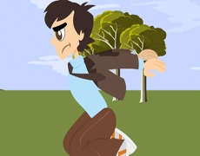Animation - Evangelion shot
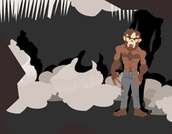Image 12 - Lighting example one
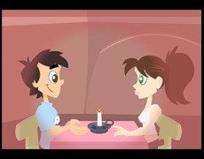Image 13 - Lighting example two
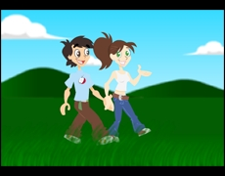Image 14 - Lighting example three

Reflecting on Texts:
- Reading a variety of textual formats

- Consider the 3 diagrams of examples of lighting in conjunction with the text on lighting. Determine BOTH how the lighting of the example suits the scene and characters shown AND any other situations where this type of lighting would be appropriate.

- Advantages and disadvantages of methods of communication

a) Provide evidence by way of information text features, words or phrases that show that this text is an information text.
b) Suggest why using a narrative form to provide this information might be a mistake using examples of narrative features to illustrate your points.

- Tone and attitude – identifying by use of language devices/techniques

- Identify the tone (tone is the author’s attitude/feelings) this text takes and give evidence in the form of words/phrases, explaining HOW the word/phrase is being used to create this tone. Remember: tone can be the attitude toward the topic at hand or toward the audience or even toward the author themselves.

- Adding understanding from outside text – hypothesising on ideas in texts – applying to different contexts – dealing with info that undermines expectations

- Statements are made in this text about power relationships being revealed by angles of camera shots.

Hypothesise on how an uneven power relationship might impact a friendship. Use the following link to give you some ideas, replacing the idea of a partner with that of a friend: https://www.psychologytoday.com/au/blog/meet-catch-and-keep/201602/4-truths-about-power-in-relationships-including-yours.

- You may not have thought about your friendships in this way before: what aspects of this consideration have challenged your ideas about friendships?

