The Road to Little Dribbling by Bill Bryson
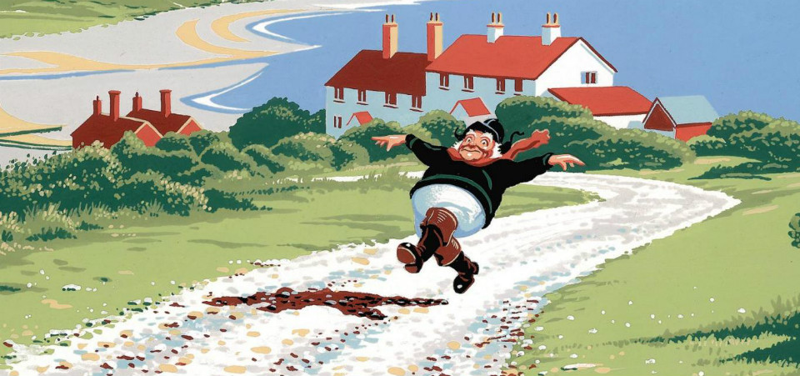

I

One of the things that happens when you get older is that you discover lots of new ways to hurt yourself. Recently, in France, I was hit square on the head by an automatic parking barrier, something I don’t think I could have managed in my younger, more alert years.
There are really only two ways to get hit on the head by a parking barrier. One is to stand underneath a raised barrier and purposely allow it to fall on you. That is the easy way, obviously. The other method – and this is where a little diminished mental capacity can go a long way – is to forget the barrier you have just seen rise, step into the space it has vacated and stand with lips pursed while considering your next move, and then be taken completely by surprise as it slams down on your head like a sledgehammer on a spike. That is the method I went for.
Let me say right now that this was a serious barrier – like a scaffolding pole with momentum – and it didn’t so much fall as crash back into its cradle. The venue for this adventure in cranial trauma was an open-air car park in a pleasant coastal resort in Normandy called Etretat, not far from Deauville, where my wife and I had gone for a few days. I was alone at this point, however, trying to find my way to a clifftop path at the far side of the car park, but the way was blocked by the barrier, which was too low for a man of my dimensions to duck under and much too high to vault. As I stood hesitating, a car pulled up, the driver took a ticket, the barrier rose and the driver drove on through. This was the moment that I chose to step forward and to stand considering my next move, little realizing that it would be mostly downwards.
Well, I have never been hit so startlingly and hard. Suddenly I was both the most bewildered and relaxed person in France. My legs buckled and folded beneath me and my arms grew so independently lively that I managed to smack myself in the face with my elbows. For the next several minutes my walking was, for the most part, involuntarily sideways. A kindly lady helped me to a bench and gave me a square of chocolate, which I found I was still clutching the next morning. As I sat there, another car passed through and the barrier fell back into place with a reverberating clang. It seemed impossible that I could have survived such a violent blow. But then, because I am a little paranoid and given to private histrionics, I became convinced that I had in fact sustained grave internal injuries, which had not yet revealed themselves. Blood was pooling inside my head, like a slowly filling bath, and at some point soon my eyes would roll upwards, I would issue a dull groan, and quietly tip over, never to rise again.
The positive side of thinking you are about to die is that it does make you glad of the little life that is left to you. I spent most of the following three days gazing appreciatively at Deauville, admiring its tidiness and wealth, going for long walks along its beach and promenade or just sitting and watching the rolling sea and blue sky. Deauville is a very fine town. There are far worse places to tip over.
One afternoon as my wife and I sat on a bench facing the English Channel, I said to her, in my new reflective mood, ‘I bet whatever seaside town is directly opposite on the English side will be depressed and struggling, while Deauville remains well off and lovely. Why is that, do you suppose?’
‘No idea,’ my wife said. She was reading a novel and didn’t accept that I was about to die.
‘What is opposite us?’ I asked.
‘No idea,’ she said and turned a page.
‘Weymouth?’
‘No idea.’
‘Hove maybe?’
‘Which part of “no idea” are you struggling to get on top of?’
I looked on her smartphone. (I’m not allowed a smartphone of my own because I would lose it.) I don’t know how accurate her maps are – they often urge us to go to Michigan or California when we are looking for some place in Worcestershire – but the name that came up on the screen was Bognor Regis.
I didn’t think anything of this at the time, but soon it would come to seem almost prophetic.

II
I first came to England at the other end of my life, when I was still quite young, just twenty.
In those days, for a short but intensive period, a very high proportion of all in the world that was worth taking note of came out of Britain. The Beatles, James Bond, Mary Quant and miniskirts, Twiggy and Justin de Villeneuve, Richard Burton and Elizabeth Taylor’s love life, Princess Margaret’s love life, the Rolling Stones, the Kinks, suit jackets without collars, television series like The Avengers and The Prisoner, spy novels by John le Carré and Len Deighton, Marianne Faithfull and Dusty Springfield, quirky movies starring David Hemmings and Terence Stamp that we didn’t quite get in Iowa, Harold Pinter plays that we didn’t get at all, Peter Cook and Dudley Moore, That Was the Week That Was, the Profumo scandal – practically everything really.
Advertisements in magazines like the New Yorker and Esquire were full of British products in a way they never would be again – Gilbey’s and Tanqueray gin, Harris tweeds, BOAC airliners, Aquascutum suits and Viyella shirts, Keens felted hats, Alan Paine sweaters, Daks trousers, MG and Austin Healey sports cars, a hundred varieties of Scotch whisky. It was clear that if you wanted quality and suavity in your life, it was British goods that were in large part going to supply it. Not all of this made a great deal of sense even then, it must be said. A popular cologne of the day was called Pub. I am not at all sure what resonances that was supposed to evoke. I have been drinking in England for forty years and I can’t say that I have ever encountered anything in a pub that I would want to rub on my face.
Because of all the attention we gave Britain, I thought I knew a fair amount about the place, but I quickly discovered upon arriving that I was very wrong. I couldn’t even speak my own language there. In the first few days, I failed to distinguish between collar and colour, khaki and car key, letters and lettuce, bed and bared, karma and calmer.
Needing a haircut, I ventured into a unisex hairdresser’s in Oxford, where the proprietress, a large and vaguely forbidding woman, escorted me to a chair, and there informed me crisply:
‘Your hair will be cut by a vet today.’
I was taken aback. ‘Like a person who treats sick animals?’ I said, quietly horrified.
‘No, her name is Yvette,’ she replied and with the briefest of gazes into my face made it clear that I was the most exhausting idiot that she had encountered in some time.
In a pub I asked what kind of sandwiches they had.
‘Ham and cheese,’ the man said.
‘Oh, yes please,’ I said.
‘Yes please what?’ he said.
‘Yes please, ham and cheese,’ I said, but with less confidence.
‘No, it’s ham or cheese,’ he explained.
‘You don’t do them both together?’
‘No.’
‘Oh,’ I said, surprised, then leaned towards him and in a low, confidential tone said: ‘Why not? Too flavourful?’
He stared at me.
‘I’ll have cheese then, please,’ I said contritely.
When the sandwich came, the cheese was extravagantly shredded – I had never seen a dairy product distressed before serving – and accompanied by what I now know was Branston pickle, but what looked to me then like what you find when you stick your hand into a clogged sump.
I nibbled it tentatively and was pleased to discover that it was delicious. Gradually it dawned on me that I had found a country that was wholly strange to me and yet somehow marvellous. It is a feeling that has never left me.
My time in Britain describes a kind of bell curve, starting at the bottom left-hand corner in the ‘Knows Almost Nothing at All’ zone, and rising in a gradual arc to ‘Pretty Thorough Acquaintanceship’ at the top. Having attained this summit, I assumed that I would remain there permanently, but recently I have begun to slide down the other side towards ignorance and bewilderment again as increasingly I find myself living in a country that I don’t altogether recognize. It is a place full of celebrities whose names I don’t know and talents I cannot discern, of acronyms (BFF, TMI, TOWIE) that have to be explained to me, of people who seem to be experiencing a different kind of reality from the one I know.
I am constantly at a loss in this new world. Recently I closed my door on a caller because I couldn’t think what else to do with him. He was a meter reader. At first, I was pleased to see him. We haven’t had a meter reader at our house since Edward Heath was prime minister, so I let him in gladly and even fetched a step- ladder so that he could climb up and get a clear reading. It was only when he departed and returned a minute later that I began to regret our deepening relationship.
‘Sorry, I also need to read the meter in the men’s room,’ he told me.
‘I beg your pardon?’
‘It says here there is a second meter in the men’s room.’
‘Well, we don’t have a men’s room because this is a house, you see.’
‘It says here it’s a school.’
‘Well, it’s not. It’s a house. You were just in it. Did you see roomfuls of young people?’
He thought hard for a minute.
‘Do you mind if I have a look around?’
‘I beg your pardon?’
‘Just a little look. Won’t take five minutes.’
‘You think you’re going to find a men’s room that we have somehow overlooked?’
‘You never know!’ he said brightly.
‘I’m shutting the door now because I don’t know what else to do,’ I said and shut the door. I could hear him making mild bleatings through the wood. ‘Besides I have an important appointment,’ I called back through the wood. And it was true. I did have an important appointment – one, as it happens, that has everything to do with the book that follows.
I was about to go to Eastleigh to take a British citizenship test. The irony of this was not lost on me. Just as I was becoming thoroughly remystified by life in modern Britain, I was being summoned to demonstrate that I understood the place.

IV
A day or so later, I met my publisher, a kindly and much loved fellow named Larry Finlay, for lunch in London, to discuss a subject for my next book. Larry lives in quiet dread that I will suggest some ludicrously uncommercial topic – a biography of Mamie Eisenhower, perhaps, or something on Canada – and so always tries to head me off with an alternative suggestion.
‘Do you know,’ he said, ‘it’s twenty years since you wrote Notes from a Small Island?’
‘Really?’ I replied, amazed at how much past one can accumulate without any effort at all.
‘Ever thought about a sequel?’ His tone was casual, but in his eyes I could see little glinting pound signs where his irises normally were.
I considered for a moment. ‘Actually there is a certain timeliness to that,’ I said. ‘I’m just about to take out British citizenship, you know.’
‘Really?’ Larry said. The pound signs brightened and began to pulsate ever so slightly. ‘You’re giving up your American citizenship?’
‘No, I keep it. I’ll have British and American both.’
Larry was suddenly racing ahead. Marketing plans were forming in his head. Underground posters – not the really big ones, the much smaller kind – were springing to mind. ‘You can take stock of your new country,’ he said.
‘I don’t want to end up going back to all the same places and writing about all the same things.’
‘Then go to different places,’ Larry agreed. ‘Go to’ – he searched for a name to nominate, somewhere no one’s ever been – ‘Bognor Regis.’
I looked at him with interest. ‘That’s the second reference I
have heard to Bognor Regis this week,’ I said.
‘Think of it as a sign,’ Larry said.
Later that afternoon, at home, I pulled out my ancient and falling- apart AA Complete Atlas of Britain (so old that it shows the M25 as a dotted aspiration) just to have a look. Apart from anything else I was curious to see what is the longest distance you can travel in Britain in a straight line. It is most assuredly not from Land’s End to John o’Groats, despite what my official study guide had said. (What it said, for the record, is: ‘The longest distance on the main- land is from John o’Groats on the north coast of Scotland to Land’s End in the south-west corner of England. It is about 870 miles.’)
For one thing, the northernmost outcrop of mainland is not John o’Groats but Dunnet Head, eight miles to the west, and at least six other nubbins of land along that same stretch of coastline are more northerly than John o’Groats. But the real issue is that a journey from Land’s End to John o’Groats would require a series of zigzags. If you allow zigzags, then you could carom about the country in any pattern you wished and thus make the distance effectively infinite.
I wanted to know what was the furthest you could travel in a straight line without crossing salt water. Laying a ruler across the page, I discovered to my surprise that the ruler tilted away from Land’s End and John o’Groats, like a deflected compass needle. The longest straight line actually started at the top left-hand side of the map at a lonely Scottish promontory called Cape Wrath. The bottom, even more interestingly, went straight through Bognor Regis.
Larry was right. It was a sign.
For the briefest of periods, I considered the possibility of travelling through Britain along my newly discovered line (the Bryson Line, as I would like it now to become generally known, since I was the one who discovered it), but I could see almost at once that that wouldn’t be practical or even desirable. It would mean, if I took it literally, going through people’s houses and gardens, tramping across trackless fields, and fording rivers, which was clearly crazy; and if I just tried to stay close to it, it would mean endlessly picking my way through suburban streets in places like Macclesfield and Wolverhampton, which didn’t sound terribly rewarding either. But I could certainly use the Bryson Line as a kind of beacon, to guide my way.
I determined that I would begin and end at its terminal points, and visit it from time to time en route when I conveniently could and when I remembered to do so, but I wouldn’t force myself to follow it religiously. It would be, rather, my terminus ad quem, whatever exactly that means. Along the way, I would, as far as possible, avoid the places I went to on the first trip (too much danger of standing on a corner and harrumphing at how things had deteriorated since I was last there) and instead focus on places I had never been, in the hope I could see them with fresh, unbiased eyes.
I particularly liked the idea of Cape Wrath. I know nothing about it – it could be a caravan park, for all I know – but it sounded rugged and wave-battered and difficult to get to, a destination for a serious traveller. When people asked me where I was bound, I could gaze towards the northern horizon with a set expression and say: ‘Cape Wrath, God willing.’ I imagined my listeners giving a low whistle of admiration and replying, ‘Gosh, that’s a long way.’ I would nod in grim acknowledgement. ‘Not even sure if there’s a tearoom,’ I would add.
But before that distant adventure, I had hundreds of miles of historic towns and lovely countryside to get through, and a visit to the celebrated English seaside at Bognor.

