TED Talk Production

Learning Intentions:
- To understand how one’s ideas and perspectives and those of the audience impact the text production process
- To experiment with new text types and their features, including language and stylistic features, in order to produce an effective oral presentation, which impacts the audience

This Production assignment is to imitate the style of a TED talk. The purpose of a TED talk is to entertain but, primarily, to inform. The idea is that you will choose a topic of interest (remember TED talks are “about ideas worth spreading”) and create a speech in the style of a TED talk for a global online audience. Here is the link: https://www.ted.com/talks; This one is how to do a good TED: https://unknowntoexpert.com/public-speaking/top-5-tedtalks-give-great-ted-talk/; do a search on ‘how to do a TED talk well’
Top TEDs: https://www.ted.com/playlists/171/the_most_popular_ted_talks_of_all_time

You can do an oral speech of up to a maximum of 6 minutes, just like a TED talk or just produce the written transcript of the speech of up to 1000 words in length. Remember there are 4000 words total across 4 pieces so you can vary the word count for each piece. At least one text must be written but it is not compulsory to do an oral.

The three created texts must demonstrate variety in text type, purpose, and/or audience. The texts may achieve different purposes, such as to entertain, persuade, interpret, or communicate information. They may be created for different audiences, for real and/or imagined contexts, and/or be appropriate for specific publications. Two or more texts could be linked.

Performance Standards

Knowledge and Understanding
1 Comprehensive knowledge and understanding of ideas and perspectives shown in a TED style talk.
3 Extensive knowledge and understanding of a wide range of ways in which TED style talks are created for different purposes, audiences, and contexts.

Application
1 Versatile and precise use of language and stylistic features to create a coherent TED style talk that addresses the purpose, audience, and context
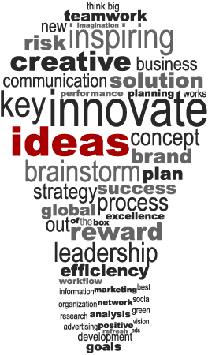
3 Sophisticated use of accurate, clear, and fluent expression.
TED is a nonpartisan non-profit devoted to spreading ideas, usually in the form of short, powerful talks. TED began in 1984 as a conference where Technology, Entertainment and Design converged, and today covers almost all topics — from science to business to global issues — in more than 110 languages.

