**Intertextual Study 2: Paul’s Use of the Old Testament in the New Testament or *Little Red Riding Hood***

*This task is about recognising the way texts can be compared to each other to add meaning that one text alone doesn’t have. For example, if an author used ideas about Superman in their novel, we would have an understanding of what kind of person or situation was meant from the film or comic book we had seen. Another example is how* Shrek *relies on the audience’s understanding of fairy tales to create its humour and meaning.*

*In this version of intertextuality, you are to look at how your understanding of biblical concepts or New Testament quotes is shaped or added to by comparing Old Testament cross quotes. Alternatively, you can consider 2 versions of* Little Red Riding Hood*. You have a maximum of 1000 words.*

**Questions:** How does the Paul use intertextuality by quoting the Old and in his New Testament letters to create understanding and explain ideas?

How effectively do the Brothers Grimm in *Little Red Cap* and Roald Dahl in his poem *Little Red Riding Hood,* target purpose, audience and context?

**Resources:**

* e-sword/Bible Hub
* Specific works on chosen topics
* All Paul’s OT quotes (and allusions): https://www.wednesdayintheword.com/paul-oldtestament/
* Hebrews too: <https://www.wednesdayintheword.com/hebrews-ot-quotations/>

**Planning Table:**

|  |  |
| --- | --- |
| **Text One:** |  |
| *Topic Details* | *Application to text (use evidence)* |
| Author/context |  |
| Audience/context |  |
| Purpose |  |
| **Text Two:** |  |
| *Topic Details* | *Application to text (use evidence)* |
| Author/context |  |
| Audience/context |  |
| Purpose |  |

**Writing your Answer:**

Use your table information to write 3 paragraphs showing comparisons and contrasts between the influences (Author, Audience and Purpose) on the two texts and how the texts have been impacted by these influences (Form and Language).

**For Bible Study Only:**

***Conclusion* on Why Paul Used this Quote**. Part 1 – explain how and why Paul used the quote from the Old Testament to make meaning in a new context. You will need to explain the link between the surrounding verses and the quote from the Old Testament. Also choose from the following and apply to your quote:

To give his teachings authority

To prove his teachings

To give proof that the Jews would respect/be familiar with

To apply a lesson from the OT in a new context

To show a fulfilled prophecy

To give an eyewitness account

To provoke thought and evaluation

To illustrate a principle

Part 2 – Put yourself in the shoes of the audience. Now explain how context, audience and purpose of the Old Testament quote might encourage or have meaning for the New Testament audience (you) in their (your) context.

**For *Little Red Riding Hood* Only:**

***Conclusion* on which text is more effective and why.** Think about which text might appeal more strongly to the target audience; which text has fulfilled its purpose most strongly; which text uses contextual elements most effectively to appeal to the audience.

**Performance Standards:**

* KU1 Depth of knowledge and understanding about ideas and perspectives in texts you explore.
* KU 3 Knowledge and understanding of ways in which texts are created for a range of purposes

and audiences.

* An1 Analysis of the relationship between purpose, audience, and context, and how they shape

meaning.

* An3 Detailed analysis of intertextual connections
* Ap3 Use of evidence such as quotes to support conclusions, with quotes and references

incorporated smoothly into writing.

* 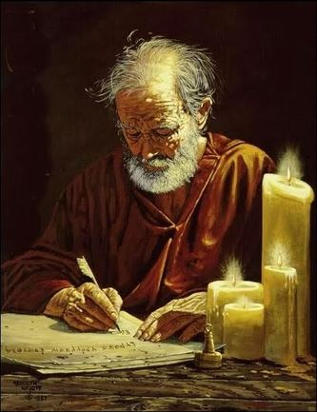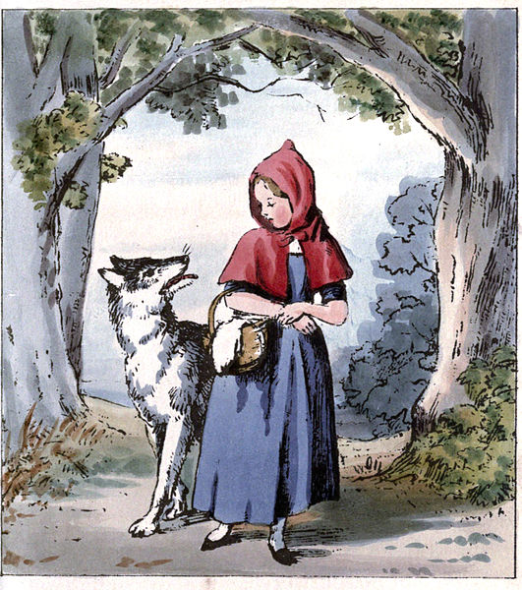Ap1 Precise, fluent, and coherent writing.