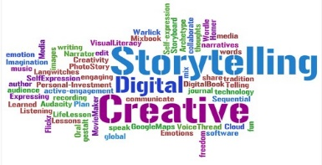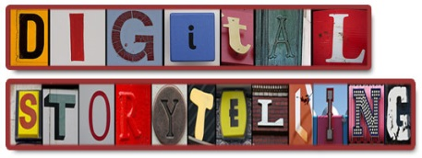

**Digital Story Assignment**

Digital Stories tend to be less a narrative and more dealing with social, environmental or other issues that people might have an interest in. This lends them to a persuasive purpose if you are so inclined. Generally, however, they are more about informing the audience on the issue and rousing sympathy or even action. Sometimes, such as a personal story about your granny’s experiences in WWII it could be just about interest.

Don’t forget to choose an appropriate audience for your style of story and purpose.

You can do a digital presentation of up to a maximum of 6 minutes. Remember there are 4000 words total across 4 pieces so you can vary the word count (or time – 1000 words is said to be equivalent of 6 minutes by SACE) for each piece.

Since this is a new style of text spend some time exploring examples and explanations of what this text type is all about (see below – the diagrams are a nice simple place to start getting your head around it all):

* *Here are examples of digital stories:* [*https://www.youtube.com/watch?v=BGsySU9iQYs*](https://www.youtube.com/watch?v=BGsySU9iQYs)*;* [*http://digitalstorytellers.com.au/*](http://digitalstorytellers.com.au/)
* 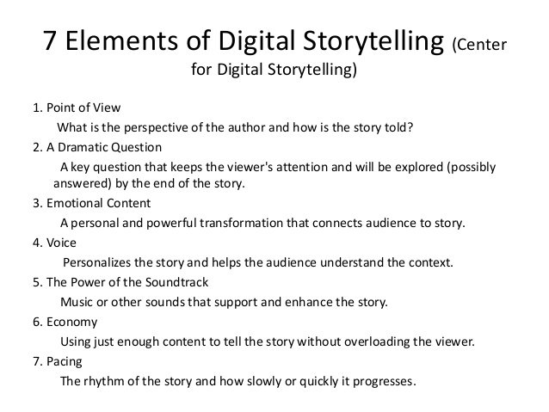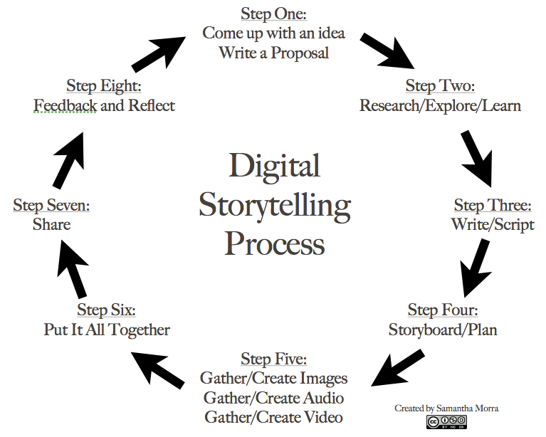*Explanations:* [*https://www.youtube.com/watch?v=JIix-yVzheM*](https://www.youtube.com/watch?v=JIix-yVzheM)*;* [*https://www.youtube.com/watch?v=LVKeO5IIR_A*](https://www.youtube.com/watch?v=LVKeO5IIR_A)

**Digital Story Performance Standards**

*Knowledge and Understanding*

1. Comprehensive knowledge and understanding of ideas and perspectives shown in a digital story.
2. Extensive knowledge and understanding of a wide range of ways in which digital stories are created for different purposes, audiences, and contexts.

*Application*

1. Versatile and precise use of language and stylistic features to create a coherent digital story that addresses the purpose, audience, and context

3 Sophisticated use of accurate, clear, and fluent expression.