The Birdsville Beast

I tried my best, I sincerely did. I could feel my little sister’s skyrocketing amusement searing through the back of my seat. We held it in. Dad exited the car taking his stony expression with him and sealed the door with a window-shattering slam which in turn cued our ear-splitting cackles and tears of laughter.

*‘The Birdsville Beast; my foot!’*

*~~~*

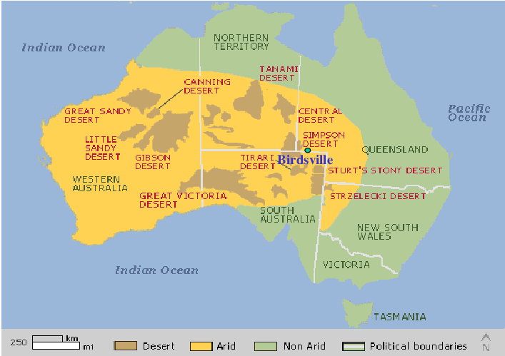This all began in the middle of nowhere in the pitifully small town of Birdsville, with the miniscule population of 140 people; where my family and I arrived on a mild Monday night, tired, grumpy and ready for a hearty pub feed. We had peregrinated all day from the also remote Charlaville and our stomachs, like 6 year old children, would not stop chattering through the last 3 hours of the journey. This is where we entered the sacred and singular restaurant of Birdsville: THE BIRDSVILLE HOTEL. Ordained with a sea of once-worn cowboy hats and bra’s on the ceiling, we sat and dined.

As I ate, I listened to the drunken chatter of jillaroo’s and jackaroo’s settling in for a night of beer and yacking before the early start that came with the morrow.

The next morning we rolled lazily out of the quiet town of Birdsville, bleary eyed and tired to our bones. Dad, on quite the opposite end of the spectrum, drove with gusto and true purpose as we entered onto the bumpy and hallowed trail of the Birdsville track. I could see his lips moving hastily and the hum of words falling out. However, I didn’t need to tune in to know he was yabbering endlessly on about ‘The Birdsville Beast.’

Our car had been christenedand the Birdsville Beast by Dad himself with utmost pride and love. And so our expedition in the Birdsville Beast began; into the the heart of Austraila; blissfully unaware of the tribulations that awaited us.

When the novelty of driving upon a dirt road wore off, that’s when I let my guard down. No sooner had I foolishly rested my heavy head upon the sleep inducing cotton of my pillow, the cries of desperate brakes screeching awoke me. Ahead, in the middle of the road, dubious cows had halted and proceeded to stare at the oncoming Birdsville Beast travelling at rapid paces of 110 kilometeres per hour. Mum was shouting inaudible instructions at the Birdsville Beast’s master. In the blur of panic and desperation I put forward my suggestion of honking at the cows in the hopes of scaring them to move off the bumpy dirt road.

The car raced, the tires screeched, our hearts pounded, we gripped our seats, bottoms clenched tight with fear, and then after an almighty HOOONNNK the cows scrambled. Their small brains apparently finally comprehended that sudden death and pain would accompany the oncoming car.

In unision we all let out a breath of relief.

Hours down the dry, crumbling road. When mirages of water in the heat drenched land had become my only joy and reason to continue…

I began to be alert, I had a horrid feeling growing in my gut. An unfavourable inkling. An awful apprehension. I proceeded to place earphones into my ears, to drown out the suspicion. No sooner had I danced with fate in my mind, I felt an almighty thud. The earth, my heart and the Birdsville Beast all shook and quaked. I knew we had reached the end of our adventure. The tyre had popped. There was no way it had survived that dip, jump and turn. A rock was wedged, a nail punctured it, something was wrong.

Against every law of physics and gravity the Beast raced onward down the track. The entire family sat there in silence, dumfounded at the apparent miracle that had just occurred. To say that the master was shaken would be an understatement but alas, he continued the drive with pace and vigour once more.

I figured that nothing else could go wrong, no more scares, no sudden turns. Finally, inevitable slumber came. It was so peacful sleeping, knowing that no more could or would go haywire.

I was awoken to the sharp jerk of the car. The moment played in slow motion as mum clutched her tea in fear, Dad clenched the wheel in panic, I grasped my seat in terror and my lovely, although aloof, younger sister continued to watch her no doubt enthralling dance show drama; maybe Ashely was about to try a new jazz routine?

I must say there is a moment in your life when you think it will be over in a matter of a few seconds and what you choose to do in that time is something I now know. I was inside my mind and the world was but nothing to me as chaos reigned. I wondered if I would ever see again those I loved dearly waiting at home, the feel of the sand between my toes and the refreshing shock of water as I lept off a jetty. Would I ever again sit in my church feeling completely safe surrounded by people who also love God? So many questions and memories raced through my mind; the good ones and the bad ones. But there was an underlying, quiet chanting in my head that lead me out of memory lane and into reality to face the chaos.

*‘Birdsville Beast.’*

*‘Birdsville Beast.’*

*‘Birdsville Beast.’*

The world spun and blurred into a haze of heavenly yellows and dusty oranges as the back wheels of the beast refused to be tamed around the omnipotent corner that had taken the reigns.

We waited as the Beast spun and twisted and as we held our breaths for what seemed an eternity; the Beast gave in. Once more Dad was in control. As we drove I spied the grin in the review mirror, the grin told me exactly what its owner was thinking: ‘*This Birdsville Beast is unstoppable.’*

~~~

And this is where we left off; with a door slam, a stony expression, the defeated Birdsville Beast and its completely shredded tyre.

‘*The Birdsville Beast my foot.’*

And we continued howling.

**Word count: 1021**