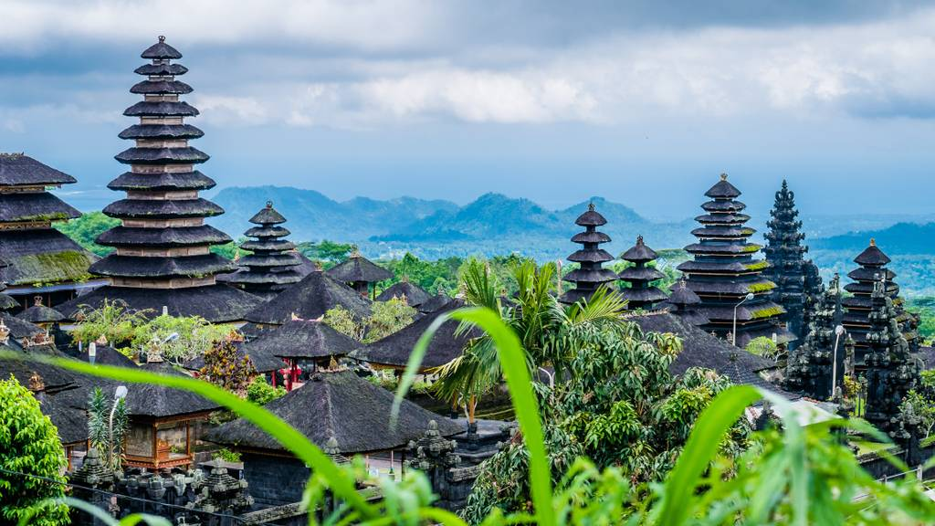**TRAVEL MEMOIR- BALI, INDONESIA   
IS IT THE PLACE TO GO?**

Figure - Bali, Indonesia

You may have been told that Bali is not the place to travel. It’s basic, it’s worth keeping your money, it’s deprived of culture, and no doubt, you will come home with the infamous Bali belly. But from my experience, I can say that with all Bali’s faults, I flew home with more than just enjoyable memories.

Bali is one of the most visited destinations and I can see why. It contains virtually every aspect of natural beauty, from scenic lakes to glorious mountain tops, with the addition of captivating attractions and activities, suitable for any family with young kids, or even a group of broke, young, university students.

It’s an island full of fellow tourists and genial locals, delicious and fascinating food, limitless experiences, and draw-dropping scenery. The positives seem endless, but although Bali may seem flawless, there is a great deal of poverty and suffering on the island. Despite this, all the best holidays come with imperfections and Bali still manages to be informative, fun, adventurous, and realistic for all ages.

**MY EXPERIENCE**

In my experience, I encountered Bali’s endless beauty constantly, alongside some negative factors, such as the thick, polluted air, surrounding tsunamis of tourists and the underlying fear of coming down with the notorious Bali belly; and although Bali comes with some faults, I highly believe that all countries do. In spite of this, Bali was still incredible. It inhabited welcoming locals, glamorous resorts, astonishing scenery and many, *many* thrilling activities. One in particular, was the visit to the Waterbomb Park.

It was the second day into our trip, when my family decided to go to the Waterbomb Park, due to the scorching heat. Heavy droplets of sticky sweat were appearing on my forehead, under my armpits, around my torso. Eve-ry-where. My family and I were passing through the crowded street markets, bumping into oblivious and obnoxious strangers. Even in the sea of people, I never managed to spot a local, *only* tourists. It was a little far off from our villa, so we had to venture across the mass of people to reach our destination. With the addition of the humidity, and the proximity between random bodies, we were desperate for any relief of some cooling, so what better place to go than a water park?

Once we arrived, we were off on our own adventures. After being there for a few hours or so, Kayla, my beloved sister, was bribed with the reward of ice cream if she attempted the Climax. Kayla was young, and hungry, and so she did what she was told. Trembling and shivering her way up to the top, to the steepest, and fastest ride in all of Asia, with only an ice-cream in mind. She was ordered to stand on the trap board with her arms crossed, as the man counted down… 3…2…1! A 40-kilogram kid zooms down the slide, almost falling off the edge, due to the lack of safety rails and protection, gliding down so swiftly that in the next blink of an eye, she was crying at the foot of the frightful slide. She was so traumatised, that as a result, she was in no mood for an ice-cream.

That story introduces how my Bali adventures occurred throughout our stay. A thrilling experience, but never perfect. Although, for me, I didn’t need perfection, and with all brutal honesty, I don’t think anyone does. When it comes to a vacation, everyone needs to fly home with gratifying recollections and valuable lessons, which Bali completely provided.

Allow me to clarify. Not only did we enjoy the waterpark, but we also experienced amusing elephant rides, infinite street market shopping, mountain top views and the taste of exotic food. Bali was extraordinary, and the insufficiencies, such as extreme poverty, scarcity of clean water and hygiene, invading tourists and the high number of homeless families, had a positive side. They taught me a lesson about appreciation and gratefulness for my own lifestyle, country, and situation. This was solidified when I witnessed two little boys scavenge for food.

A week into our trip, I noticed the maids at the villa empty the buffet leftovers at the back of the kitchen. They wrapped a mound of breakfast foods into tightly packaged garbage bags and cast them carelessly into a large dumpster. Even from afar, the stench was strong. Once the women began to leave, I saw subtle movement in the bushes behind the dumpster. Two little Balinese boys stuck their small heads out from the thicket, as they whispered and giggled to each other. Once deciding no one was present, they came out of the bush completely. Their skeletal bodies were on display as they ran towards the dumpster. The frail, emaciated boys leapt inside the sea of black plastic wrappings as they pulled out thin, pocketknives. The knives looked as sharp as tiger teeth when they effortlessly sliced through the garbage bags. In the next second, the boys were knee-deep into the rot- desperate for any source of food.

The boys were still giggling as they foraged. Even with their desperation and hunger, they were still grateful and triumphant for the food that they could find. This influenced me to appreciate my own life, as I took most of it for granted, such as the healthy and clean food given to me daily.

In reality, a truly valuable holiday comes with limitless positives *and* limitless flaws. Bali genuinely was amazing, as the flaws taught me to be thankful, and the positives made the entire experience memorable. If you’re a kid, a university student, or an adult, I am sure Bali will remind you to be grateful as well.

Bali is remarkable and I highly recommend it. It was a pleasurable holiday, and I came home with a new appreciation for my country, and my living situation, alongside some very exciting memories. **Word Count:** 997 words.