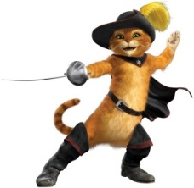

Intertextuality Study 1

*This task is about recognising the way texts can be compared to each other to add meaning that one text alone doesn’t have. For example, if an author used ideas about Superman in their novel, we would have an understanding of what kind of person or situation was meant from the film or comic book we had seen. Another example is how* Shrek *relies on the audience’s understanding of fairy tales to create its humour and meaning.*

Examples of this type of intertextuality:

* *Wide Sargasso Sea* is the story of the first wife from *Jane Eyre* by Charlotte Bronte. By telling the rejected wife’s story the author is critiquing both gender and racial issues of Bronte’s time.
* *Shrek* uses fairy tale elements to parody and make fun of stereotypes about gender and heroism in the original stories.

**Questions:**

1. Choose a minor character from *To Kill A Mockingbird* and create a short story in which they are the main character. Write the piece in the style of Harper Lee or use 5 other intertextual elements from the novel. In an accompanying writer’s statement, explain how the elements of your story (e.g. theme, plot, characters and/or language etc.) have been influenced by your knowledge of *To Kill A Mockingbird* and the meaning that the novel adds to your story.

OR

1. 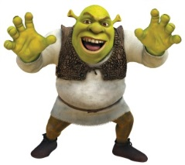Create your own short story that applies one of the themes in *To Kill A Mockingbird* to your own context. It may be fictional or based on your experiences. Write the piece in the style of Harper Lee or use 5 other intertextual elements from the novel. In an accompanying writer’s statement, explain how the elements of your story (e.g. theme, plot, characters and/or language etc.) have been influenced by your knowledge of *To Kill A Mockingbird* and the meaning that the novel adds to your story. Themes from *To Kill A Mockingbird* that could be developed through a short story are:
2. The coexistence of good and evil
3. Prejudice
4. Racism
5. Growing up/coming of age
6. Family
7. Gender

**Performance Standards:**

*Knowledge and Understanding*

* Knowledge and understanding of ways in which texts are created for a range of audiences to convey a clear message added to by links to *To Kill A Mockingbird* in both writer’s statement and narrative

*Analysis*

* Analysis of intertextual connections in the writer’s statement: style/intertextual features and added meaning identified

*Application*

* Precision, fluency and coherence of writing and speaking in both pieces
* Use of appropriate *To Kill A Mockingbird*esque language features, stylistic features and conventions in your narrative
* Use of short quotes and references to your narrative as evidence in your writer’s statement from texts to support conclusions with textual references incorporated in responses.