**Intertextual Study 2: Comparing Versions of *Little Red Riding Hood***

*For this assignment we are going to look at another aspect of intertextuality but the same principles still apply. In this version of intertextuality, you are to study at 2 texts that have similarities but also differences.* In this case I have chosen the texts for you.

**Question:** You need to write an essay, report or create a multi-media presentation, of a maximum of 1,000 words, which identifies the connections and differences between Grimm’s *Little Red Cap* and Roald Dahl’s *Little Red Riding Hood and the Wolf* and explains them in relation to purpose, target audience and their context, form and language and articulates the reasons as to which is the more effective and why.

Use the table on Haiku to gather all the relevant information and then use your table information to write 3 paragraphs of a report or essay as per the writing template. You can also present it in a multimedia form but still need same sections.

In a conclusion think about which text might appeal more strongly to the target audience; which text has fulfilled its purpose most strongly; which text uses contextual elements most effectively to appeal to the audience.

**Performance Standards:**

* KU 3 Knowledge and understanding of ways in which texts are created for a range of purposes

and audiences.

* An1 Analysis of the relationship between purpose, audience, and context, and how they shape

meaning.

* An3 Detailed analysis of intertextual connections
* Ap3 Use of evidence such as quotes to support conclusions, with quotes and references

incorporated smoothly into writing.

* 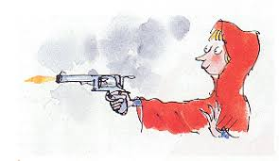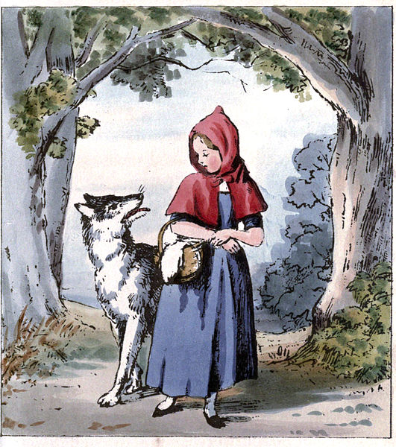Ap1 Precise, fluent, and coherent writing.