Don’t believe the hype – 10 persistent cancer myths debunked
Category: Science blog March 24, 2014 Oliver Childs
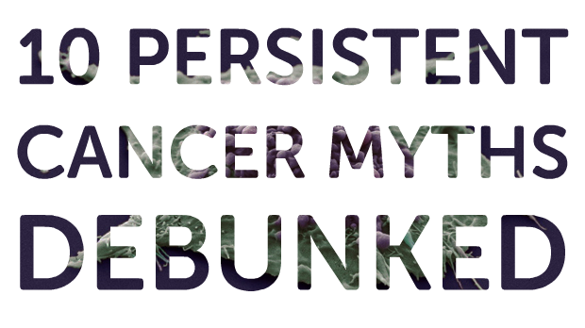
Google ‘cancer’ and you’ll be faced with millions of web pages. And the number of YouTube videos you find if you look up ‘cancer cure’ is similarly vast.
The problem is that much of the information out there is at best inaccurate, or at worst dangerously misleading. There are plenty of evidence-based, easy to understand pages about cancer, but there are just as many, if not more, pages spreading myths.
And it can be hard to distinguish fact from fiction, as much of the inaccurate information looks and sounds perfectly plausible. But if you scratch the surface and look at the evidence, many continually perpetuated ‘truths’ become unstuck.
In this post, we want to set the record straight on 10 cancer myths we regularly encounter. Driven by the evidence, not by rhetoric or anecdote, we describe what the reality of research actually shows to be true.
- Myth 1: Cancer is a man-made, modern disease
- Myth 2: Superfoods prevent cancer
- Myth 3: ‘Acidic’ diets cause cancer
- Myth 4: Cancer has a sweet tooth
- Myth 5: Cancer is a fungus – and sodium bicarbonate is the cure
- Myth 6: There’s a miracle cancer cure…
- Myth 7: …And Big Pharma are suppressing it
- Myth 8: Cancer treatment kills more than it cures
- Myth 9: We’ve made no progress in fighting cancer
- Myth 10: Sharks don’t get cancer

Myth 2: Superfoods prevent cancer
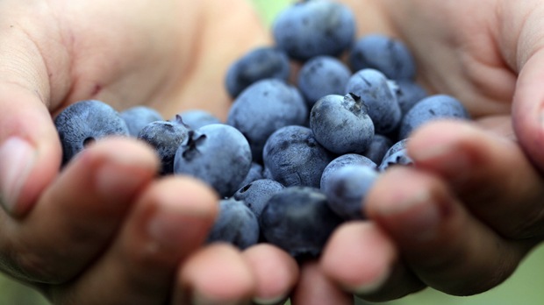
Blueberries, beetroot, broccoli, garlic, green tea… the list goes on. Despite thousands of websites claiming otherwise, there’s no such thing as a ‘superfood’. It’s a marketing term used to sell products and has no scientific basis.
That’s not to say you shouldn’t think about what you eat. Some foods are clearly healthier than others. The odd blueberry or mug of green tea certainly could be part of a healthy, balanced diet. Stocking up on fruits and veg is a great idea, and eating a range of different veg is helpful too, but the specific vegetables you choose doesn’t really matter.
Our bodies are complex and cancer is too, so it’s gross oversimplification to say that any one food, on its own, could have a major influence over your chance of developing cancer.
We’ve also written extensively on the scientific evidence about anti-oxidants and cancer in these posts – part one, part two and part three. [Added 28/03/14 KA]
The steady accumulation of evidence over several decades points to a simple, but not very newsworthy fact that the best way to reduce your risk of cancer is by a series of long-term healthy behaviours such as not smoking, keeping active, keeping a healthy body weight and cutting back on alcohol.

Myth 6: There’s a miracle cancer cure…
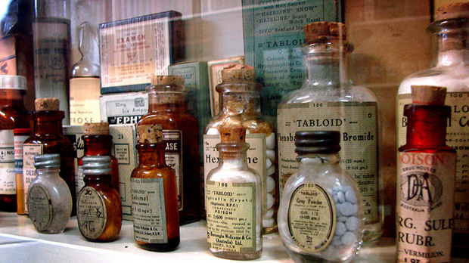
From cannabis to coffee enemas, the internet is awash with videos and personal anecdotes about ‘natural’ ‘miracle’ cures for cancer.
But extraordinary claims require extraordinary evidence – YouTube videos and Facebook posts are emphatically not scientific evidence and aren’t the same as good-quality, peer-reviewed evidence.
In many cases it’s impossible to tell whether patients featured in such anecdotal sources have been ‘cured’ by any particular alternative treatment or not. We know nothing about their medical diagnosis, stage of disease or outlook, or even if they actually had cancer in the first place. For instance, we don’t know what other cancer treatments they had.
And we only hear about the success stories – what about the people who have tried it and have not survived? The dead can’t speak, and often people who make bold claims for ‘miracle’ cures only pick their best cases, without presenting the full picture.
This highlights the importance of publishing data from peer-reviewed, scientifically rigorous lab research and clinical trials. Firstly, because conducting proper clinical studies enables researchers to prove that a prospective cancer treatment is safe and effective. And secondly, because publishing these data allows doctors around the world to judge for themselves and use it for the benefit of their patients.
This is the standard to which all cancer treatments should be held.
That’s not to say the natural world isn’t a source of potential treatments, from aspirin (willow bark) to penicillin (mould). For example, the cancer drug taxol was first extracted from the bark and needles of the Pacific Yew tree.
But that’s a far cry from saying you should chew bark to combat a tumour. It’s an effective treatment because the active ingredient has been purified and tested in clinical trials. So we know that it’s safe and effective, and what dose to prescribe.
Of course people with cancer want to beat their disease by any means possible. And it’s completely understandable to be searching high and low for potential cures. But our advice is to be wary of anything labelled a ‘miracle cure’, especially if people are trying to sell it to you.
Wikipedia has this excellent list of ineffective cancer treatments that are often touted as miracle cures, which is worth a browse.
If you want to know about the scientific evidence about cannabis, cannabinoids and cancer – a topic we’re often asked about – please take a look at our extensive blog post on the subject, including information about the clinical trials we’re helping to fund.
And if you’ve seen links to article about scientists in Canada “curing cancer but nobody notices”, these refer to an interesting but currently unproven drug called DCA, which we’ve also written about before. [Added KA 28/03/14]

Myth 7: … and Big Pharma are suppressing it
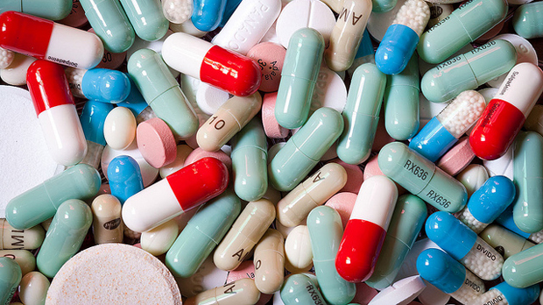
Hand in hand with the idea that there is a cornucopia of ‘miracle cures’ is the idea that governments, the pharmaceutical industry and even charities are colluding to hide the cure for cancer because they make so much money out of existing treatments.
Whatever the particular ‘cure’ being touted, the logic is usually the same: it’s readily available, cheap and can’t be patented, so the medical establishment is suppressing it in order to line its own pockets. But, as we’ve written before, there’s no conspiracy – sometimes it just doesn’t work.
There’s no doubt that the pharmaceutical industry has a number of issues with transparency and clinical trials that it needs to address (the book Bad Pharma by Ben Goldacre is a handy primer). We push regulators and pharmaceutical companies hard to make sure that effective drugs are made available at a fair price to the NHS – although it’s important to remember that developing and trialling new drugs costs a lot of money, which companies need to recoup.
Problems with conventional medicine don’t automatically prove that alternative ‘cures’ work. To use a metaphor, just because cars sometimes crash doesn’t mean that flying carpets are a viable transport option.
It simply doesn’t make sense that pharmaceutical companies would want to suppress a potential cure. Finding a highly effective therapy would guarantee huge worldwide sales.
And the argument that treatments can’t be patented doesn’t hold up. Pharma companies are not stupid, and they are quick to jump on promising avenues for effective therapies. There are always ways to repackage and patent molecules, which would give them a return on the investment required to develop and test them in clinical trials (a cost that can run into many millions) if the treatment turns out to work.
It’s also worth pointing out that charities such as Cancer Research UK and government-funded scientists are free to investigate promising treatments without a profit motive. And it’s hard to understand why NHS doctors – who often prescribe generic, off-patent drugs – wouldn’t use cheap treatments if they’d been shown to be effective in clinical trials.
For example, we’re funding large-scale trials of aspirin – a drug first made in 1897, and now one of the most widely-used off-patent drugs in the world. We’re researching whether it can prevent bowel cancer in people at high risk, reduce the side effects of chemotherapy, and even prevent cancer coming back and improve survival.
Finally, it’s worth remembering that we are all human – even politicians and Big Pharma executives – and cancer can affect anyone. People in pharmaceutical companies, governments, charities and the wider ‘medical establishment’ all can and do die of cancer too.

