How to make a simple Gantt chart
13 September 2011by Jonathan O'Donnell36 Comments
In every grant application, I want to see a simple visual guide (a Gantt chart) that shows what you are planning to do. It is the perfect time to plan your project clearly. It shows the assessors that you have thought about your research in detail and, if it is done well, it can serve as a great, convincing overview of the project.
Clearly, these charts are hard to do. If they were easy, more people would do them, right?
Here are five steps to create a simple guide to your research project.

1. List your activities
Make a list of everything that you plan to do in the project. Take your methodology and turn it into a step-by-step plan. Have you said that you will interview 50 people? Write it on your list. Are you performing statistical analysis on your sample? Write it down.
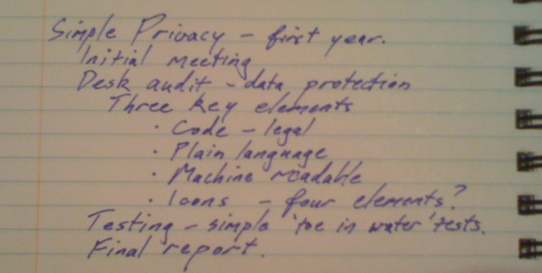
List of tasks for "Simple Privacy", a one year project

2. Estimate the time required
For each item on your list, estimate how long it will take you to do that thing. How long are you going to be in the field? How long will it take to interview your people? Realistically, how many interviews can you do in a day? When will people be available?
- Initial meeting: about 3 weeks to find a time.
- Desk audit: 4 weeks.
- Draft key elements: about 1 week each.
- Testing: about 1 week each, but can start organising as soon as first element is drafted.
- Write up: 2 weeks.
- Final report: no time, really – just need to find a time to meet.
Generally, I use weeks to estimate time. Anything that takes less than a week I round off to a week.

3. Put activities in order
What is the first thing that you are going to do? What will you do next? What will you do after that?
In the comments, Adrian Masters provided some great questions to help with this stage:
- What do I need to do by when?
- What do I need from others & when?
- How do I check that I am still on track?
One by one, put everything in order. Make a note of any dependencies; that is, situations where you can’t do one thing until another is started or finished. If you want to do interview, they can’t start until the subjects are found so you need to do that first.

4. Draw me a picture
If you use project management software to manage your project, and you are comfortable with it, then use it to produce a summary of your project, too.
Most project management software (e.g. like Microsoft Project) will allow you to group activities into summary items. Chunk your tasks into major headings, then change the time interval to your months, quarters, half-years, or whatever you have chosen to use.
Or you can just draw it up with word-processing software (which is what I always do), spreadsheet software, or even hand-draw it.
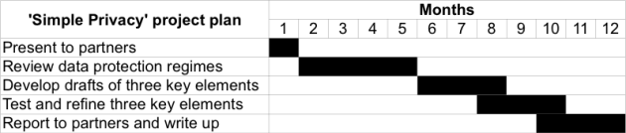
Example of a Gantt chart
BIG NOTE: your Gantt chart will need the thinking you have done + more detail on research methods to be used ON IT to be very useful for the Folio ie dependencies will be noted and reasons for time allowed will be given.

