What are some important uses of water and what properties of water make it eminently suitable for these usages?
Water, a common liquid, has unique properties that make it ideal for many uses (Johansen, 2010). It can be used for domestic procedures such as washing clothes, dishes and bodies (Gruffy & Nant, 2001). It can also be used or help in specific chemical reactions such as production of materials (DatScienceShow, 2015). A further use of water is to give life to most organisms on earth, which require water to support their biological processes (WaterUses contributors, 2016). The interesting factor is that all of these seemingly modest uses rely on complex chemistry to enable them.
The initial theme of my research and an important aspect of water to understand when exploring its usefulness is that it possesses unique properties. According to Aristu Sahu, a physicist I interviewed, water is the “only common substance which is found naturally in solid, liquid and gas forms” (Sahu, 2016). Water is unusual in that it expands when it freezes, which means that ice floats on water (WaterFacts, 2016). Water is also able to resist freezing more than most substances (Perrine & Schneitz, 2014; DatScienceShow, 2015). Combining these findings together, it could be suggested that water’s unique properties are a result of how it responds to being heated or cooled. This explains why in many of the uses of water it could not be replaced with another substance, because other chemicals might react differently when placed in hot or cold conditions.
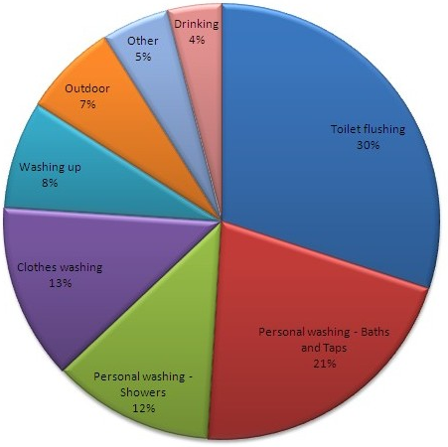
The unique ability of water to work in conjunction with detergent for washing a wide variety of substances was a further proof of its exceptional qualities. My own findings from a survey (see figure 1) included a wide variety of modern domestic washing practices that use water, including the washing of clothes, dishes and bodies (Gorgon, 2016; Sharburn, 2009). As well as such mundane uses of water, one of my findings was that wood pulp can also be washed this way (woodwashers.org, 2014). This was supported by Pogar (1994) who states: “many procedures that we might not normally think about as being washing, such as removing unwanted oils from wood, benefit from the application of soapy water”. An academic journal, Surfactants, stated that water and soap have been used for thousands of years for cleaning fabrics such as wool (Sharburn, 2009). Combining ideas from these findings, it has been possible to extrapolate that water is a very non-reactive substance as many different substances can be washed effectively in practically the same manner. Thus, one property of water that makes it highly suitable for washing is its chemical neutrality while another is its ability to exhibit enhanced cleaning action when combined with detergents.
Fig 1: Results of my survey on domestic water uses.
The use of water for chemical reactions was another evidence of water’s unique properties. Water is incredibly common in chemical processes, though often just as a substance to hold the chemicals rather than being used up itself; zinc metal production is an example of this (Cecchi, 2004). As well, water can be used to carry heat to or from chemical reactions in order to control them or use the energy for power sources (Batterton et al., 1999). A science TV show, DatScienceShow, revealed that there are many reactions which use vast amounts of water, such as producing or recycling paper (DatScienceShow, 2015). These findings collectively show that water is crucial to many chemical processes, even when seemingly not directly involved, its useful property here being its ability to hold and transfer chemicals and energy.
A final theme investigated was water’s importance in the life support of just about any organism on earth, relying on its property of preferring a liquid form. Water is able to contain nutrients in dissolved form, such as salt and minerals (Nasser, 2013). Also, water, commonly being found in liquid form, is important for transportation of nutrients, including through the roots of plants (WaterUses contributors, 2016). Another finding, attained from a documentary on the subject, was that most organisms are more than half water, and have various “strategies for collecting and storing water in order to survive” (The Secret Life of Water, 2008; Johansen, 2010). The importance of Earth’s water cycle, where water evaporates from the ocean and forms rain again and again without failing, was also discovered (Milone, 1988). Looking at all these findings as a whole, it is clear to me that life depends on water being in liquid form. Liquid water allows transportation of vital nutrients by rain outside of organisms and delivery through the organisms by flowing inside them.
In conclusion water is uniquely suited for its many uses because of the way it responds to temperature changes, that one of the most important uses of water is in washing, that water performs a crucial role in helping and controlling chemical reactions and that it is a critical component of life on Earth due to its ability to carry salts and minerals.
1000 words
Reference List
Primary Sources
Sahu, A 2016, Interviewed by Stanley Gorgon, Adelaide, 30 August
Gorgon, S 2016, Survey on Water 10-16th Sept 2016
Books and Journals
Batterton, F, Freidrich, K, Jerman, Y & Nongul, N 1999, To What Extent Can Water Be Used to Improve the Efficiency of Chemical Reactions?, New Grinswald Academy of Science
Gruffy, BN & Nant, RG 2001, Clean Chemistry, 1st edn, McGraw Hill, Sydney
Johansen, S 2010, Wonderful Water, 2nd edn. Dorling Kindersly, USA
Milone, P 1988, Earth’s Natural Cycles, 6th edn, Harrison, Melbourne, pp. 50-54
Pogar, B 1994, ‘Liquid Gold’, WASH, 14 March p19
Sharburn, G 2009, ‘Soap in Hellenistic Greece’, Surfactants, vol. 22, no. 4, pp. 10-11
Visual Texts
DatScienceShow 2015, H2O, Australian Broadcasting Corporation, Sydney, 9 July
The Secret Life of Water, 2008, Directed by Norm Zindra [DVD], UK: BBC
Websites
Cecchi, C 2004, Producing Zinc, http://bbn.news.com.au/producing-zinc-20040918.html, accessed 19 Sept 2014
Nasser, W 2013, Solubility of Common Salts, http://noguphys.co.uk/archive/2013-04-15/solubility-of-common-salts.pdf, accessed 18 Sept 2014
Perrine, L & Schneitz, T 2014, Thought of the Day, http://perriandsz.blogspot.com/2012/12/thought-of-the-day.html, accessed 15 Sept 2014
WaterFacts 2016, Why is Water so Weird?, http://wateranswers.org/a.php?qid=368677, accessed 11 Sept 2014
WaterUses contributors 2016, Xylem, http://waterwiki.org/wiki/Xylem, accessed 7 Sept 2014
Woodwashers.org 2014, ‘About Us’, http://woodwashers.org/about.htm, accessed 20 Sept 2014

