Currently there have been a lot of debates on whether or not our school system is the most appropriate way to prepare young minds for the future. I mean, not that I have a big opinion or anything, but to me, forcing students to all fit in and act the same probably isn’t the best way to celebrate their differences and prepare them for later life.
The first school ever made was established in 1635, making school 383 years old, much older than anyone reading this. Wouldn’t you think that something would have been upgraded after 383 years? Now, when you take a look at popular products the world is producing today, you’d agree with me when I say that they are changing rapidly all the time. For example, the first iPhone was created in 2007, and when you compare it to the latest iPhone, released ten years later, they are completely different, and I think it’s safe to say you’d choose the 10th edition over the 1st.
We’d never want to fly on the first plan prototype when it’s compared to the latest jet engine, and we’d choose the latest Ferrari over a horse and cart from two hundred years ago.
But what about school? Has that changed a lot in the past five years, like the iPhone? Has it even changed a lot from twenty years ago? I don’t know about you, but for the last eleven years I’ve been here, it’s still pretty much the same, and as boring as ever.
And yeah, it has changed in small ways, I’m not blind. Schools rely on technology a lot more now, which never fails, mind you, and the walls are no longer a plain white, but some fun colour with dots bright enough to give someone epilipsy. And they definatly make me want to learn more than the white walls. There are new buildings and tables, but all in all, how different is it, really?
Kids are still looking forward to prying their eyeballs open at 7am, sometimes earlier, and sitting down for hours at a time, not being allowed to talk or share what they want. I thought school, out of all places, would be the best place to share and create new ideas, but one word out of turn can cost you your limited lunch time.
Sitting in rows, not being able to go to the toilet or get a drink when you need, and doing the same thing for five days a week, up to eleven weeks at a time, for 12 years.
And did I mention they’re just kids? A test was taken with 9-12 year olds, which proved that they have more energey than adult endurance athletes. I don’t know how much training an endurance athlete does a day, maybe you can ask one, but believe me when I say it’s a lot. And the current school system is forcing these energy-riddled children to sit down for the majority of their day, with an hour break a day, getting in trouble for every word they speak out of turn.
But hey, I guess school is pretty great. You basically never have to do work at home, there are no mandatory tests, and private schooling is so, so cheap. The schools provide food, medical care, counselling and taxi service if needed.
I mean, what’s better than staying up all night, memorising information on a subject you don’t care at all about, only to forget it right after the test or exam? Not much, really.
Ok, the current school system is, frankly, terrible. I’ve done some research on the main causes of stress and some of the results were: having a heavy workload or too much responsibility, having to give speeches infornt of colleages, facing harrasment and discrimination, and working long hours. Good thing you don’t find any of these things at school, am I right?!
Students with different mindsets, backgrounds and learning abilities are all placed into one room and taught the exact same way, and then their worth is determined by the grade that they achieve.
There is a quote, presumed (but not proved) to be written by Einstein, saying; “If you judge a fish on it’s ability to climb a tree, it will live it’s whole life believing that it is stupid.” If there is a child who excels at art, and is extremely creative and interesting, but can never manage to pass her math tests with flying colours, she will be considered stupid and be told constantly to try harder, until she gets that one, simple “A”.
In this day and age, your smartness is all determined on what grade you achieve on that exam, that test, and in that class.
But is that really what determines your worth? High-school dropouts are often frowned upon and scorned, but let me name a few to help you see more clearly. Benjamin Franklin gave up on school at just 10 years old, choosing to work as a soap and candle maker before running away to Philadelphia. The much loved Walt Disney dropped out at 16 to join the army, but was rejected for being too young. Charles Dickens left once he was 12, and then again when he was 15. Then, of course, there’s our all-time favourite, Albert Einstein, who had possibly the worst report cards, and absouloutly hated school, leaving at 15.
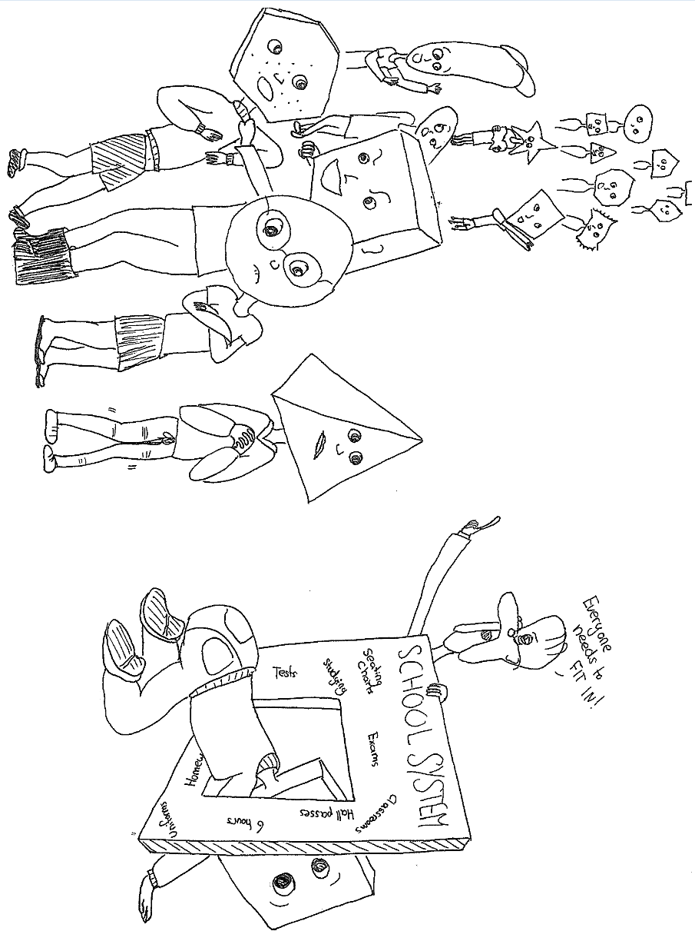
“Will this be on the test?” is the most asked question in school, along side with “When will I need to know this?” Will it be on the test. Will it? That is all school is about. Learn it for the test, and then forget it the next day. Fun fact; people forget 60%-95% of what they are told at school within three days.
But is that really learning? Memorizing enough to get a nice grade and then letting it all go for the rest of your life, never needing to know it again? No.
So, let’s change the system. Let’s leave this system, where students are scared to go to school, scared to show their parents their test, scared to even look at their grade. Let’s leave the age where your worth is determined by a single letter, where you learn things you will never need to know.
As much as I’ll miss getting out of bed and walking to the bus stop in the boiling heat or freezing cold, let’s end this age of schooling now. How, you may ask? Think of something. Create a website, flyers, appeal to whoever our Prime Minister is nowadys, or drop out. Maybe just don’t tell your parents.

