Reading Skills Practise:

Retrieving Directly Stated Information
- Using clues across large, complex texts - some inferences may be necessary
1 Look at all the times the NRA (National Rifle Association) is mentioned in this article.
Conclude what the role of the NRA is in the gun control struggle in America, giving evidence for your conclusion.
- Clues outside body of main text
2 a) Explain the cartoon, using all its elements.
b) How is this relevant to the article?
- Key language is used to explain relationships between ideas
3 Identify 3 instances of sarcasm AND explain how they are being used to strengthen the author’s point about gun control.
- Complex rephrasing of ideas
4 “Guns don’t kill people, government negligence and apathy from the NRA and the president do” is given as a famous quote.
What is the actual famous quote AND what is the author saying by misquoting it like this?
- Applying information to different contexts
5 This example is an opinion newspaper article so it should have the structure and language features of an opinion newspaper article.
So make as many conclusions as you can from the structure and language of this article about the conventional (usual/normal) structure and language of an opinion newspaper article.
The New York Times
23 Oct, 2018 Reporter: Joshua Cridland
"We can really get there, but we have to do it," stated Donald J Trump when talking about the current gun laws in the United States. After weeks of lengthy deliberations and meetings, US lawmakers have finally put the finishing touches to a detailed plan that would see them change nothing and hope for the best. Even after the Las Vegas shooting, one of the biggest mass shootings in US history, where 59 civilians were shot dead and 851 were injured, President Donald J Trump and his administration did, and continues to do, nothing.
After the US law-makers careful deliberations and long talks, they have been putting plans in motion. These plans consist of ‘winging it’ while mass shootings occur daily. The government believes that these shooting are a single instance. Sure, the 154 mass shootings this year have been single instances with no blame or fault to be placed on anyone. Government Trump must have been correct, if he wasn’t, there is no way he would have the support of the NRA, the National Rifle Association, which would have no reason to be biased in one way or the other, surely.
Perhaps America’s plan is to prove the superiority of our land. We look at all other developed world countries, with their tight control of guns and lack of mass shooting over the years, and think that somehow, we are coming out on top. But no, of course there is a much simpler way that the great Trump administration have come up with beside actual gun controls: arming teachers with weapons so that during a shooting they can run out with a gun in hand and be the hero that every American wants to be.
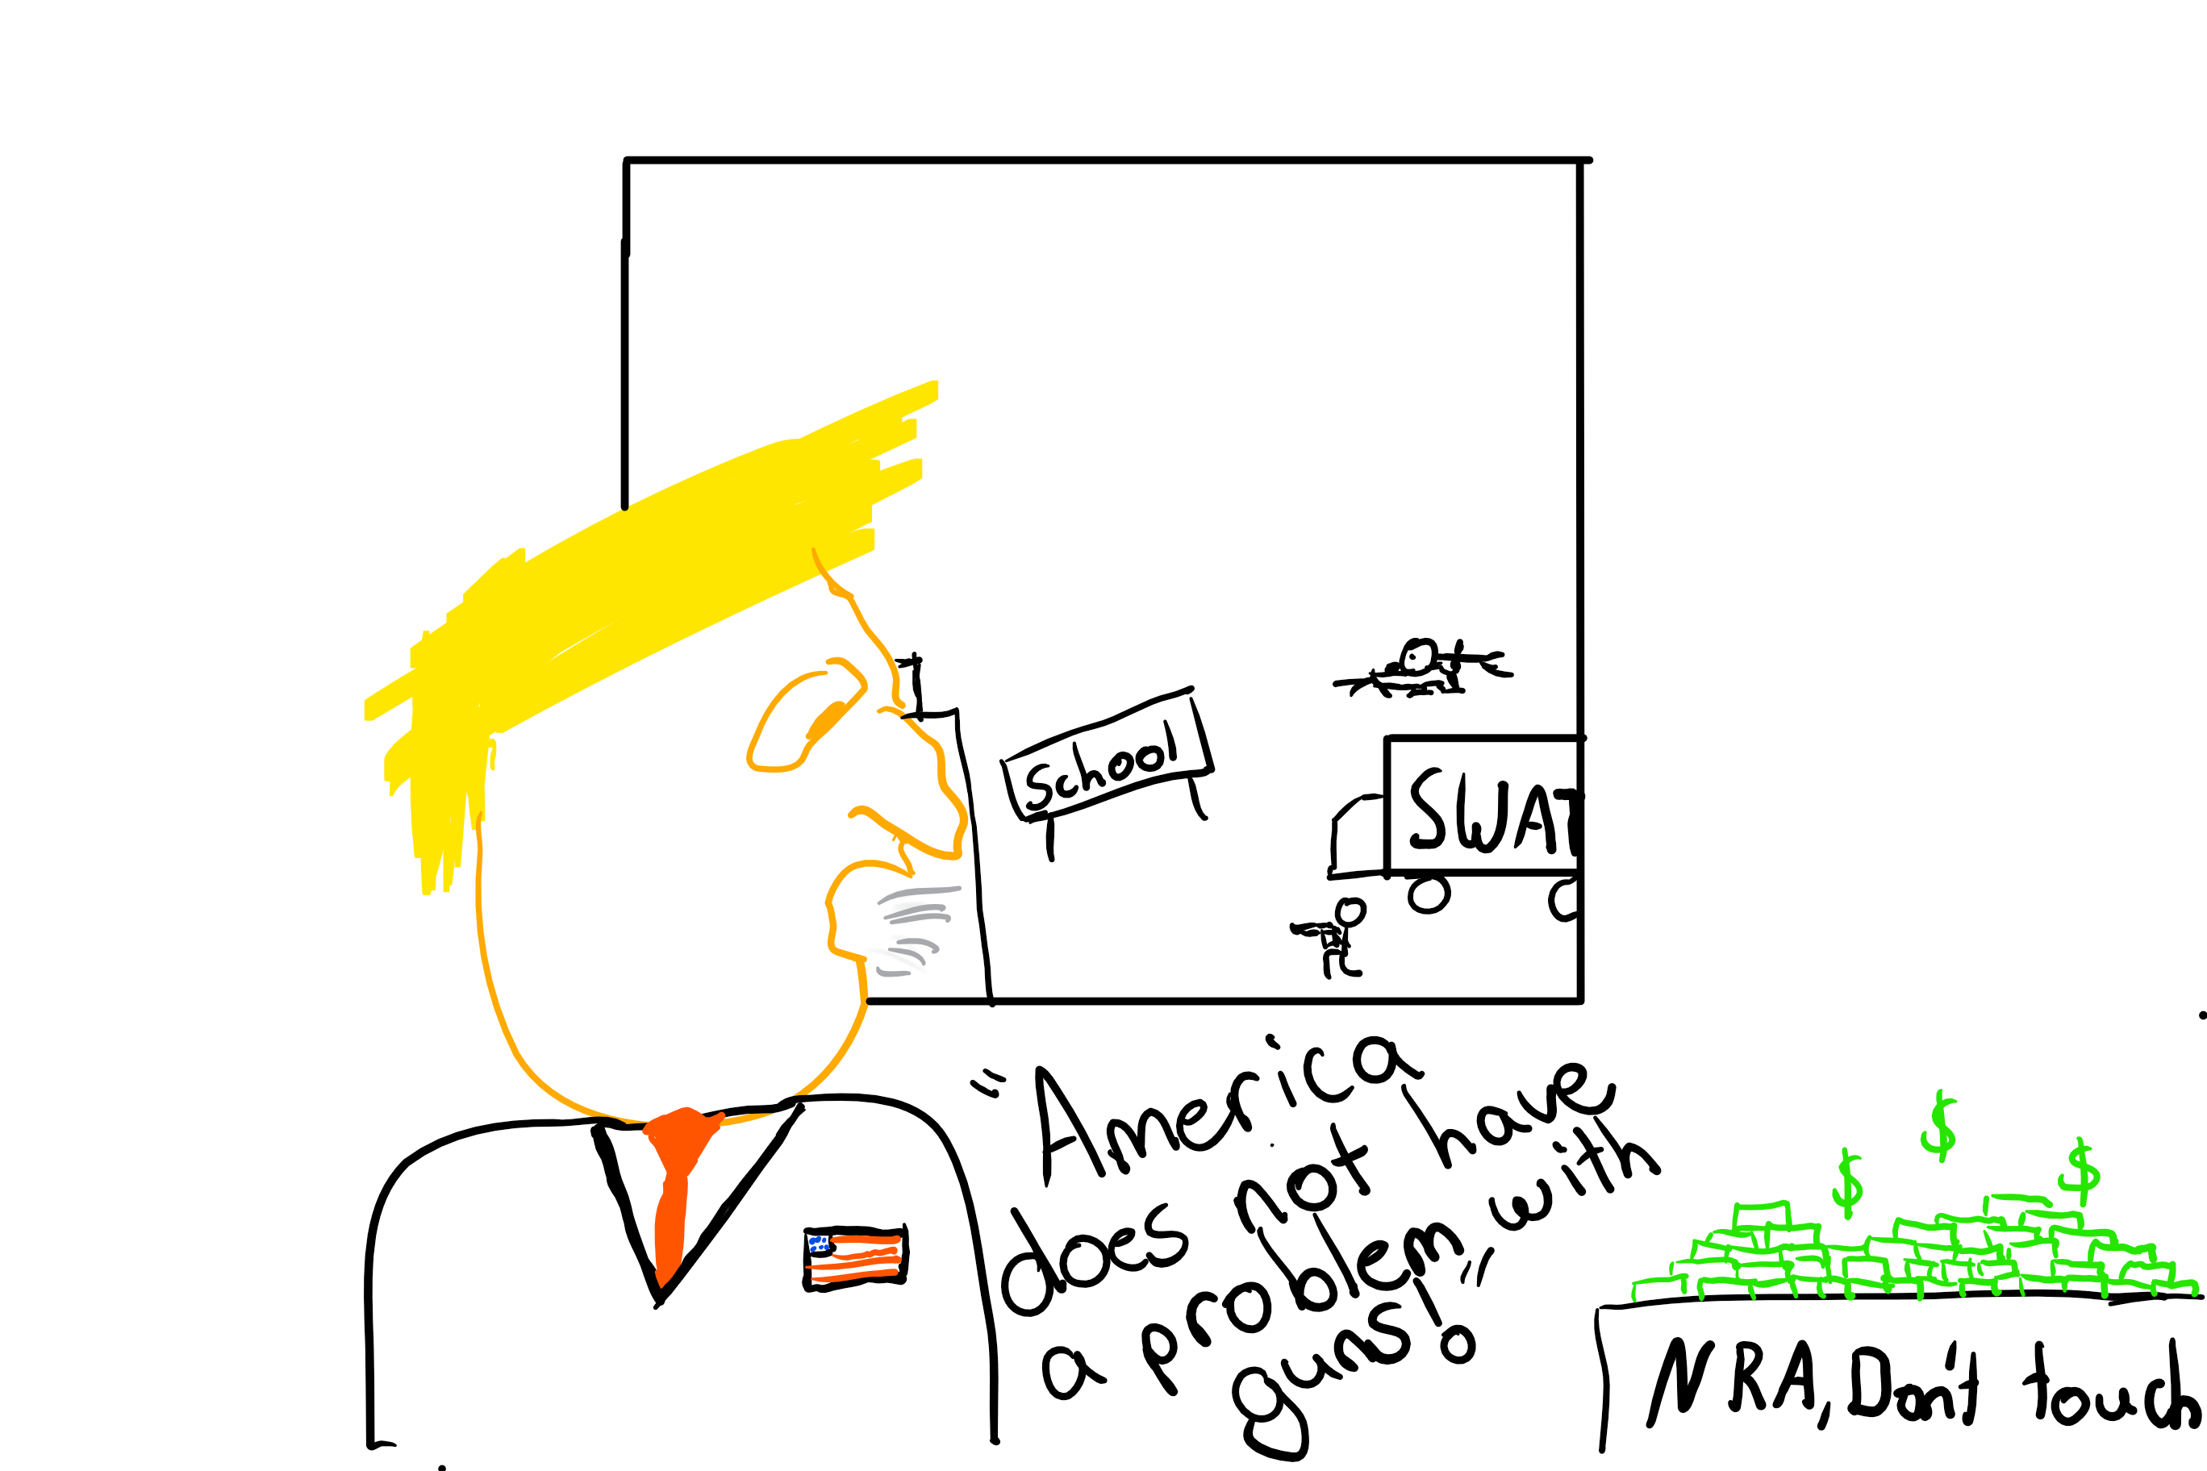
We are lucky to have an honest organisation like the NRA, looking out for the majority of America, so, like everything else that America’s doing, they can come up with small solutions to big problems, the American way. The way that Donald J Trump clearly neglects and shows apathy towards the problems of gun control. After every shooting he ‘tweets’ his prayers and best wishes, promises he will be doing something about it soon then the discussion dies off, waiting for the next mass shooting so he can once again send, what I can only guess, to be his most sincere ‘thoughts and prayers’.
Background checks in America only occur in established gun stores, which creates something called the ‘gun show’ loophole, where, if selling guns in a household, online or even at a gun show, hence the name, a vendor doesn’t have to perform a background check. I’m sure that this works out perfectly for everyone and no one abuses this honestly negligent loophole; the good, honest citizens of America would never use this loophole to, say, obtain firearms without a background check because, perhaps they are on the run and or are a convicted felon, for example, and are unable to get a firearm any other way!
When confronted with facts, Government Trump calls out all the statistics as “fake news” such as in the instance of the statistics showing that of all the mass shootings only 13% of the guns used were obtained from stores, indicating that 87% were obtained via the gun show loophole. Still Trump denies this with his classic “Fake news” scheme; if it doesn’t align with his agenda it can’t be true. In his eyes this makes him appear educated and down to earth; in reality it just makes him come across as an uneducated fool, a clown in a seat of immense power, who denies public statistics in favour of his own view from his personal ivory tower.
The Trump administration is nothing if not inclusive and considerate of all endeavours, as Trump himself has said: “I think I am actually humble; I’m much more humble than you would understand”. The great citizens of America are now safe to lay in their bed at night with nothing but the sound of shells hitting the ground and bullets firing, knowing that they are safe in the hands of Trump, that no matter what happens, it will always be the same. As the famous quote goes: “Guns don’t kill people, government negligence and apathy from the NRA and the president do.”
Written and Edited by: Joshua Cridland

Government confirms, plans to do nothing set in motion.
After 500+ mass shootings this year, nothing has changed.

