Reading Skills Practise:
(Adapted from ‘Adaptations and Transformations’ Unit 2 from www.wiley.com)
Intertextuality
noun
The interrelationship between texts, especially works of literature; the way that similar or related texts influence, reflect, or are different from each other:
i.e. the intertextuality between two novels with the same setting.

Intertextuality occurs when we can note a text’s similarity to, and connections with, other texts.
Do you recognise the texts on this page? They are all adaptations of famous literary texts. An adaptation involves reworking the characters, plot and language of a text in a new medium or text type. For example, the 1996 film Matilda is an adaptation of Roald Dahl’s novel of the same name. We adapt texts to make them simpler or more relevant to a new audience. We adapt texts by reworking them to suit a new purpose, audience and cultural context. We might also wish to emphasise a perspective or theme that was overlooked in the original text.
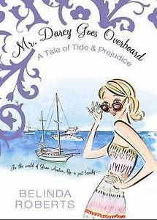

A transformation goes further by dramatically altering the original text to the point that we may not recognise its relationship with the original. Audiences of the movie Clueless, for example, may not realise that they are watching a transformation of Emma, a novel by Jane Austen. It is also possible to appreciate the musical Wicked without having read The Wizard of Oz.
Need to know…
Adaptation: changing a text to suit a new purpose, audience and cultural context. The adaptation still has an obvious connection to the original text. An adaptation can be as simple as performing a stage play from a written script.
Transformation: an adaptation that involves a more dramatic change to a text in order to create something new. The transformed text may not have an obvious connection to the original. A transformation might involve challenging the values and ideas expressed in the original text, rather than simply reproducing the same text in a new or modern way

Drawing on Shakespeare
Why are there so many adaptations of Shakespeare’s plays?
Altering and adapting literary texts is nothing new. After all, many of Shakespeare’s plays were themselves reworkings of earlier folktales, stories and historical accounts. For example, Shakespeare appropriated the basic story of Hamlet from Amleth, a twelfth-century folktale that was included in a history of Denmark by poet and historian Saxo Grammaticus.
Today, many regard Shakespeare’s plays as sacrosanct — that is, they are almost sacred and should therefore be left as they are, not altered or modernised.
However, there are many reinventions of Shakespearean plays to suit modern audiences and to reflect different cultural values. The many versions of Romeo and Juliet, for example, demonstrate that although the Bard’s plays are over 400 years old, they haven’t yet reached their use-by date.
We all know the story of Shakespeare’s Romeo and Juliet, the young lovers from sixteenth-century Verona, Italy. Despite the long-standing, bitter feud between their families — the Montagues and the Capulets — Romeo and Juliet fall in love, marry secretly, and die tragically.
The classic story has been adapted and transformed into the visual medium of film a number of times in recent decades: each time for entirely new viewing audiences. In 1968, Franco Zeffirelli’s film brought a traditional version to the screen while in 1996, Baz Luhrmann brought it to a new generation using a modern setting, and contemporary characters and soundtrack. Both films use Shakespeare’s playscript but then diverge along completely different visual paths. In the 2011 Kelly Asbury film, Gnomeo and Juliet, Shakespeare‘s classic tale is transformed using 3D animation in a parody version.
What is a literary ‘classic’?
A literary classic is a text that is regarded as having lasting value. It is deemed to be of such quality that its appeal will endure for generations. We view classics as having cultural significance; they represent a generation, time or a particular literary style. We also assume that they are well-written, possibly long and difficult to read, and convey important themes or messages.
A cult classic is a text that is extremely popular with a select audience or people who share a particular interest. An example might be the 1960s British TV series Thunderbirds.
Literary classics are regarded as belonging to the canon of English literature. The word ‘canon’ comes from the Greek word for measuring rod. The texts that are (in the opinion of readers and critics) part of the literary canon become the measure against which other texts are judged.
There are many different canons: the canon of Australian children’s literature, for instance, or the canon of twentieth century poetry.

The film posters below capture just three of the many different interpretations made possible by reimagining a literary classic, transforming it from a written to a multimodal text.
Baz Luhrmann
Romeo and the Montague family brandish guns (which they call swords) and wear bright, casual clothes. The image of the gun-wielding Romeo suggests this is an action film. The Capulets and the Montagues are represented as rival gangs; their families are rival corporations. The story is set in Verona Beach, a cross between Miami, New York and Mexico City. Director Baz Luhrmann used Shakespeare’s words; the contrast between a modern setting and the use of Shakespearean English is dramatic. Key themes are listed on the poster, revealing that this is more than just a romantic story
Franco Zeffirelli
In director Franco Zeffirelli’s 1968 film, Romeo and Juliet look as though they have stepped straight out of the Italian Renaissance. The Montagues and the Capulets are dressed in richly ornate clothes and the sword fights are realistic. While he created what seems to be the ‘look’ of a Shakespearean drama, Zeffirelli took liberties with the script. Many lines were simplified, added or omitted. More than half the play’s text was not used in the film.
Gnomeo and Juliet
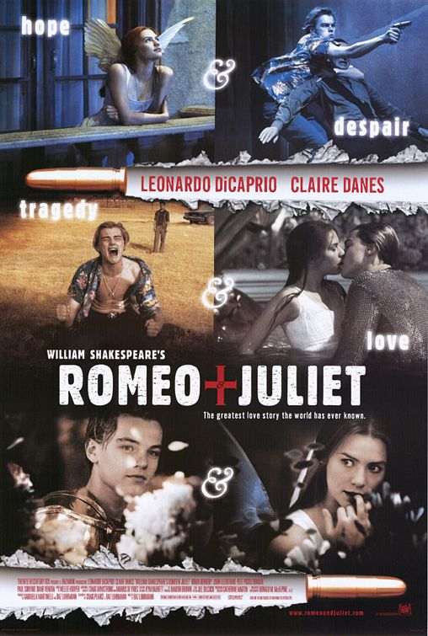
Gnomeo & Juliet is a 3D animated transformation starring warring garden gnomes. At the start of the film, a red gnome announces, “The story you are about to see has been told before. A lot”. The two households of Shakespeare’s play are now two gardens in Stratford-upon-Avon, the English town in which Shakespeare was born. The two families of gnomes try to outdo each other by creating elaborate, ornamented gardens.
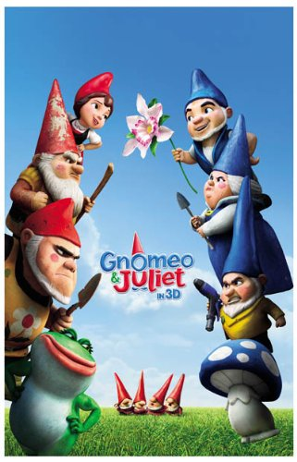
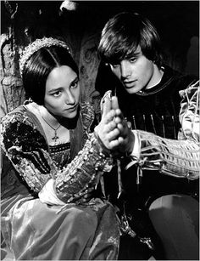

Interpreting Explicit Information:
- Decipher meanings of complex words and phrases from context
1
- From the context (read several sentences before and after for clues) define appropriation (pg 2) and multimodal text (pg 3).

- Elaborate on the clues you used to make your decision.

- Multiple links across long text or between text types
2 Read the descriptions of the films and look at the posters that match
What design elements of the posters are used to reflect what each version of Romeo and Juliet was trying to achieve/its style.

- Relationships between ideas to support or contradict an overarching concept
3 Re-read the bits on adaptations and transformations as outlined in this textbook excerpt
Explain how each of them is related to the idea of intertextuality.

- Expanding on abstract ideas found in the text
4 Draw on the whole text to make conclusions about why some texts are deemed ‘literary classics’.

- Main ideas vs supporting detail
5
- In the section ‘Drawing on Shakespeare’, what is the main idea of the passage (write this in a few words as a heading)?

- What supporting details are used to illustrate this point (summarise each section as a dot point)? Note: the heading should relate to all dot points – you are in effect writing notes on the section

