SATIRE
What is satire?
The use of humour, irony, exaggeration and stereotyping, or ridicule to expose and criticize people's stupidity or vices, particularly in the context of politics and other current issues.
Examples:
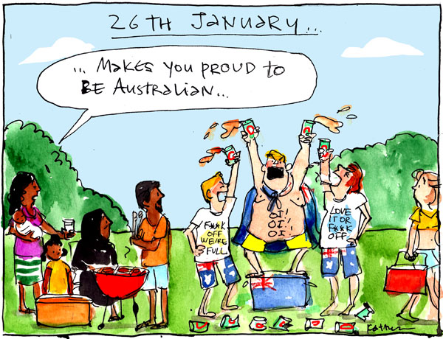
Where is the humour?
It uses ridicule to expose how awful the drunken behaviour of the ‘white Aussies’ is in contrast with a family of migrant Australians.
Get lost
lost
Why is this attitude being ridiculed?
It doesn’t take into account the feelings of others. It assumes that everything White Aussies do is right and if you question that you are excluded from the group and aren’t worthy to be called Australian.

What is the issue?
The ignorance of White Australians – seen on their tee-shirts. “Get Lost We’re Full” – no more room for migrants. “Love it or Leave” – You must enjoy Australia Day celebrations or you’re a loser.
Get Lost
Lost
Leave

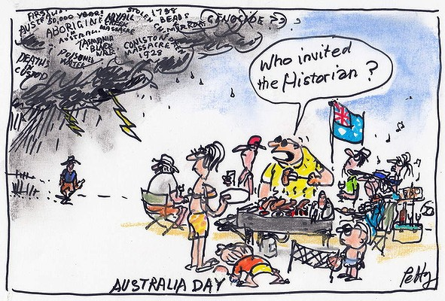
What is the issue?
White Australians need to take time out on Australia Day to remember that they weren’t the first Australians and that the Indigenous Australians their deserve respect.
Where is the humour?
It uses exaggeration to expose White Australian’s tendency to stick their heads in the sand when faced with Indigenous problems and their past and comments on their desire just to party and have fun on Australia Day.

Why is this attitude being exposed?
As a reminder that many Indigenous Australians hold ‘Invasion Day’ when White Australians celebrate Australia Day.

Your Turn:
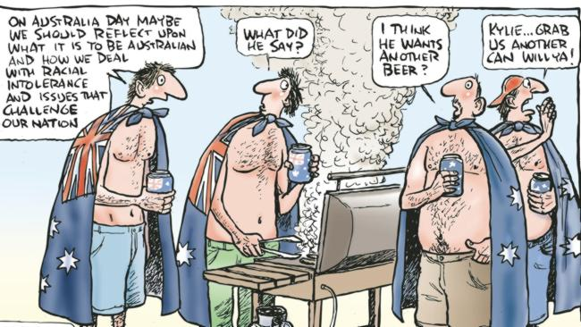

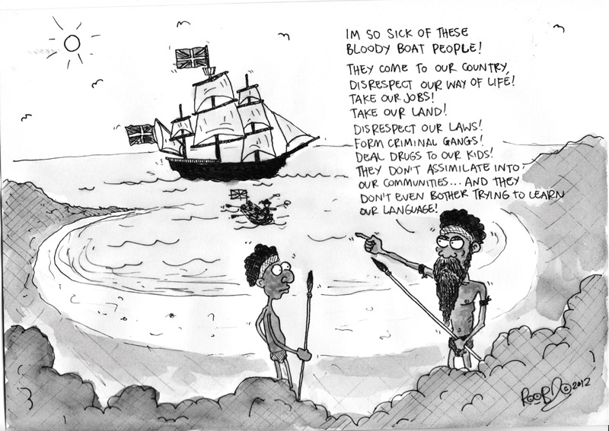

STEREOTYPES
What is a stereotype?
A commonly held but fixed and oversimplified image or idea of a particular type of person or thing.
Examples:

All Africans wear ‘weaves’
People with glasses can’t see
Muslims are terrorists
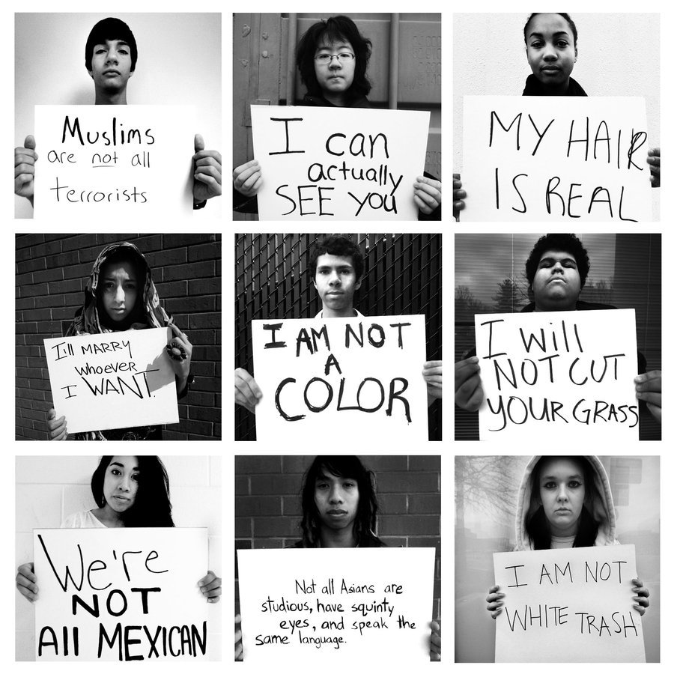
All Muslims have arranged marriages
Everyone who looks Mexican IS Mexican
All Asians are the same – and are squares
All people should be judged on their colour
All ‘poor’ white people are trash
All Mexicans are grounds keepers

Your Turn:

STEREOTYPES QUESTIONS
- Why do you think stereotypes exist? What is the point of them?

- Explain who you think came up with the following stereotypes:

All blondes are stupid:

All single people must be ugly:

All Asians are squares:

All Aborigines are drunks:

- What is wrong with stereotyping?

- What stereotypes do you think other cultures have of Western society? Why?

- To what extent are these stereotypes accurate?

Looking at Both Sides of an Issue
JANUARY 26 – Australia Day AKA Invasion Day – the questions below are examples only – come up with as much as you can on both views.
SIDE 1:
- Who celebrates Australia Day?
- Why do they celebrate?
- What do they do to celebrate?

SIDE 2:
    - Who holds Invasion Day?
    - Why do they call it Invasion Day?
    - Why can’t they celebrate Australia Day?

INDIGENOUS AUSTRALIANS - Day of Mourning
On Australia Day’s 150th anniversary, in 1938, Aboriginal activists named the day a “Day of Mourning”, alluding to the annual re-enactment of Phillip’s landing. They refused to participate in the re-enactment because it included chasing away a party of Aboriginal people (which, by the way, had been carted to this event against their will). Finally, by 1988, the re-enactments were discontinued. This same year was named a Year of Mourning by and for the Australian Aboriginal people.
On Australia Day Aboriginal people mourn their forbears who suffered and perished during colonisation.
We all still suffer from the life-draining, over-legislated madness called British Australia, which never seems to abate to the reason of sound voices or even democracy. Then they expect us to join in their triumphant dances over our ancestors' graves each January 26.
—Phill Moncrieff, Aboriginal musician

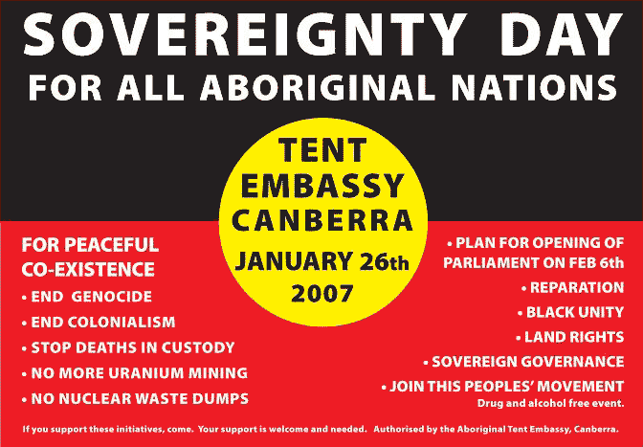

Our Survival Day
by Raylene Campion

Another Australia Day has arrived
Celebrations across our land
Guess they don't think what we've been through
Our ancestors tried to hold our land
Keep us together to protect our clans
Barbecues burning and sweet tasting wine
The white man's celebrating what belongs to us
But we're here in the background
Being proud of who we are
Our red, black and yellow unites us all
Saying we have survived another century
Of white man's invasion

Towards a new Australia Day
Many Australians recognise that Australia Day is no longer an appropriate day for celebrations and call for a new day which includes all Australians. Some suggest to rename Australia Day to ‘Arrival Day’.
People happy with the current Australia Day base their arguments often on racist grounds. Surprisingly, many show a lack of knowledge and awareness of the controversy surrounding Australia Day.
They don’t care about the particular date and just enjoy the holiday. Any controversy around moving Australia Day to another day would most likely soon be forgotten.
Aboriginal activist Michael Mansell believes a new public holiday should celebrate an inclusive Australia, but he calls for a treaty first.
“There may come a time… when a treaty has been made between Aborigines and Australia to include a land settlement, designated seats in the parliament and our own assembly… The date of the agreement could mark a new national date for celebration, where both peoples acknowledge each other’s rights and aspirations, thus avoiding the current ‘whites only’ celebrations.”
90% of people are saying Australia Day should be inclusive of Aboriginal and Torres Strait Islander cultures. I firmly believe that some day we will choose a date that is a comprehensive and inclusive date for all Australians.
—Mick Dodson, Aboriginal Law Professor and Australian of the Year 2009
I would however make a strong plea for a change of date. Let us find a day on which we can all feel included, in which we can all participate equally, and can celebrate with pride our common Australian identity.
—Dr Lowitja O’Donoghue, Aboriginal Australian of the Year 1984

AUSTRALIA DAY – IN THE CITY - ADELAIDE
Australia Day in the City is the major public event to celebrate Australia Day in SA in Elder Park on Sunday 26 January! Since becoming a twilight event in 2010, the crowds have continued to grow with 30,000+ attendees enjoying the street parade, concert and fireworks each year! Headline acts in previous years have included Ricki-Lee, Stan Walker, Jessica Mauboy and Vanessa Amorosi.
THANK YOU to everyone who came to Australia Day in the City in 2014! We hope you had a great day and we hope to see you again in 2015!
The event began at 6pm with one of the largest Australia Day Parades in the country, featuring more than 4000 people celebrating what they love about Australia and being Australian. The event then moved to Elder Park for the Concert from 7pm. Aussie dance and singing sensation Timomatic headlined Australia Day in the City proudly presented by Adelaide City Council. Timomatic was supported by Sarah De Bono who is one of Australia’s most exciting upcoming artists. The Concert was followed by a spectacular fireworks display! For photos of the event, and other events run by the Australia Day Council of South Australia, visit www.facebook.com/AusDaySA

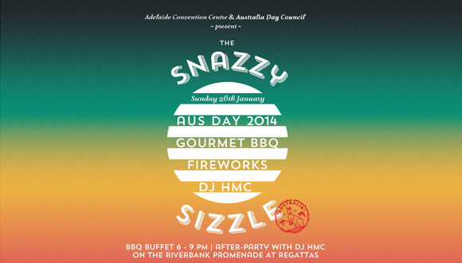

AUSTRLIA DAY - Melbourne’s Celebrations
Fun, free and family friendly events take place across various locations in Melbourne on Australia Day.
Information about public transport and road closures can be found on the Getting Around page.
The first event of the week is the Australia Day Luncheon on Thursday 23 January and will feature the Australia Post Legends. For ticket details see Australia Day Luncheon.
Start your Australia Day at 10.30am with the Australia Day Flag Raising Ceremony at the Melbourne Town Hall, followed by the Australia Day Parade along Swanston Street from the Town Hall into St Kilda Road. The Parade is a celebration of our community and cultural diversity and will feature chorus and music groups and over 80 sporting, special interest and multicultural groups.
The parade will end at the RACV Sounds of Australia Day celebration in the Queen Victoria Gardens off St Kilda Road. There will lots of Australian music, choirs, performers and family events to watch or to join in with. The Eastern Service Lane of St Kilda Rd will tempt you with diverse food and beverage options and RACV will be on site with many giveaways throughout the day.
During the day, join in the RACV Australia Day Picnic and Federation Vehicle Display in Kings Domain Gardens and along St Kilda Road. Activities in the Gardens include the multi-talented James Morrison and other entertainers, over 400 heritage, vintage and classic vehicles, RAAF Roulette display, interactive displays and activities and a diverse range of food vendors.
Bring the kids to enjoy the Melbourne Now: Children’s Festival, being held at the National Gallery of Victoria over the Australia Day weekend. It’s art and design inside and out and great time for families to explore the Gallery and Melbourne Now.
The Sidney Myer Music Bowl will feature two shows – Tidal Rhythms at the Bowl from 2.30pm – 5pm, and Shortlisted! The Cooper’s Australian Music Prize from 6pm – 8pm.
Australia Day will conclude with a spectacular fireworks display at Docklands. In the lead up to the fireworks entertainment will include music, Great Aussie backyard activities, family entertainment and a range of food options.

Satire, Irony and Stereotypes
– Persuasive Opinion Newspaper Article

You need to choose a problem or issue preferably a political, environmental or other ‘big picture’ one and write a persuasive newspaper article using satire to convince an audience that one side is in the right while the other side is pretty ridiculous!

Learning Intentions:
- An understanding of what satire, irony and stereotypes are
- An enhanced ability to persuade using sophisticated tools such as satire, irony and stereotypes
- An enhanced ability to argue and support arguments with evidence
- An enhanced appreciation of both an issue impacting society and an unfamiliar style of writing

You must include:
- A satirical cartoon you have drawn yourself on your issue
- A satirical view of the stereotypes involved in your issue.
- Persuasive techniques to make your argument appealing to the audiences such as:
  - A hook
  - Rhetorical questions
  - Emotive adjectives and adverbs
  - Choose words carefully for connotations
  - Bias toward your side of the argument
  - Inclusive language (e.g. of course, we all, as you can imagine)
  - Alliteration
  - Irony
  - Hyperbole (exaggeration)
- Labels on your work showing the above!!!
- Correct lay out of a opinion newspaper article.
  - Headline
  - Orientation – 1st paragraph; who, what, where, when.
  - Incident
  - Interpretation – using evidence, especially quotes
  - Cartoon where the picture would be
  - Call to action
- A convincing argument.

How to do it:
- Decide on your topic
- Work out the two sides of the argument
- Choose the your side and draw a satirical cartoon exposing the stupidity of the other side
- Decide what stereotypes go against your side of the issue and come up with sentences to ridicule them (to be included into your article somewhere).
- Plan your argument (decide on your points, choose evidence to support them and organise your argument into paragraphs)
- Write your article and set it out correctly.
- Proofread and add more persuasive techniques.

SUCCESS CRITERIA AND MARKING RUBRIC

SUCCESS CRITERIA  FEATURE | WELL ABOVE EXPECTATION | ABOVE EXPECTATION | AS EXPECTED | BELOW EXPECTATION
Student shows a clear appreciation of what satire, irony and stereotypes are | Clear understanding and use of the features in appropriate contexts in the writing | Generally clear understanding and use of the features in appropriate contexts in the writing | Some clear understanding and use of the features in appropriate contexts in the writing. | Little clear understanding or use of the features
Student shows proficiency in persuasive writing including effective use of: persuasive techniques; a convincing argument with 2 clear sides | Extremely effective persuasion; 10+ techniques are used effectively to support the persuasion; both sides of the issue are clearly and effectively explained | Generally effective persuasion; 8-9 techniques are used generally effectively to support the persuasion; both side of the issue are clearly and generally effectively explained | Some effective persuasion; 5-6 techniques are used generally effectively or 6-7 are used weakly; clearly identifies both sides of the issue but limited meaningful explanation of one of them and the other is clearly explained | Little effective persuasion; fewer than 5 techniques used or 5-6 used weakly; both sides are identified but not explained clearly or only one side is identified and explained
Student shows a clear understanding of the issue being satirised and its impact or relevance to society | Deep understanding of issue and relevance to society clearly articulated | Clear understanding of the issue and relevance to society generally clearly articulated | Generally good understanding of the issue and some clear articulation of the relevance to society | Limited understanding of the issue with little evidence of meaningful relevance to society
Labels are clear and complete | All labels completed clearly | Most labels completed clearly | Some labels completed clearly | Few labels completed clearly
Opinion newspaper article has appropriate features and format and a self-drawn cartoon | All features and formatting used well and effectively to organise the piece | Most features and formatting used well and effectively or all features used but a few not so effectively to organise the piece | Most features and formatting used but not so effectively to organise the piece or some features used well to organise the text | Has few features or all features are not used well to organise the text
Evidence is well used to support arguments | Multiple well-chosen examples and quotes about the issue under discussion are used and they are extremely helpful in supporting the argument being made. | Multiple well-chosen examples and quotes about the issue under discussion are used and they are relevant to the argument being made | Only a few (2-3) examples and quotes used about the issue under discussion or more are used but not very effectively | No examples or quotes or a few used but not very effectively

