Merchant of Venice Modernisation/Intertextual Assignment
Learning Intentions:
- To appreciate the timelessness of good literature and reflect on how the issues of Merchant of Venice are relevant to our current society
- To understand and adapt the original narratives’ themes, values, beliefs and assumptions about worth
- To understand how language can be used to empower or disempower people and reflect the social position of characters
Your task is to take the themes and ideas we have covered in studying The Merchant of Venice and convert this matter into a modern version of the story. You will need:
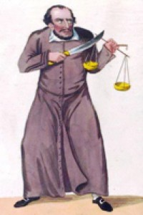
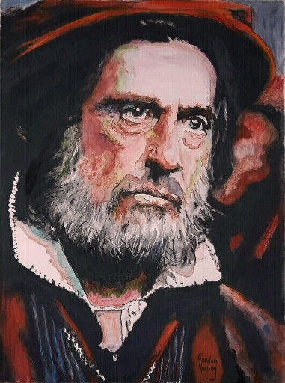
A Villain/Antagonist
Shylock was:
Misjudged/prejudiced against
Had sympathetic and objectionable traits

A Protagonist
Antonio was:
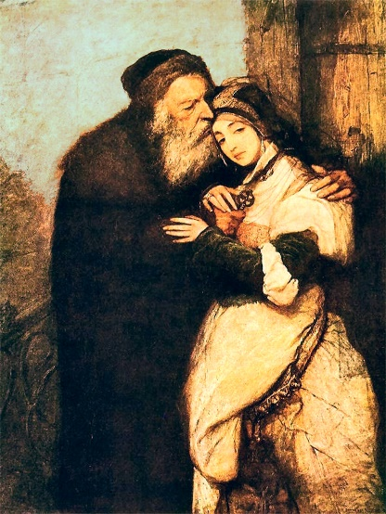
Cruel to his enemies and prejudiced
Generous to his friends and those he respected
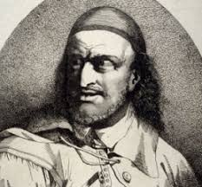
Some Other Main Characters
Bassanio was:
A bad business man
Charming but weak
Portia was:
Smart and loyal
Limited in power

Basic Plot – Just the Really Main Points
- Main Character 1 (Bassanio) needs help/favour from Protagonist (Antonio) to get with Main Character 2 (Portia)because of his character flaw.
- Protagonist needs help/favour from Antagonist (Shylock) to do so (Protagonist has the power in the relationship and is contemptuous of Antagonist)
- Main Character 2 has a problem they can’t seem to solve
- Protagonist falls into Antagonist’s clutches (power)
- Antagonist has their own problems
- Main Character 1 and Main Character 2 make an alliance
- Protagonist has even more problems
- Main Character 2 rescues Protagonist from Antagonist
- Antagonist is punished
- Main Character 1 and 2 fall out over broken trust (by Character 1) but make up
- Protagonist gets a happy ending

You now have your basic characters and storyline but need to find equivalent characters and a situation that rings true today to apply them to.
Please Include in Your Intertextual Narrative:
- A minimum of 4 main characters (as above) but you can put in minor characters as you need. These main characters should be of the same ‘type’ as the ones in the original story but can be your version of the type
- Follow the plot points above
- A theme (see the PowerPoint)
- A symbol (see the PowerPoint)
- A modern setting and events
- Language, especially in conversations, that shows that the Protagonist has more power in society than the Antagonist, who is unable to defend themselves.

Merchant of Venice Modernisation Success Criteria Rubric

Success Criteria | Well Above Expectation | Above Expectation | At Expectation | Below Expectation
Successful modernisation of setting and plot from Renaissance Venice to modern day | Extremely suitable setting and plot chosen that gives opportunity to explore the themes and ideas of narrative in depth | Suitable setting and plot chosen that give opportunity to explore themes and ideas in some depth | Setting and plot allow themes and ideas to be included but doesn’t support them well | Setting and plot undermine ability to successfully explore themes and ideas in any depth
Successful adaption of the main themes of the original narrative | Main ideas and themes of narrative are represented in depth | Main ideas and themes are explored in some depth | Main ideas and themes are included but not explored well | Main ideas and themes mentioned but not explored and many of them are missing
Successful use of symbols which help expand on themes or ideas in the text | Symbols ably incorporated | Symbols included although incorporation a little rough | Symbols included, although not well | Symbols not included or very badly used
Successful modernisation of characters | Characters have a great depth and reflect the qualities of the originals well | Characters have some depth and reflect the main qualities of the originals | Characters are recognisable but lack depth and some of the original qualities | Characters are not really recognisable
Language used effectively to empower or disempower and reflect the social position of characters | Language used illustrates the power relationships and social positions of characters | Language ably illustrates some of the power relationships and social positions of characters | Language less ably used to illustrate the power relationships and social positions of characters | Power relationships and social position not really illustrated through language use

