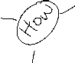

***Revised Metacognitive Questions***

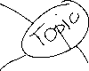

**Fill out the Why, What and How Can do a Mindmap**

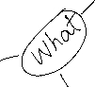

The Why: What is my purpose in doing this? (entertain, inform, persuade or a mixture)

* What impact should this have on my writing? Be specific to the text at hand.

The What: What outcome am I trying to achieve? Use the Task Sheet and Rubric/PS

* What will my finished piece look like/where would it be published? It won’t actually be published but think about where it would be appropriate and how that will impact the writing – draw in diagrammatic form on plan page below
* Who will the audience be? (age, culture, education, ideas and values (audience context)) Be specific as possible.
* What kind of writing style will suit the audience?
* What type of vocabulary and language techniques will suit the audience? Give examples specific to task on plan page below
* What kind of text structure will suit the audience?

The How: What strategies do I need to use to succeed?

* Read the Task Sheet and other Resources available: have I overlooked anything?
* Read the Performance Standards/Rubric: what do still I need to make sure I do?
* Plan the structure/paragraphs – write on plan page below
* Do I need to do further reading? Do it
* Are there any other tasks I need to do before I can start writing? Do them
* Can anyone else help me?

**Mastery** – teach it; review and fill gaps; organise and simplify.

**Drafting** – Keep It, Build It, Bin It

* How successful have I been (use Performance Standards)
* What do I need to do to improve the task?

**Reflection**

* What are the skills I have learned and practise in this task?
* Are the skills I have used translatable to other situations?

**Plan – Write on this Page**

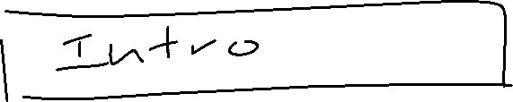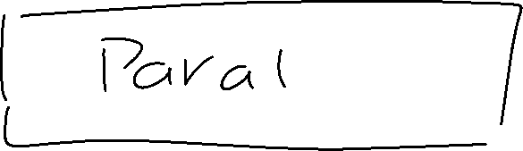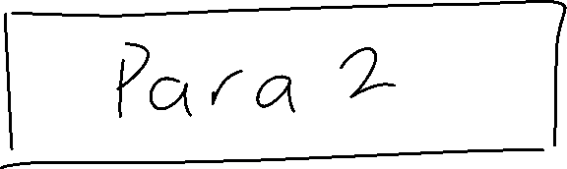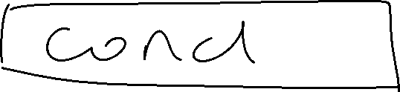

**Language Elements**



**Section/Paragraph Plan (dot points – show structure (PEEL))**

**Intro**

**Table Paragraph Planner Option**

|  |  |  |  |  |  |
| --- | --- | --- | --- | --- | --- |
| Technique  **Evidence** | Example(s)  **Evidence** | Analysis of Meaning  **Elaboration** | Link to Death  **Elaboration** | Perspective on Death  **Elaboration** | Compare/Contrast  Perspectives of 2 (or More) Poems  **Compare** |
|  |  |  |  |  |  |
|  |  |  |  |  |
|  |  |  |  |  |  |
|  |  |  |  |  |
|  |  |  |  |  |  |
|  |  |  |  |  |

**Para 1**

**P – identify technique**

**E (poem 1) – WHAT - Specific example/quote**

**E - HOW do the words make meaning (explain the way the connotation/technique makes you think and feel); WHY is the author using them (impact of technique on the audience to give perspective of death)**

**E - (poem 2) - WHAT - Specific example/quote**

**E - HOW do the words make meaning (explain the way the connotation/technique makes you think and feel); WHY is the author using them (impact of technique on the audience to give perspective of death)**

**E – (poem 3?)**

**E -**

**C – compare/contrast perspectives of 2 (or 3) poems**

**L - summary**

**Para 2**