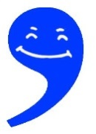
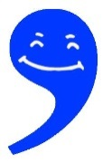
Commas
1 Commas are used to separate the parts of the sentence out so the reader can see what is happening. Generally things like phrases and clauses are marked out.
The green grass, trodden on by thousands of football fans, was now brown with mud
- This is a complex sentence with a subordinate clause in the middle, marked out by commas for clarity.
2 Prepositions are time and space words: during, before, after, around, in, under. They are a clue to a phrase or clause at the start (usually) of the sentence.
After the thousands of football fans had trodden it underfoot, the green grass was brown.
- This is also a complex sentence but an additional clue that a comma is needed to mark off the ‘extra’ information (the subordinate clause) is the preposition “after”.
3 With a conjunction like however, therefore or thus, the way they are used is often as an ‘extra’ to the sentence. Read it out loud to see the natural gap.
However, the grass was now brown. It was the football fans, therefore, that ruined it.
4 Most ‘ands’ or other common conjunctions (so, but) don’t really need a comma with them because they are already marking out the parts of the sentence without needing a comma.
The grass used to be green but now is brown.
- Other times there is another rule that overrides this, which is the clause rule.
The grass is dead, which was trampled to brownness, and is now resting in peace.
5 Pieces of information are added in to the main sentence to add meaning. A clue to these can often by a ‘who’ or ‘which’ or an ‘ing’ word.
The ocean, which is stormy, scares me
- This phrase – which is stormy – adds information about the ocean and tells us why the person is scared.
The scared person, having closed their eyes, became calmer.
- Again the clause – having closing their eyes – explains how the person becomes calmer.

