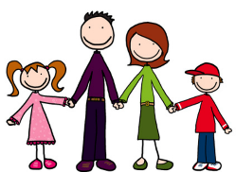
Personal Development:
Personal and Social Capability Worksheet
This Photo by Unknown Author is licensed under CC BY-NC-ND
This Photo by Unknown Author is licensed under CC BY-SA
How can you develop:
- Confidence?
- Self-discipline?
- Independence?
- Resilience?
- Initiative?
- Adaptability?

Social Development:
How can you build skills in:
- Communication?
- Working collaboratively?
- Conflict resolution?
- Leadership?

