Critical Thinking Activities
1. Use different modes: Explain EITHER the story of Jesus walking on the water OR how to fold a paper aeroplane in:
a) an auditory way
b) a visual way and
c) a kinaesthetic way

Write notes and show me.

2. Teach it in a simple way: Explain EITHER how to make a rainbow with a prism OR Abraham’s family tree to a 6-year-old.
Teach me.
3. Understand and challenge your biases: Choose your favourite out of cats or dogs. Now find a minimum of 5 good things about the one you DON’T like. Write them down.
4. Work backward to get a new perspective: Proofread the following working sentence by sentence backward (individual sentences forward but start with last one).
Naffy were fixing Maxs computer while quinny was watching. Poppy and Bri was chatting about the weekend. Jack was looking at pictures on his laptop an Ben was trying to get the cricket too play on internet. The three girl’s at the back (Joey, Tayla-lee and Abbie) had work out a way to look busy without doing anything at all. Maddie is sleeping, Hannah was dastardly studying for her music exam and Bella was dreaming about water skidding. May and Leah were carrying on an email conversation. Meanwhile, Annie and Lucy are finishing there Science homework. No one student was doing their English.
Include the corrected version here:
5. Ask other people to explain their thought processes: Talk to another person, who you don’t usually get help from, about how they solved (or attempted to solve) the puzzle below:
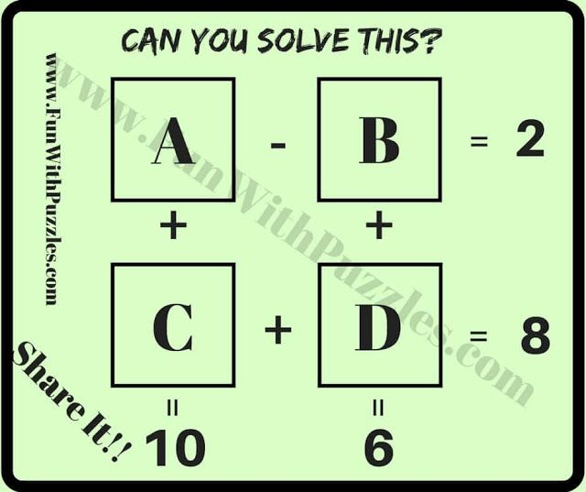

Summarise what they said here:
6. Expose yourself to new content and new creators: watch a TED talk on a topic you don’t know much about. Write notes.
7. Experiment with brain teasers: Write the answers in
