Writer’s Statement
The idea of the Writer’s Statement is to show your thought process in using the intertextual features from To Kill A Mockingbird. You are trying to prove that you have written a sophisticated intertextual text.
To do this you should compare how and why you have used each feature with how and why To Kill A Mockingbird has used that feature. Can you draw connections between your use and the novel’s or have you used the feature differently, for deliberate effect? Perhaps the connection is that you have used similar features to remind the audience of To Kill A Mockingbird so you can add ideas from that novel to your story.
Read the examples on Haiku to get the idea of what connections you could be making.

Performance Standards
Knowledge and Understanding

- Knowledge and understanding of ways in which texts are created for a range of audiences to convey a clear message added to by links to To Kill A Mockingbird in both writer’s statement and narrative

Analysis

- Analysis of intertextual connections in the writer’s statement: style/intertextual features and added meaning identified

Application

- Precision, fluency and coherence of writing and speaking in both pieces

- Use of appropriate To Kill A Mockingbirdesque language features, stylistic features and conventions in your narrative

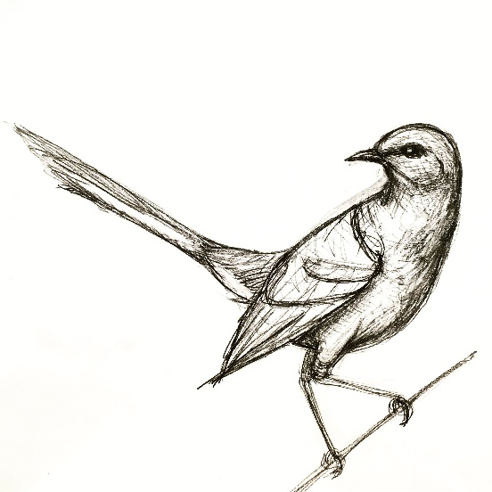
- Use of short quotes and references to your narrative as evidence in your writer’s statement from texts to support conclusions with textual references incorporated in responses.

