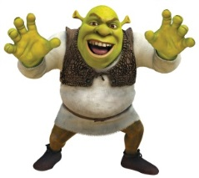

Intertextuality Study 2

For this assignment we are going to look at another aspect of intertextuality but the same principles still apply. This time the task is to write a short narrative (1000 words max) using form and language features of To Kill A Mockingbird to create an intertextual piece. There must still be meaning added by your doing this so you have to plan what you want to achieve by your intertextuality.

Examples of this type of intertextuality:
- Wide Sargasso Sea is the story of the first wife from Jane Eyre by Charlotte Bronte. By telling the rejected wife’s story the author is critiquing both gender and racial issues of Bronte’s time.
- Shrek uses fairy tale elements to parody and make fun of stereotypes about gender and heroism in the original stories.

Questions:
- Choose a minor character from To Kill A Mockingbird and create a short story in which they are the main character. Write the piece in the style of Harper Lee or use 5 other intertextual elements from the novel. In an accompanying writer’s statement, explain how the elements of your story (e.g. theme, plot, characters and/or language etc.) have been influenced by your knowledge of To Kill A Mockingbird and the meaning that the novel adds to your story.
OR
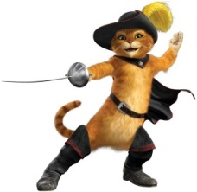
- Create your own short story that applies one of the themes in To Kill A Mockingbird to your own context. It may be fictional or based on your experiences. Write the piece in the style of Harper Lee or use 5 other intertextual elements from the novel. In an accompanying writer’s statement, explain how the elements of your story (e.g. theme, plot, characters and/or language etc.) have been influenced by your knowledge of To Kill A Mockingbird and the meaning that the novel adds to your story. Themes from To Kill A Mockingbird that could be developed through a short story are:
- The coexistence of good and evil
- Prejudice
- Racism
- Growing up/coming of age
- Family
- Gender

Performance Standards:
Knowledge and Understanding
- Knowledge and understanding of ways in which texts are created for a range of audiences to convey a clear message added to by links to To Kill A Mockingbird in both writer’s statement and narrative
Analysis
- Analysis of intertextual connections in the writer’s statement: style/intertextual features and added meaning identified
Application
- Precision, fluency and coherence of writing and speaking in both pieces
- Use of appropriate To Kill A Mockingbirdesque language features, stylistic features and conventions in your narrative
- Use of short quotes and references to your narrative as evidence in your writer’s statement from texts to support conclusions with textual references incorporated in responses.

