Harper Lee Style Features Summary
- Uses description extensively – heavy on the metaphors, similes and personifications as well as adjectives and uses a variety of other techniques ie onomatopoeia and alliteration (Ch 1 pg 6 – description of Maycomb)
- Factual rather than emotional tone (almost any narration)
- Informal style overall and informal speech and use of slang for appropriate characters – reflects the society story is set in (hot steams, collards, Johnson grass, rabbit tobacco, ‘growing cotton’, calling “hey” at someone’s door)
- Dual narrator – child and adult
- Sophisticated vocabulary
- Accents appropriate to groups in society ie African Americans, poor whites, rich whites, educated whites
- Use of racist terms for African Americans – creates realism for audience’s understanding of events and shows attitudes of speakers ie nigger, darky, Negro, coloured person
- Vocab and style that suits specific character ie look at speech of Mrs Merriweather, Burris Ewell, Atticus
- Humour – ironic and satiristic (Ch 9 pg 106 – Simon Finches “trust” of his daughters; Ch 1 pg 5 about Atticus’ first clients as a lawyer; Ch 24 - Mrs Merriweather and her “love” of Africans; Ch 13 pg 172 - “when Aunt Alexandra went to school, self-doubt could not be found in any textbook, so she knew not it’s meaning”)
- Aphorisms (a pithy observation which contains a general truth.ie “the old aphorism: ‘the child is father to the man’”) (Ch 13 pg 175 – “No Crawford Minds His Own Business” etc.)
- 1st person narrative from perspective of writer
- Gothic elements
- Use of foreshadowing, symbols and motifs
Simple Intertextual Elements and Meaning Made
- Any of above
- Names of characters – remind audience of the original character and their actions in To Kill A Mockingbird
- Someone is reading the novel in your narrative – remind audience of message to add to yours.
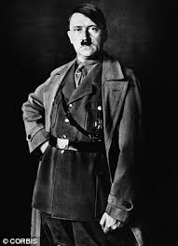
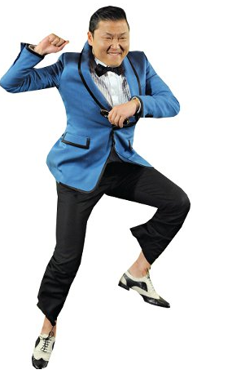
http://thebestnotes.com/booknotes/To_Kill_A_Mockingbird_Lee/To_Kill_A_Mockingbird_Study_Guide21.html; http://resources.mhs.vic.edu.au/mockingbird/style.htm; http://www.shmoop.com/to-kill-a-mockingbird/writing-style.html

