Types of Hooks: Creating Interesting Writing

Just like a fisherman uses different hooks to catch fish, writers use different strategies to ‘catch’ readers. Writers do this by making their first sentence or two very interesting for the reader, so they WANT to keep reading!
- You need to think about what would interest the audience of your writing.
- Don’t write for yourself, write for your audience.

Examples of HOOKS:
- A call to action
  - An analogy
    - A command
      - A bold statement/interesting fact
        - Thoughts or feelings
          - A definition
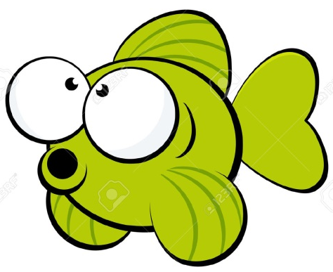
            - A quote
              - A question
                - A description

