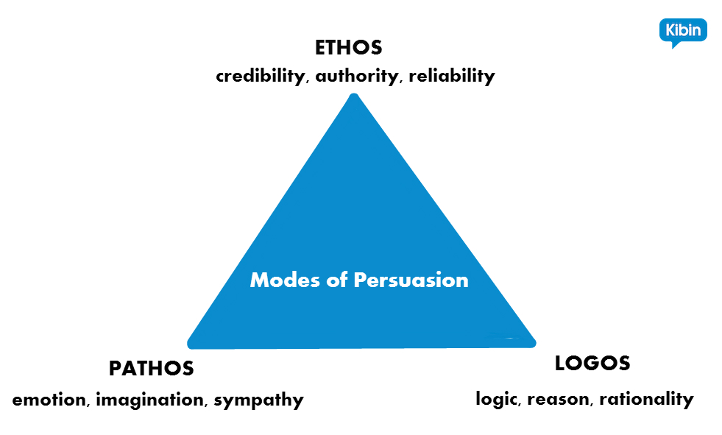
3 Pillars of Persuasion and…

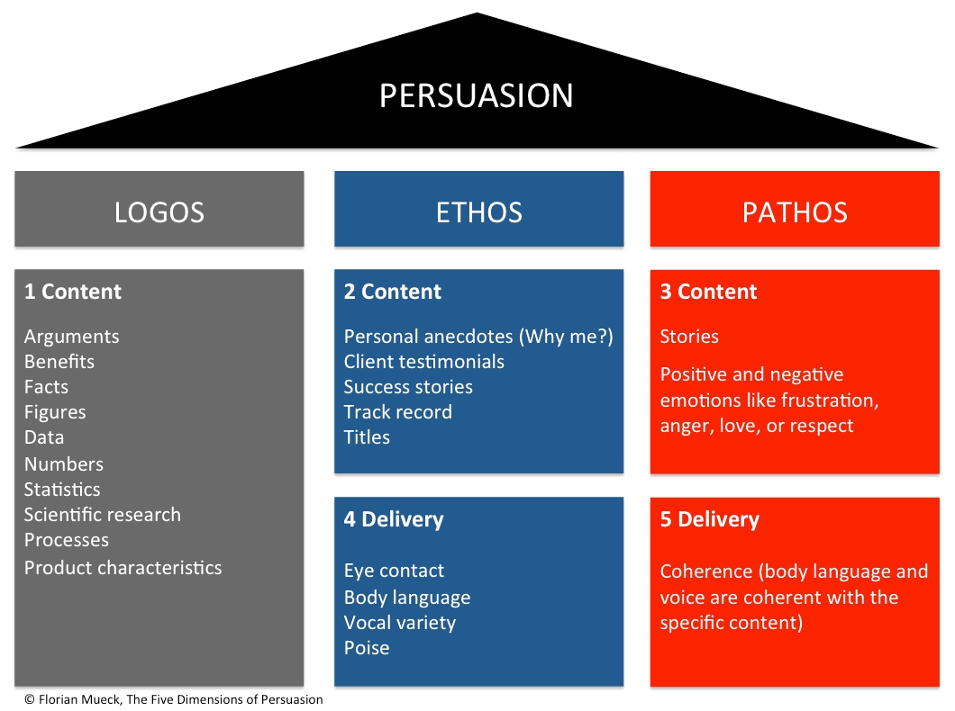

Authorities/experts

…When to use Them

Because of the way our brains work the most effective approach to persuasion is:
- Start with ethos: establish your credibility in the introduction and use the first paragraph to outline your most ethos based argument.
- In the second paragraph/argument start with pathos and then use logos to hammer the point home. Use the same main techniques for the other paragraphs and counter argument.
- Use the conclusion to reiterate your credibility.
This doesn’t mean you can’t use pathos in the intro or ethos in the last section of the body; it does mean there will be a main focus on the above approaches.

