The Poems

Night Mail

By WH Auden
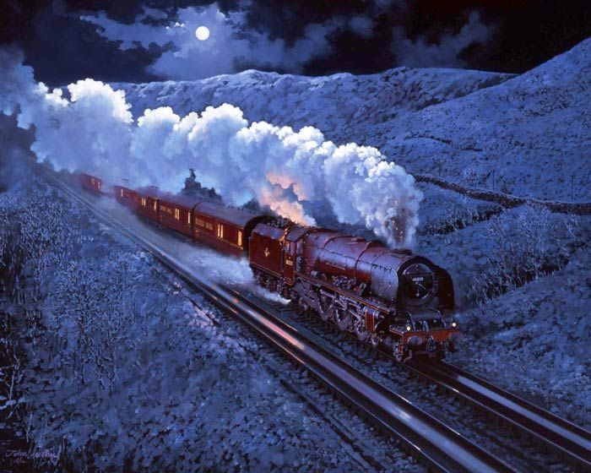
This is the night mail crossing the Border,
Bringing the cheque and the postal order,
Letters for the rich, letters for the poor,
The shop at the corner, the girl next door.
Pulling up Beattock, a steady climb:
The gradient's against her, but she's on time.
Past cotton-grass and moorland boulder
Shovelling white steam over her shoulder,
Snorting noisily as she passes
Silent miles of wind-bent grasses.
Birds turn their heads as she approaches,
Stare from bushes at her blank-faced coaches.
Sheep-dogs cannot turn her course;
They slumber on with paws across.
In the farm she passes no one wakes,
But a jug in a bedroom gently shakes.
Dawn freshens, Her climb is done.
Down towards Glasgow she descends,
Towards the steam tugs yelping down a glade of cranes
Towards the fields of apparatus, the furnaces
Set on the dark plain like gigantic chessmen.
All Scotland waits for her:
In dark glens, beside pale-green lochs
Men long for news.
Letters of thanks, letters from banks,
Letters of joy from girl and boy,
Receipted bills and invitations
To inspect new stock or to visit relations,
And applications for situations,
And timid lovers' declarations,
And gossip, gossip from all the nations,
News circumstantial, news financial,
Letters with holiday snaps to enlarge in,
Letters with faces scrawled on the margin,
Letters from uncles, cousins, and aunts,
Letters to Scotland from the South of France,
Letters of condolence to Highlands and Lowlands
Written on paper of every hue,
The pink, the violet, the white and the blue,
The chatty, the catty, the boring, the adoring,
The cold and official and the heart's outpouring,
Clever, stupid, short and long,
The typed and the printed and the spelt all wrong.
Thousands are still asleep,
Dreaming of terrifying monsters
Or of friendly tea beside the band in Cranston's or Crawford's
Asleep in working Glasgow, asleep in well-set Edinburgh,
Asleep in granite Aberdeen,
They continue their dreams,
But shall wake soon and hope for letters,
And none will hear the postman's knock
Without a quickening of the heart,
For who can bear to feel himself forgotten?

The Eagle
By Alfred, Lord Tennyson
He clasps the crag with crooked hands;
Close to the sun in lonely lands,
Ring'd with the azure world, he stands.

The wrinkled sea beneath him crawls;
He watches from his mountain walls,
And like a thunderbolt he falls.
