Discussion 1 on TKAM
Ch 1-6
- Ch 1 – Introduction of main characters and setting
- Ch 2 – Half Scout’s first day at school and wider community introduced
- Ch 3 – Walter’s lunchtime visit, second half of Scout’s first day and its aftermath; more wider community introduced
- Ch4 – presents in the tree incident, the tire incident and playing Boo Radley
- Ch 5 – Miss Maudie and trying to make Boo come out
- Ch 6 – Jem loses his pants incident

- What are main themes of this section?
- Connect incidents with themes
- Why have I chosen to discuss these first 6 chapters as a section?
Class Discussion Prep:
You will need to come to class prepared for a short small group discussion to share thoughts, lingering questions, and epiphanies (TQEs) you have about the reading. Use the question stems below to come up with these:
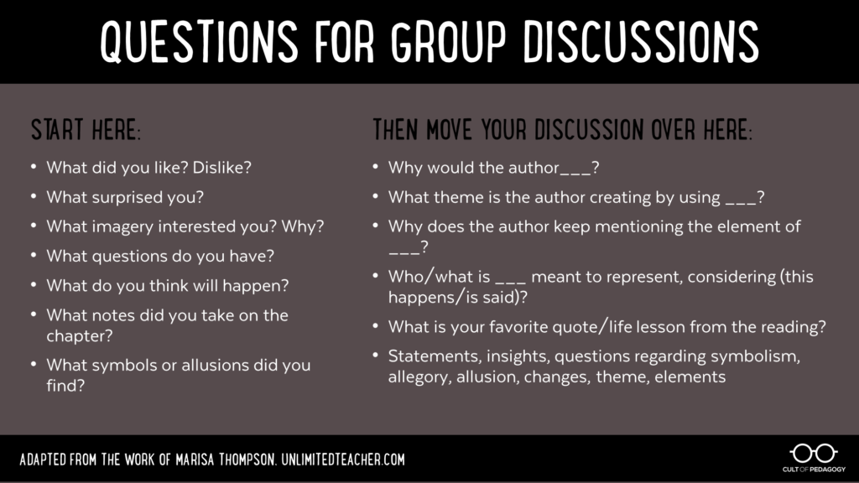

Each group needs to decide on their favourite thought, question and epiphany to put on the board as the basis of whole class discussion. Your contributions are part of your analysis grade.

