Source 1:
Hindmarsh, H, Harnack, C, 2009, Nelson Ancient History: The Near East, Nelson Cengage Learning, Melbourne
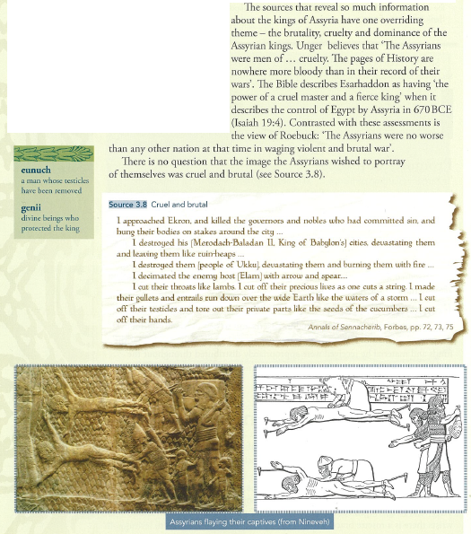

Source 2:
Mark, J J, "Neo-Assyrian Empire," Ancient History Encyclopedia, 2014, https://www.ancient.eu/Neo-Assyrian_Empire/, accessed 20 Feb, 2018
“While the reputation for decisive, ruthless, military tactics is understandable, the comparison with the Nazi regime is less so. Unlike the Nazis, the Assyrians treated the conquered people they relocated well and considered them Assyrians once they had submitted to central authority. There was no concept of a 'master race' in Assyrian policies; everyone was considered an asset to the empire whether they were born Assyrian or were assimilated into the culture. Kriwaczek notes, “In truth, Assyrian warfare was no more savage than that of other contemporary states. Nor, indeed, were the Assyrians notably crueller than the Romans, who made a point of lining their roads with thousands of victims of crucifixion dying in agony” (209). The only fair comparison between Nazi Germany in WWII and the Assyrians is the efficiency of the military and the size of the army, and this same comparison could be made with ancient Rome.”

Source 3:
Meyers, R, e-Sword, 2011
Israeli warfare:
2Sa 8:2 “And he (David) smote Moab, and measured them with a line, casting them down to the ground; even with two lines measured he to put to death, and with one full line to keep alive. And so the Moabites became David's servants, and brought gifts.”

Jos 8:24 “And it came to pass, when Israel had made an end of slaying all the inhabitants of Ai in the field, in the wilderness wherein they chased them, and when they were all fallen on the edge of the sword, until they were consumed, that all the Israelites returned unto Ai, and smote it with the edge of the sword.
Jos 8:25 And so it was, that all that fell that day, both of men and women, were twelve thousand, even all the men of Ai.
Jos 8:26 For Joshua drew not his hand back, wherewith he stretched out the spear, until he had utterly destroyed all the inhabitants of Ai.”

Speaking to Judah of Babylon:
Jer 6:23 “They shall lay hold on bow and spear; they are cruel, and have no mercy; their voice roareth like the sea; and they ride upon horses, set in array as men for war against thee, O daughter of Zion.”

Source 4:
Wikipedia, Assyrian Siege of Jerusalem, 2018, https://en.wikipedia.org/wiki/Assyrian_siege_of_Jerusalem, accessed 20 Feb, 2018
“Sennacherib's Prism, which details the events of Sennacherib's campaign against Judah, was discovered in the ruins of Nineveh in 1830, and is now stored at the Oriental Institute in Chicago, Illinois.^{[2]} The account dates from about 690 BCE. The text of the prism boasts how Sennacherib destroyed forty-six of Judah's cities, and trapped Hezekiah in Jerusalem "like a caged bird." The text goes on to describe how the "terrifying splendour" of the Assyrian army caused the Arabs and mercenaries reinforcing the city to desert. It adds that the Assyrian king returned to Assyria where he later received a large tribute from Judah. This description inevitably varies somewhat from the Jewish version in the Tanakh. The massive Assyrian casualties mentioned in the Tanakh are not mentioned in the Assyrian version, but Assyrian government records tend to commonly take the form of propaganda claiming their own invincibility, with the result that they rarely mention their own defeats or heavy casualties.”
Source 5:
Bradley, P, 2017, “Chapter 8 Weapons and Warfare in Assyria,” in The Ancient World Transformed, Cambridge University Press, Cambridge, pp 326-327
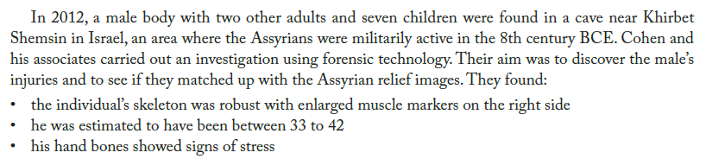

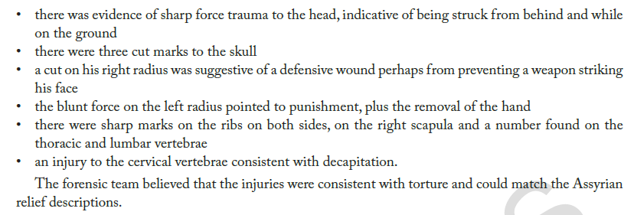

Source 6:
Persian warfare:
Translator: Tolman, H C, Vanderbilt University, Nashville, Tennessee, 1908 from: Butterfield, Bruce J, 1998, http://mcadams.posc.mu.edu/txt/ah/Persia/Behistun_txt.html, accessed 20 Feb, 2018
Behistun (3) Inscription by Darius I (Behistun is the place this is carved on a cliff face and the 3 is column number quoted below):
[3.14] “Says Darius the king: When I was in Persia and in Media, a second time the Babylonians became estranged from me; one man, Arakha by name, an Armenian son of Haldita, he rose up in Babylon; there (is) a region, Dubala by name - from here he thus lied to the people; I am Nebuchadrezzar, the son of Nabu-na'id; afterwards the Babylonian people became estranged from me (and) went over to that Arakha; he seized Babylon; he became king in Babylon.
[3.15] Says Darius the king: Afterwards I sent forth my army to Babylon; Intaphernes by name, a Persian, my subject, him I made chief of them; thus I said to them; go, smite that Babylonian army which does not call itself mine; afterwards Intaphernes with an army went to Babylon; Auramazda bore me aid; by the grace of Auramazda, Intaphernes smote the Babylonians; and [he led them bound to me]; 22 days in the month + + + + were in course - that Arakha, who called himself Nebuchadrezzar, and the men who [were his foremost allies they seized and bound]; [this Arakha] and what men were his foremost allies were put on crosses (crucified) at Babylon.”

