Year 12 The Importance of Being Earnest
Script: https://www.gutenberg.org/files/844/844-h/844-h.htm
Question:
Use one or more themes or ideas from The Importance of Being Earnest to explain Wilde’s ideas (i.e. what is he critical of?) about the gap between ideals and reality in Victorian society. Present the task as an oral of a maximum of 6 minutes arguing whether the ideas you explored have continued relevance from modern perspectives.
Sites:
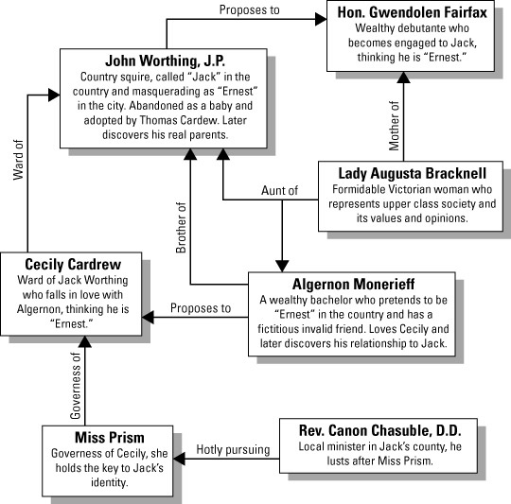
Cliff’s Notes
Summary and Analysis sections very good but 1st one has disturbing content – skip over; the Character Analysis section is very good and detailed.

SparkNotes
Analysis of Major Characters section good; some of Themes, Motifs and Symbols section useful; Important Quotations Explained may be useful

GradeSaver
Theme section quite good; some of Summary and Analysis sections will be useful.

Shmoop
Themes section not detailed but questions on each theme might be useful, as might the quotes section; Characters section and Analysis section, under Symbolism, Imagery and Allegory, Genre and What’s Up With The Title? will be helpful.

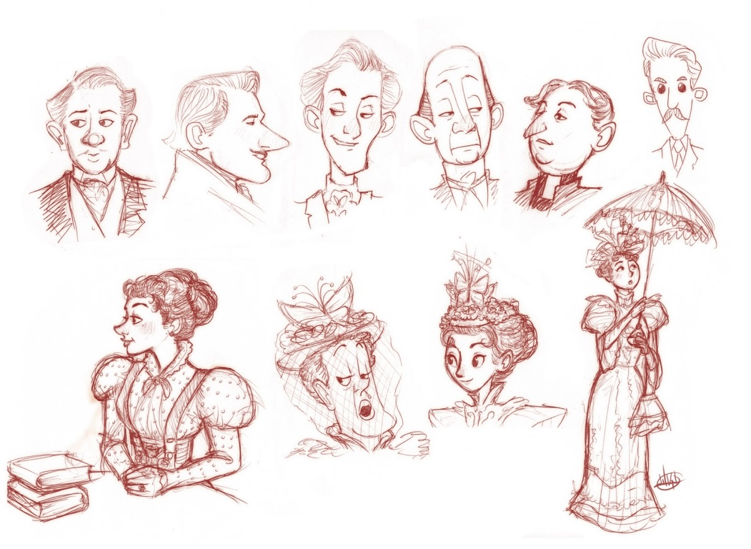
Relevant Themes about the Victorian “shallow mask of manners”:
Lies and Hypocrisy/Lack of Sincerity – Jack and Algy lie to get out of social responsibility; Bunbury/Ernest represent shallow Victorian values that accept or even expect deceit – no punishment for deceit. The play is saying that the Victorians didn’t value honesty and responsibility as much as their real values: money and class, and the use of imaginary friends show how shallow these concerns are. They are hypocrites who pretend to value duty, honour and responsibility. Name Ernest “inspires absolute confidence” but the people don’t live up to the name.
Marriage – presented as a means to social advancement and getting richer; even younger generation doesn’t really break society’s rules here. Women want to marry someone called Ernest – not interested in character. The women are very idealistic/unrealistic about marriage – most people have an ideal that doesn’t exist and in Victorian times most were prevented from marrying for love anyway. Ridiculous obstacles to marriage at end of play echo the ridiculousness of class as an obstacle to marriage.
Gender - Society produces a sameness in Cecily and Gwendolyn by its expectations of women. Miss Prism is unmarried and so her job is her identity – she is obsessed with marriage because it is the only way she can better her situation but she can’t say anything outright as it would be against social convention – she has to be asked. Men free to get away from responsibilities and make own life choices, women more restricted, especially about who they marry. There is one set of expectations for women and another for men.
Morality/Respectability – you need to have this even if you don’t really deserve it by your actions – it is all about appearances; societal expectations different for men and women. Jack is serious about keeping up appearances, more than Algy; Lady Bracknell is addicted to scandal – evidence of shallow values and actually a lack of respectability really. Play is about people pretending to be earnest but not actually being so (what does the last line mean?). Play lampoons the self-righteous moralism and hypocrisy of Victorian society. Cecily is mostly interested in Algy because he (as Ernest) is “wicked”.
Techniques Used:
Symbols – Ernest and Bunbury
Allegory - The handbag and the train line
Inversions – see SparkNotes
Foreshadowing – see SparkNotes
Irony
Satire
Witty repartee
Contrived situations
Incongruity
Deception
Parody
Paradoxes
Epigrams

