The television programmes, Jamie Cooks Italy and Nigellissima, although sharing similar applications of conventional film techniques, character and music, differ in social context, purpose and target audience. Oliver appeals to his audience, simplistic, active and young to middle-aged amateur cooks, to create food that is environmentally and personally beneficial. In contrast, Lawson persuades her mature, sophisticated, upper-class home cooks that cooking is a therapeutic activity that can unite families and create new relationships.
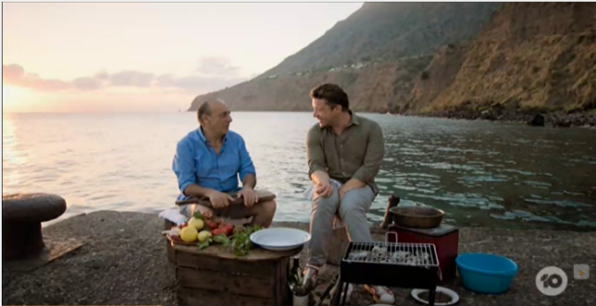
Both shows display the conventions of film, using techniques such as the longshot and the medium shot, to communicate their purpose. Oliver’s use of the longshot captures the view of the sea and the mountainous island-scape all within a single frame (fig.1). Not only does this conventional long shot establish the setting of the scene, to provide visual context, it also inherently displays the correlation between the sea the land and the food. The background represents various aspects of the squid dish, the sea suggesting the freshness of the squid, as if been caught at that moment, whilst the land provides the capers, the handpicked local produce, alluding to when Oliver describes the capers as, “The ingredients of the island” and when the two aspects are combined, as Contaldo states, “it’s the islands in a plate”. In contrast, Lawson utilises the medium shot (fig.2) to create an intimate sense of unity with the friends and family she’s serving. Additionally, the use of orange filters and natural sunlight, paired with darker coloured objects bring warmth into the scene, adding to the intimate vibe. The scene is constructed in this method to convey her purpose, to the audience, concerning the importance of home cooking and how it unites people. This creates a desire in the audience to cook for their family and friends, as the realisation is made that cooking could be utilised as a tool for bonding and building relationships. Comparatively, Oliver utilises the longshot to convey the importance of using local and fresh produce. This creates awareness for the audience that healthier lifestyle choices are paramount and that the use of local produce not only benefits them but the environment also. Therefore, both Oliver and Lawson utilise film techniques to express their individual purposes, however, Lawson’s ability to personally and emotionally connect to the audience, with a relatable purpose, allows her use of film techniques to have a greater effect on the audience.
Figure 2
Figure 1
In both shows, the presenter’s character is employed to appeal to their audience by displaying traits that are valued in their respective demographic. Lawson expresses her sophistication by dressing formally (fig. 3), speaking in an upper-class accent, due to her upbringing, and uses of complex language features (IMDB, N/A). Lawson employs various s metaphorical terms such as, “an inferno of chili flakes” and “my great love affair with Italy” to create imagery and to appeal to the senses. Furthermore, she uses Italian words, such as “Sale”, meaning salt in English, to demonstrate her bilingual capabilities, hence displaying her close connection with Italian culture. The combination of these erudite skills allows the character to connect with a mature and upper-class audience as sophistication is viewed as an element of credibility. Thus, the audience’s perception of the show is effectively manipulated as they now regard the show as a professional method of gaining cooking knowledge. In contrast, Oliver’s character is portrayed as ‘laid-back’ and this is conveyed by the way he dresses (fig.4), verbal language and accent. Oliver’s dressing style, a simple T-shirt and jeans, presents him as less sophisticated, in comparison to Lawson’s formal dress. Additionally, Oliver’s Essex accent and simplified language, exemplified by his humorous terms such as, “hum dinger”, “big boy” and “funny one”, furthers his informality (BIBLIOGRAPHY, 2014). Oliver’s nonchalant characteristics allow him to address his purpose to a larger audience; his target demographic is young to middle-aged amateur home cooks who prioritise simplicity hence, generating a larger target audience when contrasted to that of Lawson. Oliver’s simplistic character is vastly more effective, in contrast to that of Lawson’s, at effecting the audience due to the personal relationship he constructs. This personal relationship allows the audience to further relate with Oliver, despite his net worth of over $300m. Due to relatability, the perception is made, to the audience, that cooking can be an approachable task performed by anyone, no matter their background, upbringing or gender. Oliver’s use of his character is far more effective, in contrast to Lawson’s, as his personality can be used to attract a larger spectrum of people as almost every age-bracket can appreciate the approachable nature of his persona.
Figure 4
Figure 3
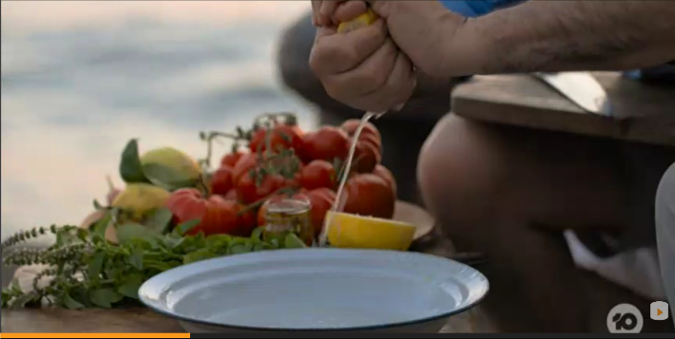
The implementation of music, to manipulate the audience’s emotions to attract varying audiences, can be seen in both shows. Oliver’s choice in percussive, fast-paced and upbeat Italian music throughout the programme is not only utilised to represent cultural aspects of Italy and the bright countryside colours, but to create a perception that cooking is highly active. The upbeat music intensifies the cooking and creates a feeling, within the audience, that the scene is building up to an eventual climax. Although Oliver appeals to both genders, the intensive and exhilarating aspects of cooking with the integration of his masculine traits, exemplified by Oliver hand squeezing lemons (fig.5), attracts a younger male audience by disregarding the societal stigma around the feminine stereotyping of cooking. On the contrary, Lawson uses calm, sophisticated jazz style music to represent the complex and cultured aspects of her character. The jazz style music specifically attracts her mature audience as 87% of jazz listeners are over the age of 45 (Jarenwattananon, 2011). In contrast to Oliver, Nigella uses music to create the opposite effect as she creates a soothing environment to display that cooking can become a therapeutic activity. As Harvard health research states, “jazz music has neurological effects, as it: calms the mind, lowers blood pressure and lowers stress levels”, which is valuable to her mature demographic (Harvard, 2011). Due to the neurological effect of jazz music, Lawson’s utilisation of music was more precisely targeted to her audience demographic in contrast to Oliver.
Figure 5
Through the comparison and analysis of the infotainment programmes, Jaime Cooks Italy and Nigellissima, various similarities can be drawn regarding the conventional film techniques, characters and the use of music. However, there is a dissimilarity in the purposes and audience, with Oliver aiming for a more diverse audience who appreciates the sourcing of sustainable local produce as opposed to Lawson’s sophisticated, more educated, demographic who value the importance of building and sustaining relationships through cooking.

Word count - 1084

BIBLIOGRAPHY, 2014, Jamie Oliver Bibliography, https://www.biography.com/personality/jamie-oliver (Accessed 18/05/20)
IMDB, N/A, Nigella Lawson Bibliography, https://www.imdb.com/name/nm0991861/bio (Accessed 18/05/20)
according to Ashford university studies, Jazz
Harvard, 2011, Music and Health, https://www.health.harvard.edu/staying-healthy/music-and-health (Accessed, 20/05/2020)
Jarenwattananon. P, 2011, Actually Useful Research About Younger Jazz Listeners, https://www.npr.org/sections/ablogsupreme/2011/08/15/139659935/actually-useful-research-about-younger-jazz-audiences (accessed, 20/05/2020)

