Comparative Study: Jamie Cooks Italy/Nigellissima
In Jamie Cooks Italy and Nigellissima, the directors have designed language, stylistic features and form differently to fulfil varying purposes and to appeal to their audiences as well as their contexts. This comparative study aims to explore how these texts have effectively utilised setting, character and shots to achieve these ends.
The settings of both films are chosen to suit the preference of their respective audiences and assist in communicating the purpose. Jamie Cooks Italy is filmed on the Aeolian islands in Italy, where the weather seems always sunny and warm. The refreshing Mediterranean Sea view and the clear, blue sky in the background make the viewers feel tranquil and joyful. This vibrant atmosphere of the Aeolian islands is an effective setting to entice the show’s predominantly British viewers to continue watching as British people often associate Italy with relaxation and holidays. Oliver accentuates the essence of Aeolian islands’ cuisine – that it’s natural, fresh and unprocessed by choosing to cook outdoor with organic ingredients and minimal resources. This colourful setting breaks the stereotype that cooking is mundane and stale. Rather, the show feels like an exotic, exhilarating adventure away from the busy modern life to seek for precious home cook recipes, thus fulfilling Jamie Oliver’s purpose of entertaining his audience. This setting is effective at appealing to young people under 30 years old and relaxed retirees as they themselves seek exciting moments in life over comfort and stability; thus, they’re likely to embrace the show’s energetic, vibrant atmosphere. In contrast, Nigellissima is filmed in Nigella Lawson’s tastefully decorated home in the UK. All the cooking is done in a prepared kitchen and the setting rarely changes. The director incorporates sparkly fairy lights and decorations into the background to create a homelike, cosy atmosphere. This setting reflects that the film’s purpose is to communicate the message that Italian cuisine can be made in anyone’s home with common ingredients and essential cooking tools. Nevertheless, the film doesn’t feel plain or tedious to watch, due to its warm, romantic atmosphere that brings soothing joy and comforting memories to the audience. This setting is appealing to sophisticated middle-aged female audience as they tend to prefer old-fashioned romance over thrill and excitement as their entertainment. Therefore, both Oliver and Lawson have successfully attracted their respective audiences through dissimilar settings.
The hosts of both films utilize specific vocabulary and varying styles of cooking to attract different audiences. In Jamie Cooks Italy, the humorous and approachable character that Oliver has produced is designed to make the viewing experience feel free and relaxed. His uniqueness as a host partly stems from his simple vocabulary and casual tone of speech. For example, Oliver incorporates common idioms, slangs and terms such as “curly-wurly” and “big boy” in his speech to make his language more reflective of his easy-going personality. This makes the audience forget his prestigious profile as a celebrity master chef; rather, an approachable individual. In contrast, Lawson uses more complex language and imagery, giving the positive impression that she sounds educated and classy. For instance, her description of Tuscan fries, “you could hear the crisp” appeals to the sense of hearing, whilst her imaginative use of imagery: “The burnished, fiery juices just trickle on top.” sophisticatedly describes her delicacies and appeals visually. This technique is aimed to attract middle-aged audience with a refined taste as they are accustomed to complex grammatical constructions and proper vocabulary. Lastly, Lawson’s movements and cooking techniques are also more feminine and delicate, which distinctively differs from Oliver’s masculine, unadorned style. For example, she uses a lot more kitchen utensils when working with raw ingredients, so she doesn’t get them all over her hands, whereas Oliver effortlessly grabs a hot pan with a towel and flips the food in it like a chef. (fig.1) In summary, Lawson’s cooking techniques appeal to more refined female audience as men may not find her cooking techniques as approachable. In contrast, although Oliver’s techniques aren’t as safe, they break the stereotype that many men hold – that cooking is a boring, tiring chore. After watching Jamie Cooks Italy¸ many men may find Oliver’s style captivating and may even aspire that they too could have Oliver’s talents at cooking. In this respect, Oliver’s character is more effective at appealing to his relaxed, multi-aged audience as they can better accept his casual style.
Figure 1: Jamie Oliver flipping food
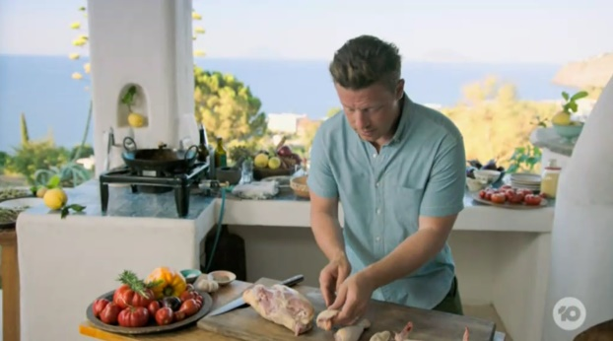
The varying shots used in both films help to meet the aesthetic understanding of their respective audiences. The natural, direct shots used in Jamie Cooks Italy engage the audiences and make them feel part of the scene. At most times, the camera captures Oliver from waist up with a medium shot at just a comfortable distance away, simulating how people see each other in casual daily conversations. (fig.2) By positioning the audience openly close to his figure, Oliver evokes a natural tendency to embrace him as friend. This shot aids in attracting the film’s multi-aged, middle to lower class male and female audiences, who appreciate friendly, uncomplicated conversations over formal, sophisticated speech. On the contrary, Nigellissima demonstrates an extensive use of shots when filming Lawson’s figure. The camera tends to film her from the side, capturing her beautiful posture and creating a layered shot structure, with ornamental pot plants and ceramics nearest to the audience, Lawson and the food in the middle, and a background decorated with dazzling fairy lights that’s in soft focus, creating a beautiful depth of field. (fig.3) Using these cinematic shots, Lawson incorporates a lovely, cosy mood that attracts her middle-aged, refined female audience, whose aesthetic ideals tend to be more sophisticated, classy and delicate. In conclusion, both Lawson and Oliver utilize varying film shots to appeal to their audiences. However, Lawson is better able, through using complex film techniques to persuade her refined, educated female audience that cooking is a stylish activity that spreads joy and comfort to other people.
Figure 3: Shot in Nigellissima
Figure 2: Shot in Jamie Cooks Italy
Nigella Lawson, in satisfying the aesthetic ideals and the romantic aspirations of her middle-aged, sophisticated, mainly female viewers, is quite effective at attracting and influencing her audience. Likewise, Oliver is effective at fulfilling his purpose of making cooking more approachable to the middle to lower class British public, who is in general, more casual in outlook. Through his relaxed, free character and captivating cooking style, Oliver’s audience understands that cooking can be effortlessly done anywhere and anytime, using natural ingredients and minimal resources. In conclusion, both films have successfully conveyed their purposes and attracted audiences, via utilizing language, stylistic features, and form.

1097 words

