Travel Writing

Places You Could be Published:
- Airline In-flight Magazines
- Specialist magazines ie food magazines like epicurious
- Online magazines ie CNN Travel, Travel and Leisure, Smithsonian Magazine
- Travel blog
- Travel book
- Travel guide ie Lonely Planet
- Newspapers

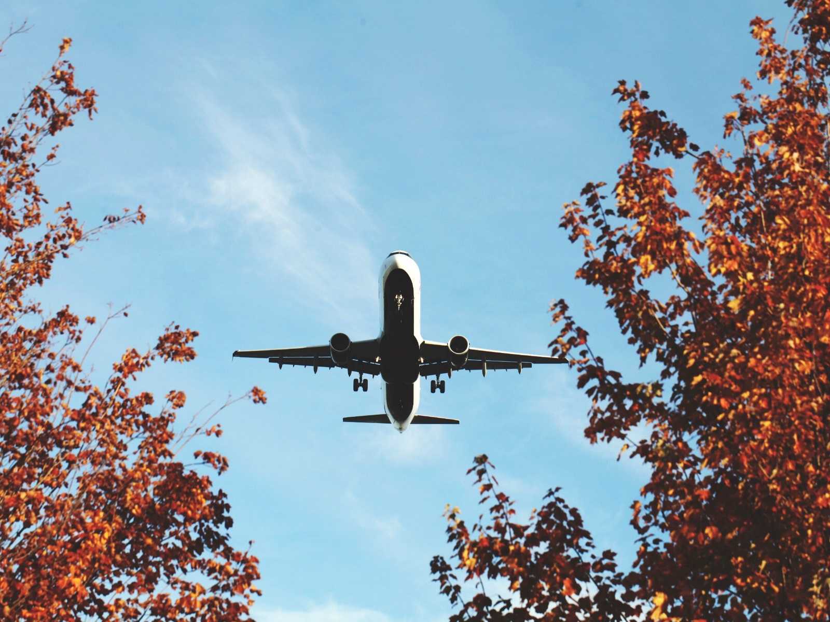

Types of Travel Writing:

Destination articles
Here, the game’s in the name: destination articles tell readers about a place to which they might want to travel one day. One of the most standard type of travel stories, these pieces act as the armchair reader’s bird-eye view of a place. Useful or interesting facts pepper the writing. History, points of interest, natural scenery, trendy spots: a destination article can touch upon them all within the framework of a broad narrative.

Where the average article gives readers a sense of the destination, the best of the best convinces readers that this is a destination they want, nay, need to visit. As such, though some destination articles are written in first person, the focus is rarely on the writer. Instead, the destination is the star of the show.

For examples of destination articles, check out:
- Besalú, the most interesting Spanish village you probably don’t know (LA Times)
- In Indonesia (Washington Post)
- 36 Hours In The Finger Lakes Region of New York (New York Times)

Credit: judithscharnowski @ Pixabay

Special-interest articles
Special-interest articles are offshoots of destination articles. Instead of taking the reader on a tour of an entire country or city, these pieces cover one particular aspect of the destination. This kind of writing can cover anything from art in Colombia, ghost towns in the U.S., trekking in Patagonia, alpaca farms in Australia, motorbiking in Brazil, railroads in France, volunteering in Tanzania — you get the gist.

Since special-interest articles are narrower in topic, many writers tailor them for niche magazines or websites. Before you start pitching, we recommend flipping through the Writer’s Handbook, one of the most useful guides to the freelance publishing market, to see which publications fit your target audience.

For a taste of some special-interest articles, see:
- Exploring Portugal — From Pork To Port (epicurious.com)
- This Unsung Corner of Spain is Home to Fabulous Food (Washington Post)
- Karsts of China's Getu River region attract rock climbers, other travelers (CNN Travel)

Holiday and special events
Holiday and special events travel articles ask writers to write about a destination before the event takes place. The biggest global events are magnets for this type of travel writing, such as the World Cup, the Olympics, the World Expo, fashion weeks, and film festivals. Depending on the publication, regional events work just as well.

Want to see what special events pieces look like? Have a read through these:
- This summer’s solar eclipse is southern Illinois’ chance to shine (Chicago Tribune)
- How To Plan A Trip To The 2016 Rio Olympics (Travel & Leisure)

Round-ups
You’ll recognize a round-up article when you see one, as it’ll go, “40 best beaches in West Europe,” or, perhaps, “20 of the greatest walks in the world!” It’s a classic tool in any magazine or newspaper writer’s toolbox, taking a bunch of destinations and grouping them all under one common thread.

Ultimately, a clear motif makes this type of article a breeze to read, as they’re a play on the ubiquitous List Format. But, OK, before you jump at this excuse to sacrifice your belly at 99 food trucks in New York City, remember that your premise should be original, not to mention practical. What’s tough is coming up with X ways to do Y in the first place, as that demands you put in the travel and research to produce a thorough write-up.

Credit: cowins @ Pixabay

Want even more examples of round-up articles? Here you go:
- 12 new art exhibits to see this summer (Smithsonian)
- 21 ways to see America for cheap (Huffington Post)
- 41 places to go in 2011 (New York Times)

Travel Blogging:

Credit: KuyaAndy @ Pixabay

When typing “travel blog” into Google returns 295 million results, we can guess it’s a fairly competitive market.

Here’s the plus side: bloggers get to write what they want and go where they please. When it comes to blog posts, there are no editors, no gatekeepers. Only you and the “PUBLISH” button.
We won’t go revisit the types of travel writing we covered earlier (such as the roundup format). Instead, we’ll explore some of the other formats bloggers use to tell their travel stories. Since the rules of travel blogging are next to non-existent, our tally below is by no means definitive. And, again, our best advice is to note what your favourite bloggers do on their blogs.

Travelogues
In travelogues, authors record their adventures in a way that illustrates or sheds insight upon the place itself. Travelogues possess a storied past, from Lady Mary Wortley Montagu’s Turkish Embassy Letters in 1763 to Mark Twain’s 1867 The Innocents Abroad, which paved the way for the sort of comic travelogues that Bill Bryson’s perfected today.

Up for some travelogues? Check out:
- Notes From A Small Island, by Bill Bryson
- In Patagonia, by Bruce Chatwin
- Travels with Charley In Search of America, by John Steinbeck

Travel memoirs
Nowadays, travel memoirs are practically synonymous with Elizabeth Gilbert’s wildly popular Eat, Pray, Love and Cheryl Strayed’s bestselling Wild, which were both recently adapted into Hollywood blockbusters.
That said, be aware that you’ll need a pretty exceptional personal story for your memoir to compete in today’s market. If you’re still set on writing or self-publishing a travel memoir, it’s tricky to balance personal backstory and travel for 400 pages, so think about taking on a professional for a second pair of eyes.

In addition to Eat, Pray, Love and Wild, you can read:
- Under the Tuscan Sun, by Frances Mayes
- Coasting, by Jonathan Raban
- Wind, Sand, and Stars, by Antoine de Saint-Exupéry

Guidebooks
As Oscar Wilde said, “I never travel without my diary. One should always keep something sensational to read in the train.” But these days, people are replacing diaries with travel guides — the ubiquitous Lonely Planet becoming one of the more common sights on transit.

Travel writing in guidebooks is straightforward, informative, and fact-filled. In addition, there’s a certain amount of responsibility that comes with the job. Lonely Planet alone is read by millions of travellers worldwide.

How to Write Travel Writing Style:

Find a Hook
Start out with an exciting scene — don’t meander. Use the inverted pyramid (a journalism idea), and put the most interesting part of your trip right at the beginning.

Everything else stems from that place. You can backtrack from there. It’s like when you get back from a trip — the first information you share when people ask you how your trip went is the information that should be your lede. Below is how Bruce Northam set the scene for his piece about Annapolis, Maryland:

“Annapolis, Maryland is an iconic, charming, thought-provoking destination, and with good reason—awesomeness tempts you from every angle. The Naval Academy (you don’t get it until you take the tour), America’s oldest state capitol in continuous legislative use (intimate, gorgeous, screams history), and the epic leisure-boat port vibe are just part of the appeal in America’s Sailing Capital.”

Get Right to the Point.
Tell your reader where the story is set, where you’re going, and what the story is about. Don’t keep them guessing. If it takes three paragraphs for the reader to find out where the story is set, you need an editor. Here is an excellent example of setting the time, place and scene written by Andrew Castillo, on GoNOMAD about Burlington VT:

“It’s after 9 p.m. and one of those nights when my feet are soaked, but my spirits aren’t.
How can they be, when I’m in Burlington, Vermont, for the Discover Jazz Festival.
The raspy wail of an electric guitar floats out from under the awning of a tucked-away bar on Church Street. I push open the door and the full brunt of sad notes invade my emotions. It’s like ‘90s grunge met smooth jazz and produced an offspring. Or maybe John Bonham from Led Zeppelin reincarnated as a jazz drummer.”
(Read the rest of his Burlington VT story)

The Hardest Part, The Story Arc and Use a Narrative
People want to see WHY a place is worth visiting, and they see it how you share what happened. Plot out what happened. “Finding the arc of the story. Some suspense. Something has to happen. Characters have to meet resistance and change, just as in any good short story or novel. Something has to be at stake. Otherwise, the piece is just a litany of We saw this, then this.” (Peter Heller)

Make it a story; don’t make your travel article a checklist. Delve into what moved you, take out anything that’s not really crucial to understanding the place you went.

Use All the Senses and Include Emotion
Don’t forget about smells, sounds, taste, sights. Your reader hasn’t been to the places you’ve been to. Put them there with vivid, tantalizing descriptions that fully immerse them into the environment.
A good example is Max Hartshorne and photographer Paul Shoul at the 2016 NY Times Travel Show (Truffle hunting story example).

Show how the trip affected or changed you. Human emotion is important to make the reader care about what you did and where you went.

Best Advice: Use Dialogue From Locals
Peter Heller, of Outside Magazine, said this about dialogue and details:

“I met John McPhee once. He told me to carry a notebook and write everything down, everything everyone says, exactly as they say it. Even while you’re climbing a mountain. Don’t try to remember dialogue at the end of the day, it will all end up sounding like you, and will be inaccurate. So that’s what I always did, on an eco-pirate ship in a storm, on a trail, I scribbled everything down as I heard it. Nothing can evoke a sense of character and authenticity better than letting the characters do it themselves.

Write everything down. Save receipts, save business cards, use a composition book and glue stick to keep as many reminders of where you went and matches, details, etc.”

Stick to One Tense
The present tense is NOT GOOD. Use the past tense. Don’t be tempted to use present tense, because most of the time it will have to change eventually. We all do it sometimes but keep it to a minimum.

Use Simple Language but Avoid Cliches
Write conversationally. Maintain a personal, unique voice that has a distinct flavour. Talk the way you talk, use your own voice, but make it descriptive and don’t use overused words boring words like great, awesome, beautiful, nice….THINK HARDER…think harder for the right word, be more precise, don’t be lazy.

Be a Reporter
Details details DETAILS! Be a reporter. Use visual descriptions and provide EXACT locations. Make sure you document, for instance, how much hotels cost. Travel writing has been described as part reporting, part dear diary and part providing information for the reader.

Wikipedia is good place to start but also use tourism board materials, state dept info, and ask experts. It’s harder being a reporter than a writer but if you want to get stories that people will want to read, ask more questions and dig deeper! Steve Szkotak, AP editor and reporter often says it’s harder to be a reporter but way more valuable than a writer. Heller suggests finding experts, asking for experts and trusting their answers.

Take a Fresh Perspective; Be Unusual; Write Ironically
Writing from a different point of view makes the story more interesting. For instance: Skiing in the desert — be ironic! Surprise your readers with topics and ideas they don’t expect. Monaco for the Average Joe. Wineries in Mexico….

Learn to see the world from a fresh perspective. Write about familiar places in unfamiliar ways. When writing about mundane experiences, pretend that they are new and exciting. Document your findings in vivid, immersive detail.

Everyone is a local somewhere
You don’t need to travel halfway around the world to be a good travel writer. Start local. Write about what you know. People are interested in where you live, more than you might be, and it’s the perfect place to start. Look for things people can do, places you take friends—travellers would also be interested.

It’s About Their Trip
Focus on what the readers can do, not what you did. Include events and places that anyone can visit, if you have an exclusive view to something, it’s not that interesting. No one cares about your massage or big meal unless they can get one too. The fact that you went to a location isn’t necessarily interesting.

The fact that you’re showing the reader how THEY could go, makes it interesting. Also, a story about a fascinating location can be boring, just as a story about a boring location can be fascinating. The location doesn’t make the story, it’s what happens and how they can relate.

Make Your Pitch
Be a salesman for yourself: write about places that haven’t received much attention from travel writers, such as the Middle East. Pitch your story to editors using a well written, succinct paragraph outlining what your story is about.

Max Hartshorne blogs.gonomad.com/readuponit
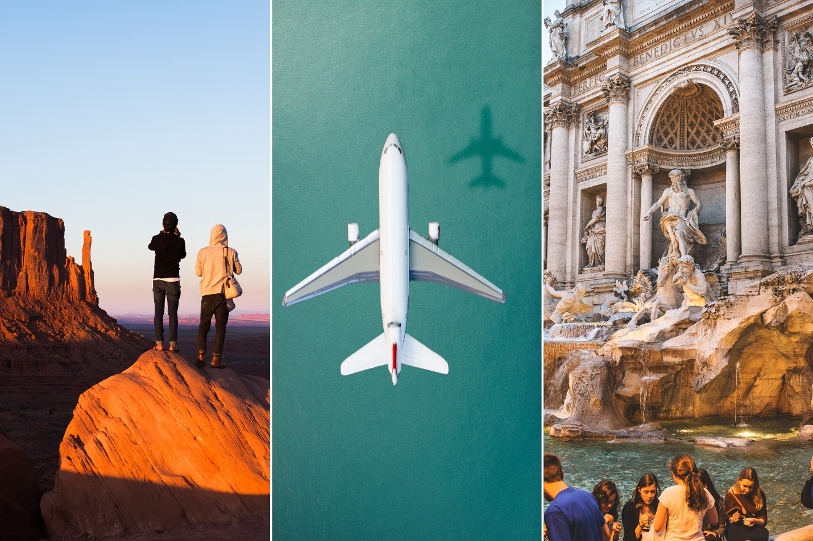

Example Beginnings:

Michele Petersons’s Lede (Opening) Paragraph Travel Writing Example
I’m hiking through a forest of oak trees following a farmer who is bleating like a pied piper. Emerging from a gully is a herd of black Iberian pigs, snuffling in response. If they weren’t so focused on following the swineherd, I would run for the hills. These pigs look nothing like the pink-cheeked Babe of Hollywood fame.

These are the world’s original swine, with lineage dating back to the Paleolithic Stone Age period where the earliest humans decorated Spain’s caves with images of wild boars. Their powerful hoofs stab the earth as they devour their prized food, the Spanish bellota acorn, as fast as the farmer can shake them from the tree with his long wooden staff. My experience is part of a culinary journey exploring the secrets of producing jamón ibérico de Bellota, one of the world’s finest hams.

Elaine Masters’ Lede (Opening) Example
I jiggered my luggage onto the escalator crawling up to the street. As it rose into the afternoon light, an immense shadow rose over my shoulder. Stepping onto the sidewalk, I burst into giggles, looking like a madwoman, laughing alone on the busy Barcelona boulevard. The shadow looming overhead was the Sagrada Familia Cathedral. It had mesmerized me forty years earlier and it was the reason I’d finally returned to Spain.

Bret Love’s Lede Example
Congo Square is quiet now. Traffic forms a dull drone in the distance. A lone percussionist taps out ancient tribal rhythms on a two-headed drum. An air compressor from Rampart Street road construction provides perfectly syncopated whooshes of accompaniment.

Shaded park benches are surrounded by blooming azaleas, magnolias, and massive live oaks that stretch to provide relief from the blazing midday sun. It’s an oasis of solitude directly across the street from the French Quarter.

Congo Square is quiet now. But it’s here that the seeds of American culture as we know it were sown more than 200 years ago. And the scents, sounds, and sights that originated here have never been more vital to New Orleans than they are now, more than a decade after Hurricane Katrina devastated the city.

Example Middle Paragraphs:

Joe Baur’s Middle Paragraph Example
I first became aware of the Harz mountains and the Brocken when reading the works of some of Germany’s great writers, like Goethe and Heinrich Heine. Legends of witches congregating with the devil being the main theme of the mountain’s mythology. I, however, was more interested in a refreshing time spent in nature rather than reveling with the devil.

The first stage from Osterode to Buntenbock was a warm-up to the more rigorous stages ahead. It began on sidewalks before sliding into the forest sporting a healthy shade of green — a gentle jaunt that made my hiking boots feel a bit like overkill given the dry, pleasant weather.

Example Ends:

Below is the closing of Don George’s story included in the ebook: Wanderlust in the Time of Coronavirus: Dispatches from a Year of Traveling Close to Home
I continued hiking up to Lost Trail and then along Canopy View Trail. Around noon I serendipitously came upon a bench by the side of the trail, parked my backpack, and unpacked my lunch. Along with my sandwiches and carrot sticks, I feasted on the tranquility and serenity, the sequoia-swabbed purity of the air, the bird and brook sounds and sun-baked earth and pine needle smells, the sunlight slanting through the branches, the bright patch of blue sky beyond.

At one point I thought of shinrin-yoku, forest bathing, the Japanese practice that has become widely popular in the U.S. This was a perfect example of shinrin-yoku, I thought: Here I am, alone in this forest, immersed in the sense and spirit of these old-growth redwoods, taking in their tranquility and timelessness, losing myself to their sheer size and age and their wild wisdom that fills the air.

I sat there for an hour, and let all the trials, tremors, and tribulations of the world I had left in the parking lot drift away. I felt grounded, calm, quiet—earth-bound, forest-embraced.

In another hour, or two, I would walk back to the main paved trail, where other pilgrims would be exclaiming in awe at the sacred sequoias, just as I had earlier that day.

But for now, I was content to root right here, on this blessed bench in the middle of nowhere, or rather, in the middle of everywhere, the wind whooshing through me, bird-chirps strung from my boughs, toes spreading under scratchy pine needles into hard-packed earth, sun-warmed canopy reaching for the sky, aging trunk textured by time, deep-pulsing, in the heart of Muir Woods.

