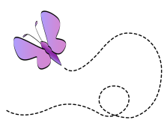
How to Become a More Effective Learner

By Kendra Cherry, updated April 28, 2016
Are you interested in finding ways to learn new things faster? Do you want to become a more effective and efficient learner? If you are like many students, your time is limited so it is important to get the most educational value out of the time you have available.

Speed of learning is not the only important factor, however. Retention, recall, and transfer are also critical. Students need to be able to accurately remember the information they learn, recall it at a later time, and utilize it effectively in a wide variety of situations.

So what can you do to become a better learner? Becoming an effective and efficient student is not something that happens overnight, but putting a few of these tips into daily practice can help you get more out of your study time.

Keep Learning (and Practicing) New Things
One sure-fire way to become a more effective learner is to simply keep learning. A 2004 Nature article reported that people who learned how to juggle increased the amount of gray matter in their occipital lobes, the area of the brain is associated with visual memory. When these individuals stopped practicing their new skill, this gray matter vanished.
So if you're learning a new language, it is important to keep practicing the language in order to maintain the gains you have achieved. This "use-it-or-lose-it" phenomenon involves a brain process known as "pruning." Certain pathways in the brain are maintained, while other are eliminated. If you want the new information you just learned to stay put, keep practicing and rehearsing it.

Learn in Multiple Ways/Understand How You Learn Best
Focus on learning in more than one way. Instead of just listening to a podcast, which involves auditory learning, find a way to rehearse the information both verbally and visually. This might involve describing what you learned to a friend, taking notes, or drawing a mind map. By learning in more than one way, you’re further cementing the knowledge in your mind.
According to Judy Willis, “The more regions of the brain that store data about a subject, the more interconnection there is. This redundancy means students will have more opportunities to pull up all of those related bits of data from their multiple storage areas in response to a single cue. This cross-referencing of data means we have learned, rather than just memorized.”

Teach What You've Learned to Another Person
Educators have long noted that one of the best ways to learn something is to teach it to someone else. Remember your seventh-grade presentation on Costa Rica? By teaching to the rest of the class, your teacher hoped you would gain even more from the assignment. You can apply the same principle today by sharing your newly learned skills and knowledge with others.
Start by translating the information into your own words. This process alone helps solidify new knowledge in your brain. Next, find some way to share what you’ve learned. Some ideas include writing a blog post, creating a podcast, or participating in a group discussion.

Utilize Previous Learning to Promote New Learning
Another great way to become a more effective learner is to use relational learning, which involves relating new information to things that you already know. For example, if you are learning about Romeo and Juliet, you might associate what you learn about the play with prior knowledge you have about Shakespeare, the historical period in which the author lived, and other relevant information.

Gain Practical Experience
For many students, learning typically involves reading textbooks, attending lectures, or doing research in the library or on the Web. While seeing information and then writing it down is important, actually putting new knowledge and skills into practice can be one of the best ways to improve learning.

Look Up Answers Rather Than Struggle to Remember
Of course, learning isn’t a perfect process. Sometimes, we forget the details of things that we have already learned. If you find yourself struggling to recall some tidbit of information, research suggests that you are better off simply looking up the correct answer.
One study found that the longer you spend trying to remember the answer, the more likely you will be to forget the answer again in the future. Why? Because these attempts to recall previously learned information actually results in learning the "error state" instead of the correct response.

Use Testing to Boost Learning
While it may seem that spending more time studying is one of the best ways to maximize learning, research has demonstrated that taking tests actually helps you better remember what you've learned, even if it wasn't covered on the test.

Stop Multitasking
For many years, it was thought that people who multitask, or perform more than one activity at once, had an edge over those who did not. However, research now suggests that multitasking can actually make learning less effective.
In the study, participants lost significant amounts of time as they switched between multiple tasks and lost even more time as the tasks became increasingly complex. By switching from one activity to another, you will learn more slowly, become less efficient and make more errors.
How can you avoid the dangers of multitasking? Start by focusing your attention on the task at hand and continue working for a predetermined amount of time.

Final Thoughts
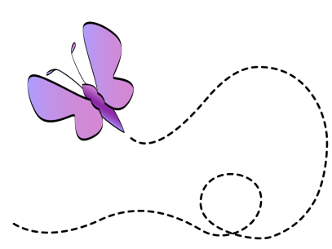
Becoming a more effective learner can take time, and it always take practice and determination to establish new habits. Start by focusing on just a few of these tips to see if you can get more out of your next study session.

