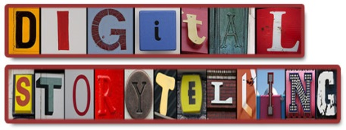
Digital Story, Recount or Narrative Assignment

This is the third Production, so is again approximately 1000 words/6 minutes maximum or to fit into the 3000-word limit of the 3 pieces overall.
The format of this Production of a choice of 3 creative writing types:
- One is a straightforward narrative, the challenge being the length.
- Another choice is a recount, which is easier in so few words
- The other form, a digital story, is lighter on words but requires a more visual and ICT based approach.
Here are examples of digital stories: http://digitalstorytellers.com.au/
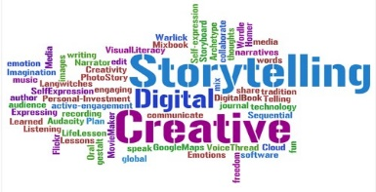
Don’t forget to choose a new audience to go with your primarily entertaining purpose. Of course, there is crossover of purpose, especially if you do a recount or digital story, as they also inform, generally on a meaningful topic.
Use the resources available on Haiku for narratives and recounts too!
Performance Standards
Knowledge and Understanding
2 Knowledge and understanding of ways in which creators of entertaining texts use language features, stylistic features, and conventions to make meaning.
3 Extensive knowledge and understanding of a wide range of ways in which entertaining texts are created for different purposes, audiences, and contexts.

Application
1 Versatile and precise use of language and stylistic features to create a coherent entertaining text that addresses the purpose, audience, and context
3 Sophisticated use of accurate, clear, and fluent expression.
