Consideration and refinement of a Research Question

PMI

Pluses – My topic allows me to make a business and learn about how businesses can make a profit. My topic also allows me to talk to business owners and see a real life context in how to operate a business. This information will make my findings more useful. I’ll be able to take the knowledge and skills I learn throughout the process to help my in actually running my business, and I also hope to start my own business when I have left school, so this information will also help me with that.
Because I live next door to a nursery, it should be easy for me to get in contact with a business owner. I might also be able to interview another nursery owner as my dad knows someone through work.
Another positive of my topic is that I’m currently doing Business & Enterprise in Year 12 and can talk to my B&E teacher. There should be lots of sources I can talk to.

Minuses – Getting the right kinds of sources that are relevant to my topic. It’s a bit different to other topics that people are doing as it’s going to involve a lot of action research. Most of my friends will be looking at academic articles, but my task isn’t really analyzing articles, it’s more putting things into practice based on things I’ve researched.

Interesting – For me, this topic will be very interesting because I want to run my own business when I leave school and so I can actually apply the things that I’m learning as I go.

Question Refinements (Extracts)

1-12-14 – How can I run my own business?
I want to start a business when I leave school so I thought that I could do this as my Research Project

21-12-14 – How does a business get enough capital to start?
This is the biggest problem I’m going to face as I don’t have a job, and don’t have ready access to money. I’m not going to spend my Xmas money a school assignment so need to think of ways that businesses actually raise enough money to start

2-2-15 – Can I start an effective business?
In speaking to the teacher, the last question wasn’t that great. I’ve decided to go back to my original idea of starting a business. It turns out that the school can give me a loan

7-2-15 – What are the areas that I need to consider when starting a business?
I’m wondering whether I do actually need to run the business and maybe I can just look into how to do it rather than actually run one.

12-2-15 – How does the planning of a business affect its performance?
I’m finding that the biggest issue in business success is the planning.

14-4-15 – Considering areas of Finance, Marketing, Management and the business environment, how can I develop a profitable business?
Breaking the question down this way is going to allow me a lot more structure and will give me a direction when doing my research.

16-2-15 – (FINAL QUESTION) Considering the areas of Finance, Marketing, Management and the business environment, how can I develop a profitable business using a micro-business as a test case?
In speaking with my teacher and a business owner, I’ve decided that it would be possible for me to actually run a business. Yay!! Based on the research I’ve done so far, I’m going to plan a micro business of selling succulents, but using all the research I’ve done so far (and more) to plan and implement the business. The different areas in the question will give me direction and based on the research I’ve done so far, will give me a good basis to form and operate the business.

Planning of the processes appropriate to the question.

Ethical considerations
There aren’t many ethical considerations to take into account in my topic as I can do most of my research unobtrusively through texts, video and speaking with my B&E teacher. I will need to think about ethics however when speaking to business owners, ensuring that I’m not taking up their valuable time unnecessarily. In doing that, I will need to make sure I come well prepared to interviews so I don’t waste their time.

Capabilities
I’m planning on developing both my numeracy and critical and creative thinking capabilities. These are two areas that relate a lot to my topic. I am OK at maths, but I want to see exactly how a business uses their figures to determine the direction they need to take a business. I also will need to reflect a lot on what I am doing and think critically about all the processes I’m going through. I will do this by: learning how to apply new knowledge and skills e.g. applying understanding of financial documents; explaining the reasons behind the responses I’ve made E.g. question refinement; developing a greater understanding of a range of processes e.g. surveys and analysis of results; learning how to find, organize, use and evaluate information e.g. arranging all my research, keeping accurate records of financial transactions.

Planning for individual processes (Example)

Interview with Business owner
Purpose – to gather key findings about how businesses operate, with regards to their marketing methods. The key findings will then be used/tested in my own business operations.

Challenges | Opportunities
Finding more than one business owner to provide me with reliable information | Gather highly relevant information from business owners in the industry I operate in
Making sure I’ve got appropriate questions and have done enough research before the interview to get the most out of them | Developing my critical and creative thinking capability of reflecting on what I’m doing and refining before I get to the interview

I have outlined the purpose of this specific research process in answering my question and a few challenges and opportunities. I did this for each research process.
Partnership Agreement

I developed a partnership agreement with Angela and Mae who were my business partners. Partnership agreement can be seen below.
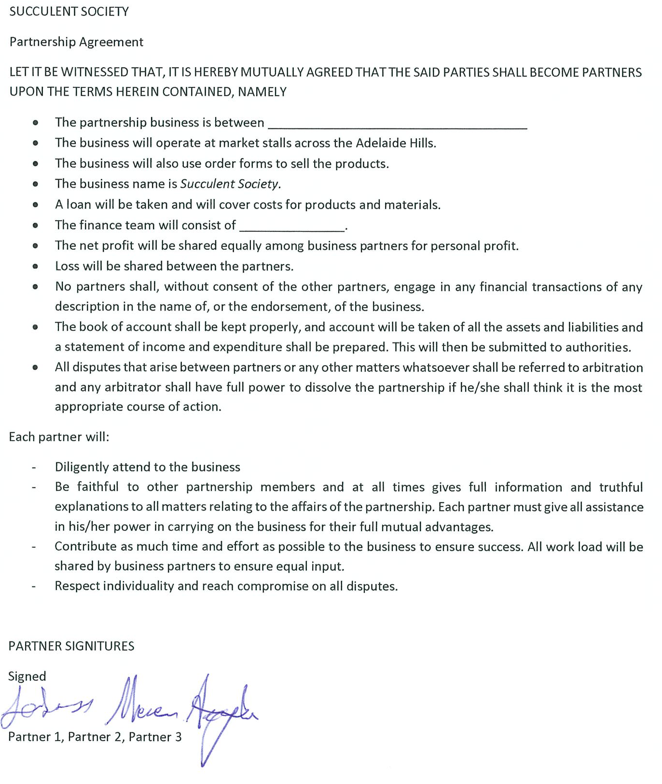

Action Research

Purpose – To put into practice those things that I’m discovering regarding business operations. I can then evaluate the effectiveness of each decision that I make.

Challenges | Opportunities
Setting enough time aside from my other subjects to spend time actually running the business. This will involve a lot of weekends at various markets as well as in school time | Developing my business will be a high quality case study of how modern business techniques might work in a micro business
 | Develop my numeracy skills in the keeping of accounting information and learning how to create accurate financial documents

Requests for Interviews

Email transcript sample – interview 1 – demonstrating that I’ve looked into what I want to speak to the owner about and how I’ve planned how the interview would go as well as giving prior warning to the owner.

BANK RECONCILLIATIONS

NAME AND PUBLICATION DETAILS OF SOURCE | RESEARCH PROCESS USED
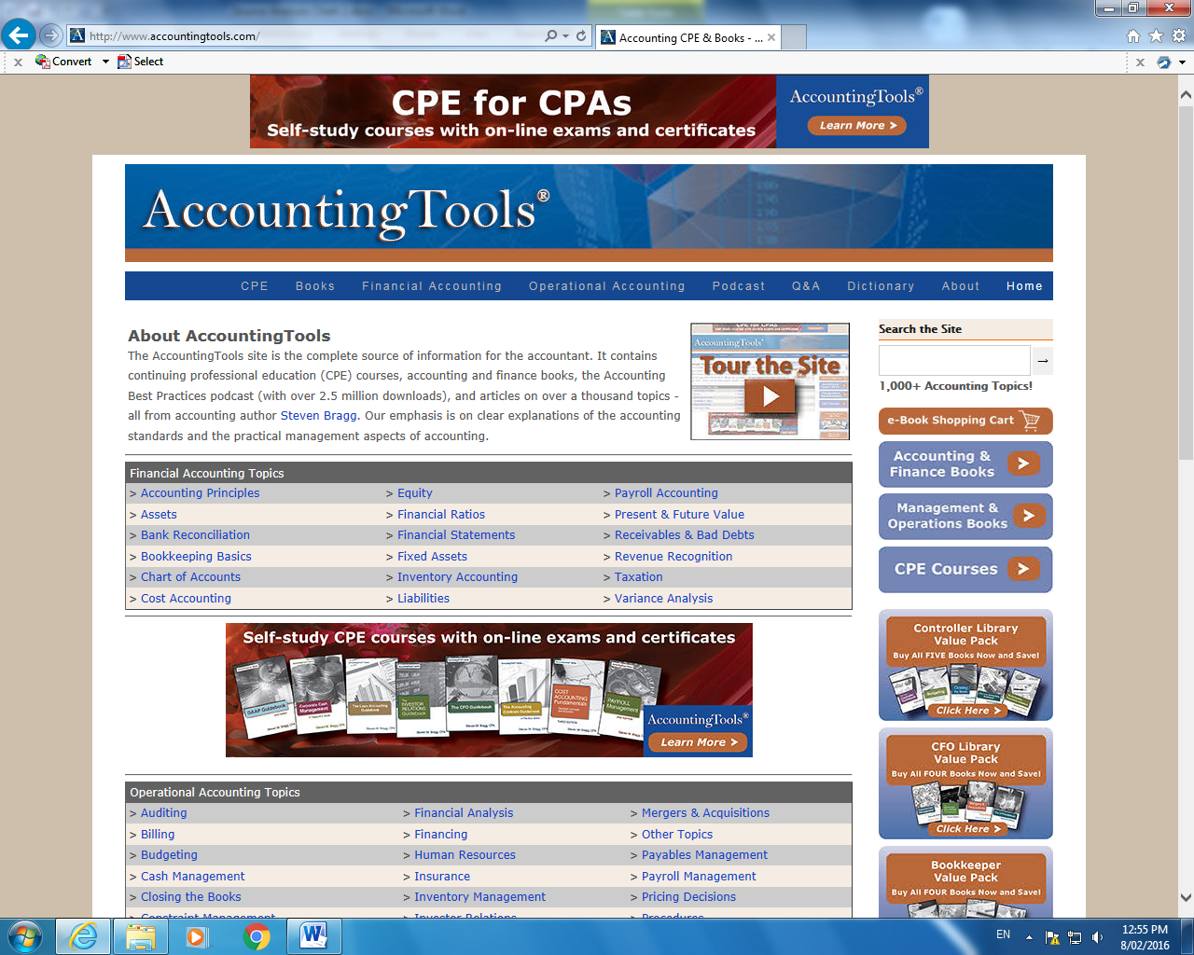  Bragg, S. (2015). Accounting CPE & Books – Accounting tools. (Online) Accounting Tools. Available at http://www.accountigntools.com  Accessed 10 May 2015  This was a great site for getting accounting information and how to conduct basic accounting operations. | - Reading and analyzing the website  - Questioning Accounting teacher  - Talking to business owners
 | TYPE OF SOURCE
Website – Accounting processes
Interview with Accounting Teacher
Interview with Business owner
KEY FINDINGS
What information have you gained? What new knowledge or ideas have you discovered?
- How to conduct a bank reconciliation
- You use your bank statement to conduct a bank reconciliation
- Any items that don’t appear on the statement need to be reconciled with businesses records
- If there is a difference between the bank statement and business records there is an error either by the business or the bank
- Errors can be easily overcome through checking records or contacting the bank
- Go through any extra random things on the banks statement and make sure you have them in your own records
VALIDITY
How relevant? How useful? How is it ‘fit for purpose’?
- The site is useful but I didn’t really understand a lot of the information initially as I haven’t done accounting. I need to talk to the accounting teacher about how to actually do them, and any templates
- I was a bit worried about the site being American and whether processes might be different to Australia
RELIABILITY
How accurate? How objective/biased? How trustworthy How credible? How current?
- Reliable – validated through discussion with teacher and business owners and accountants
- Worried if it were American that they would have different requirements to Australia
SKILLS AND KNOWLEDGE
Describe the type of research process undertaken and outline what skills and/or knowledge you developed.
- Reading – understanding about bank reconciliations and what they are. Developing skills and understanding in how to conduct one.
- I spoke with the Accounting teacher about how to do one, and she showed me a template that I can use. I tried doing one with her and was successful in doing it. I can understand the process and can now apply it to my business.
- I spoke with LOCAL BUSINESS OWNER about whether they think a bank reconciliation is relevant and they said they use them every month
EFFECTIVENESS
What feedback, opportunities, questions, challenges, problems did you encounter? How did you respond to, overcome, solve these?
How did you review and adjust the direction of your research in response?
- I didn’t understand the information at first so spoke with the accounting teacher and Mr Smith from the LOCAL GARDEN BUSINESS about bank reconciliations
- I was worried that I wouldn’t be able to do a bank reconciliation just from the information on the website, so asked the LOCAL BUSINESS if they really need to be done in one of my interviews with them.
CAPABILITY
How have you developed one or more of your Capabilities?
- Numeracy - I did not know how to conduct a bank reconciliation before, now I do.

ACTION RESEARCH – Conducting the business I came across the problem of low and falling sales. I talked to the teacher and they suggested doing a survey of customers to find out why sales were falling
Research Process

Analysis of Customer Survey Responses | Action from analysis
Question 1 – How did they hear of the business. 16 said word of mouth, 5 said the flyer in the library, 2 said the poster in the canteen. | I’m going to put less time into preparing paper and hardcopy advertising as it isn’t very profitable for the amount of time I put into it. I’ll still do it, but just not as much.
Question 2 – what type of advertising do people look at  15 said facebook, 10 said word of mouth, 3 said flyer | I started a facebook page and advertised Succulent Society to my network of friends. Looking at the survey results, I need to spend more time talking to people about the business as well as this is where most of my sales come from.

I developed skills in survey writing through speaking to the RP teacher and also the B&E teacher so that I could survey the target market effectively. I learned that survey writing should follow a format that gives you the information you need.

Skills
Developing the survey allowed me to address target market concerns and therefore increase my sales . I had to change to meet the needs of my target market
Effectiveness
Capability
Capability
Critical and creative – in reflecting on the market research I was able to change the tack of my product presentation and also the marketing to better access my target market. I learned to develop market surveys and to ask questions of my target market that allowed me to change what I was doing.

ACTION RESEARCH – Social Media Analysis

I developed new skills in social media advertising and understanding how to interpret the statistics they provide about the reach of my ads and consumers engagement with them. I also learned how to develop a marketing campaign based on the 4 P’s of marketing.
Effectiveness
Skills
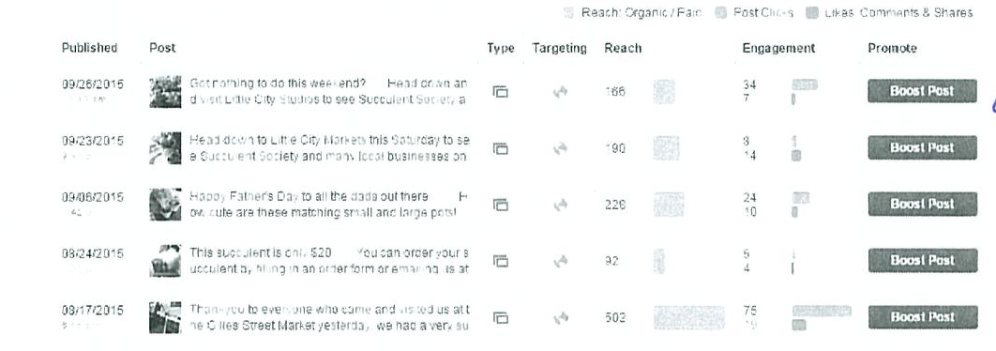
Critical and Creative – This process allowed me to rethink the direction I was taking the business through my marketing. In getting statistical feedback from customers I was able to scrap things marketing methods that were detracting from the business and enhance the things that were working – such as social media advertising.
Capability
Analysis of facebook advertising at regular intervals allowed me to monitor the reach of ads and their effectiveness in attracting sales. It showed me how I can better target my target market and what methods of marketing were working.

Type of source | Research Processes
Notes from B&E Text, Key chapters relevant to my business – colour coded for cross references and organising my information.  - Fusco A, Ratsch-Jenke J & Panayi-Motus A 2012, Business and Enterprise, SACE 2 Key Ideas, 1st edn, Essentials, Adelaide Tuition Centre, Australia | KEY FINDINGS  What information have you gained? What new knowledge or ideas have you discovered?
- This book helped me develop many areas of my research from Marketing, to Human Resources, to the legalities of running a business as well as operational issues from day to day. One area that it didn’t help a lot with was the Financial side however.
- Key findings with regards to Marketing were
- To use the 4 P’s of marketing as a base theory – pricing of the product, promotion, placement (where it’s going to be sold) and product (kind of like the brand and what it is that I’m selling). It also allowed me to think about how to promote my business online
- Key findings about human resources
- The human resource cycle, which also caused me to think about the way that I was looking for people to employ and how I can keep them happy while working for me.
- Key findings about business operations
- For a micro business like mine, the most appropriate form of management structure was a flat structure, because it allows employees to feel partly responsible for the business as well as gives good avenues of communication between myself as the owner and the employees.

VALIDITY  How relevant? How useful? How is it ‘fit for purpose’? | RELIABILITY  How accurate? How objective/biased? How trustworthy How credible? How current?
- This book was highly relevant to my entire business operations being conducted as it covers a wide range of business areas. | - The Authors of this book have published a number of books on this topic over many years. The School B&E teacher also said that they are all current teachers of B&E as well. Therefore the things that they speak about in the book are reliable. A limitation of this however is that they may have limited actual business experience as they are teachers and not business owners
CAPABILITY
How have you developed one or more of your Capabilities?
- Critical and creative – Conducting this type of research taught me a lot about the depth of what is needed in starting a business. I learned to think more critically, and in particular clearly define what it was that I wanted to do in my business. This process provided me with a lot of information about the many different areas of business that I needed to think about before I actually conducted the business.

Type of source | Research Processes
INTERVIEW 2 – GRAEME MCCULLOCH | KEY FINDINGS  What information have you gained? What new knowledge or ideas have you discovered?
- Running an effective and profitable business takes a lot of planning and effort. There is no ‘down time’ for business owners as they need to be working on their business full time to make it succeed. This is going to be difficult for me as I am still at school. It showed me that I’ll need to put a lot of effort into what little time I do have.
- Marketing is crucial to success and having a well planned marketing strategy
- Allowing employees to have some ownership over their positions worked well. Trying not to be too controlling as a manager/owner usually gets a better output from employees. Employees can even give good ideas on how to improve.
- A decreasing $A is bad for importing products as it makes them cost more
- I need to keep very accurate financial records so that I can do a balance sheet, income statement and bank reconciliation. They get a lot of their accounting outsourced to an accounting firm, but still do a lot of day to day accounting ‘in house’
RATIONALE FOR INTERVIEW QUESTIONS  How relevant? How useful? How is it ‘fit for purpose’? | VALIDITY AND RELIABILITY  How accurate? How objective/biased? How trustworthy How credible? How current?
- Q1 – business structure – I’ll operate as a sole trader, but for the possibility of future expansion I asked about the structures they considered and why  - Q2 – management – I will be having employees, I wanted to know how they managed their employees and to what extent did they give them autonomy in their positions.  - Q3 – external influences on business – Some of my stock will be bought from overseas online, I wanted to know if they knew of any good suppliers and the impact that a falling $A was having on their business  - Q4 – How does their business deal with competition.? Expansion of Bunnings and Masters has caused a lot of competition (See News Article)  - Q4 – Business objectives – how do they maintain focus on their business goals  - Q5 – Marketing – to what extent do they use marketing strategies spoken of in the textbook E.g. 4P’s. How effective do they think their marketing is? How do they monitor it – particularly interested because I was having trouble with my sales  - Q6 – Technology – what kind of technology do they use, particularly social media in their marketing. I want to know how to use this for myself and how effective it is  - Q7 – Finance – I will need to keep good financial records. How do they keep their own records and assess their progress based on them | - Graeme McCulloch is the owner of McCulloch’s Nursery  - They have owned and operated this small gardening store for 23 years. They therefore have good experience in running a business on a practical level  - Graeme has no formal business qualifications, but does have a lot of experience in running a business, which does provide some very valid information.  - They were obviously biased in their interview about Bunnings and Masters and the negative impact they were having on smaller businesses like themselves. They can offer the same products a lot cheaper than their business.  - The interview questions were chosen to provide information relevant to my question. The information that I gathered from them was focused on the different areas I had research already about what is needed to run a business
LEADS
Did the interview lead to any new avenues to pursue?
As can be seen from the annotations in the margin, I had quite a few comments and questions. I followed up my questions with LOCAL BUSINESS OWNER. They provided me with lots of new information which helped redirect and further my research. This included:
- That management of employees can be authoritative or more relaxed. He mentioned McGregor’s Theory X/Y that I can refer to
- Marketing – They also mentioned that they have the 4P’s but marketing is greater than just this. They mentioned that the layout of their store is also important
- Competition – they said I should talk to other small business owners in the industry. They gave me the name and number of another business owner they knew would be willing to talk to me about it.

CAPABILITY
How have you developed one or more of your Capabilities?
- Critical and creative – Conducting this type of research taught me a lot about the depth of what is needed in starting a business. I learned to think more critically, and in particular clearly define what it was that I wanted to do in my business. This process provided me with a lot of information about the many different areas of business that I needed to think about before I actually conducted the business.
Capability: Numeracy
Prior to this I had no experience or knowledge about accounting as I didn’t take it as a subject. I needed to become familiar with excel formulas in order to make sure my results were accurate

How my learning developed:
I learned many things from doing the financial documents for the business, but the most important thing was the importance of keeping good accurate records.

For my business, these documents revealed to me that although I put a lot of time and effort in, the reward that I was getting out, while OK, was not that great. E.g. I could work in my job at Coles for 1 week and earn as much money as I made from this business, yet I put in months of work for the same amount of money. It taught me that I need to find smarter ways of doing business, not just waiting for people to come to me.

Where to from here?
In future, I would approach other businesses (probably retail and gardening stores) if they would sell my products, rather than me selling them myself. This way, I can sell lots of plants in bulk, at a cheaper price per plant, but selling more, therefore making more money.

I need to show more initiative in finding business. I would also look at online possibilities of selling my products through a website.
Capability:
Critical and creative thinking – In reflecting on my accounts receivable I realized that I needed to change some of the things that I was doing to make sure that I was recovering the money that was yet to come into the business. I was at first fearful of approaching people, but the more I did it, the more confident I became.

Key Findings:
I was getting a little nervous with some of the accounts receivable because at one point (August) they were getting quite large. To overcome this, I made sure I was sending regular reminders to people with overdue accounts. I learned that keeping good records of accounts was very important. While I had this money/value on paper, it was worthless until I actually had the money myself.
I initially spent a lot of my own money (capital) which I needed to get paid back to me from the business. I realized that I was not actually the business, but that I was a separate entity to the business for accounting purposes. This, I discovered, is known as the accounting entity concept.
Reliability and validity
I checked the way I was doing the P&L statements with the accounting teacher and they confirmed with me that I had done it correctly. Therefore, my results from this were reliable as well as valid.
Key Findings:
I found that I made a good profit from the 4 months of operation, but not enough to live on. It made me question whether all the effort that I put in was worth it for this much money. To be more successful I need to look at more efficient ways of operating as well as finding new ways to generate profit. I learned that running the business isn’t just a case of sitting back and waiting for people to come to you. You need to go out and find the business
Financial Documents Analysis
Skill Development:
I developed skills in accounting that I did not have before. I learned to use formulas in excel as well as apply accounting formulas and principles to my business
Effectiveness:
Conducting this action research proved to me that business is a lot more difficult than I had originally thought.
FINANCIAL DOCUMENTS

Capability
Critical and creative thinking – on reflection, I did meet my goals/targets, however the targets were set towards the start of the Research Project. The more I learned about operating a business as I went, the more naive I found my initial targets. Only with practical understanding of running a business was I able to see that these targets, although good, really lacked a lot of depth. For example:
- Financial – maintain a steady income of 5% - this was not enough for me to live on, and certainly not enough to compensate me for the time I spent on the business.
- Sales – sell 20 units per fortnight – this was initially a made up figure as I thought it would be a good profit. The more I looked at operating the business, the more I realized that I not only needed to cover my costs, but I also had to provide myself a decent income from all the work I was doing. 20 sales therefore was nowhere near enough to compensate for the time I spent running the business. The target should have been a lot more.
- Human Resources – Open communication – While we met this goal, there were also a lot of shortfalls in it. We did communicate a lot, but towards the end of the business, I found myself asking ‘so what’. What is the point of continuing to communicate if we’re not really increasing our sales. I thought that when we talk in future, we need to have some more focus on how we can improve the business and sales.
- Customer satisfaction – The more I think about this one, the more simplistic I feel it is. I need to match my performance against competitors.

What I learned
I learned that business is a lot more than just doing the day to day ‘busy’ work. It’s also about creating new business and finding new sales/customers. I did a lot of work in this business, time wise, but the reward for my effort wasn’t that much money. In fact, I could do a weeks work in a shop and receive a lot more money.

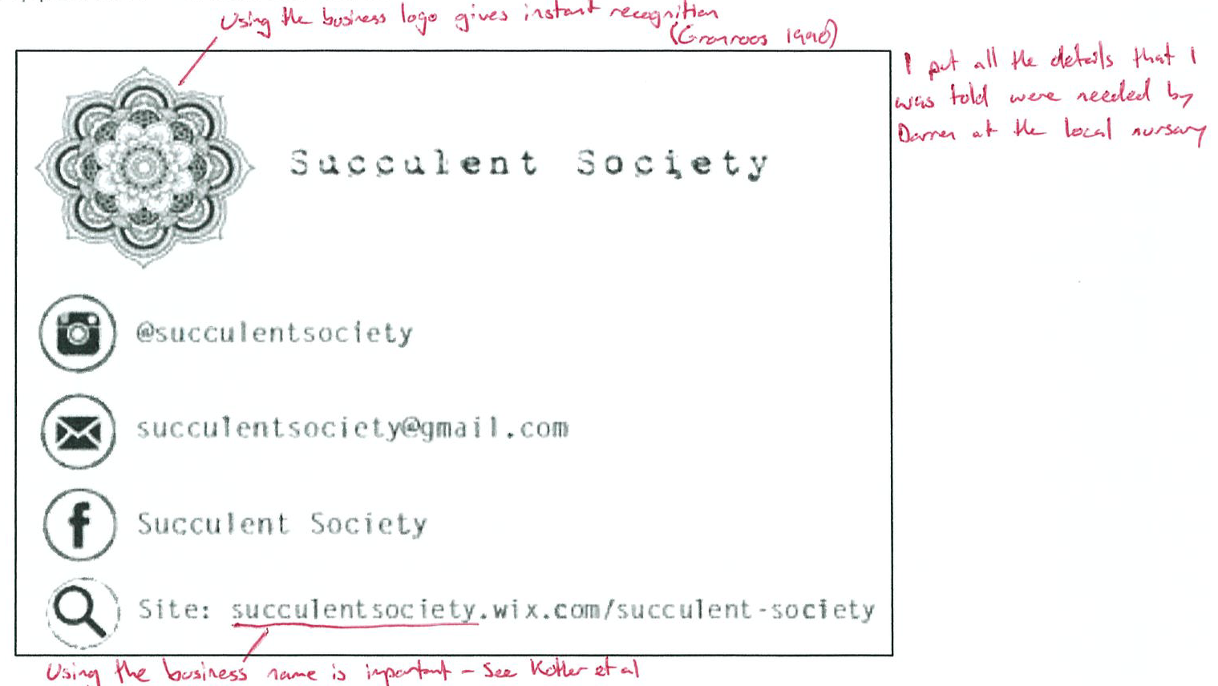

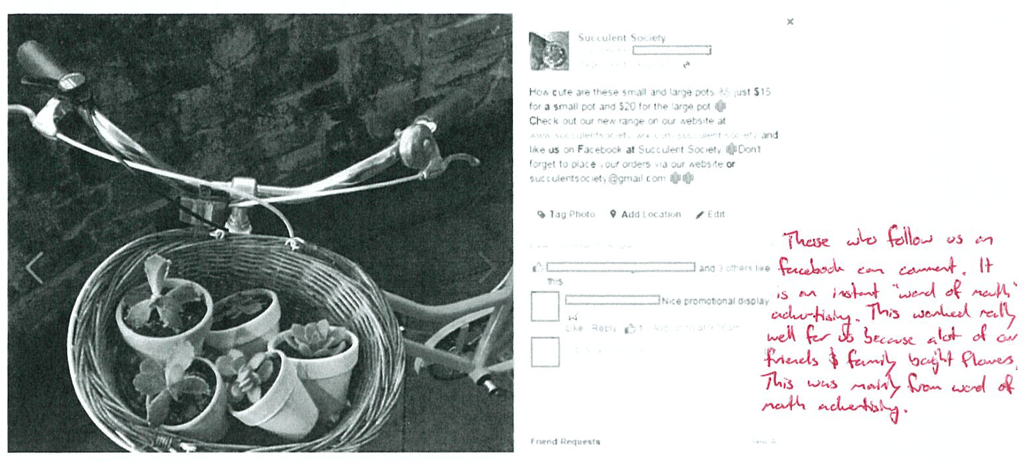

Product | Price | Promotion | Place
Succulents  Pots  Jars  Terrarium | $8-20  $10-15  $50 | Facebook, Instagram, flyers in the library, signs at the markets | Mainly at school  Gillies St Markets
Effectiveness – in evaluating the initial marketing plan there were some obvious problems that I came up against. I think that next time I do this, that I’ll ask a lot more questions of business owners for what they think works for this industry rather than just go from text books.

One thing that I did learn is that the text books are written with much larger businesses in mind, and while the general principles may still apply to a micro business like mine, there are a lot of areas that don’t. One of these was the budgets that they had for advertising. Many textbooks talked about paying for advertising in different places, such as online, tv, radio etc… but I just couldn’t do that because I never would have made my money back because it was such a small business and I didn’t have the ability to generate that many succulents.
Capability – critical & creative thinking: In reflecting on this plan, there are a lot of things that I would do differently next time. I was relying mainly on people seeing my ads and responding to them. One thing that I’ve learned is that you can’t rely on that alone because it just won’t bring in the money. You need to get out and talk to people about your business. Most of my sales came from friends and family, so the more I talk to people I know or interact with, the more likely I am to sell my products.
BIBLIOGRAPHY

Internet sources
- Blumenthals, The annual print Yellow Page page count and other dead horses, 18/04/14, http://blumenthals.com/blog/2014/04/08/the-annual-print-yellow-page-page-count-and-other-dead-horses/ accessed 10/09/15
- Chron, The Impact of Technological Change on Business Activity,2015, http://smallbusiness.chron.com/impact-technological-change-business-activity-2191.html accessed 11/10/15
- Entrepreneurship.org, Budgeting Strategies, 2006, http://entrepreneurship.org/resource-center/budgeting-strategies.aspx accessed 29/09/15
- Industry, Furniture, Cabinets and Joinery Manufacturing, N.D, http://www.industry.gov.au/industry/IndustrySectors/woodenfurniture/Pages/default.aspx accessed 21/09/15
- News.com, Four Ways a Lower Aussie Dollar will make your Life Better, 6/08/15, http://www.news.com.au/finance/economy/four-ways-a-lower-aussie-dollar-will-make-your-life-better/story-fnu2pwk8-1227471609208 accessed 23/09/15
- Mind Tools, Theory X and Theory Y, 2015, https://www.mindtools.com/pages/article/newLDR_74.htm accessed 15/09/15
- Swartz T, Iacobucci D, 2000, Handbook of Services Marketing and Management, (ebook,) California, Sage Publications, Pg. 60, https://books.google.com.au/books?id=xbdyAwAAQBAJ&pg=PA60&lpg=PA60&dq=backstage+front+stage+marketing&source=bl&ots=x-YgXHKm1v&sig=5dgkgKv3mNaLelWZa1fG4Cglk40&hl=en&sa=X&ved=0CCYQ6AEwAWoVChMIjJfIt_uLyAIVxiOUCh2mPQ2M#v=onepage&q=backstage%20front%20stage%20marketing&f=false, accessed 23/09/15
- The Daily Reckoning, Australian Dollar, 2015, http://www.dailyreckoning.com.au/category/australian-dollar-1/, accessed 23/09/15
- Smart Company, Bunnings is like a vulture: Small business backs former woolies chief on how hardware giant screws competitors, 2015, http://www.smartcompany.com.au/growth/48006-bunnings-is-like-a-vulture-small-business-backs-former-woolies-chief-on-how-hardware-giant-screws-competitors.html accessed 23/09/15
- Make It Happen, About MIH, 2015, http://mih.com.au/mih-marketing-agency/, accessed on 26/08/2015
- Lead Generation Company, Home, 2015, http://leadgeneration.com.au/, accessed on 26/08/2015
- Pro Internet Marketing, We make our lead generation experience work for you, 2014, http://www.pro-internet-marketing.com.au/lead-generation.html, accessed on 26/08/2015
- Forrest Marketing Group, Lead Generation, 2012, http://www.fmgroup.com.au/telemarketing/lead-generation, accessed on 26/08/2015
- Caroline Malamut, 16 Surprising B2B Lead Generation Statistics, 2014, http://blog.capterra.com/b2b-lead-generation-statistics-2014/, accessed on 28/08/2015
- HubSpot Inc, All the marketing statistics you need, 2014, http://www.hubspot.com/marketing-statistics, accessed on 28/08/2015

Book Sources
- Chapman S, Devenish N, Dhall M, 2000, Business Studies in Action, Preliminary Course, John Wiley and Sons Australia, Queensland, Pg. 63
- Fusco A, Ratsch-Jenke J & Panayi-Motus A 2012, Business and Enterprise, SACE 2 Key Ideas, 1st edn, Essentials, Adelaide Tuition Centre, Australia
- Gronroos C, Service Management and Marketing, Managing Moments of Truth in Services Competition, Free Press/Lexington Books, 1990
- Kotler, Armstrong, Brown, Adam, Chandler, Marketing, Prentice Hall Australia 1998,
- Lovelock C, Patterson P, Walker R, Services Marketing, Prentice Hall Australia 1998, Pg. 15

Primary Research
- Survey 1 – market research to determine problems
- Survey 2 – market research to better determine marketing strategy

Interview
- Business owners x 2 – gardening and random person
- Business SA
- Accounting teacher
- B&E teacher
- Customer Services, (2014). Port Adelaide Enfield Council Legislative Requirements, 22 September.
- Dowsett, P. (2014). Legislative Requirements by the Department of Primary Industries and Regions South Australia, 24 September

