BANK RECONCILLIATIONS

NAME AND PUBLICATION DETAILS OF SOURCE | RESEARCH PROCESS USED
screenshot  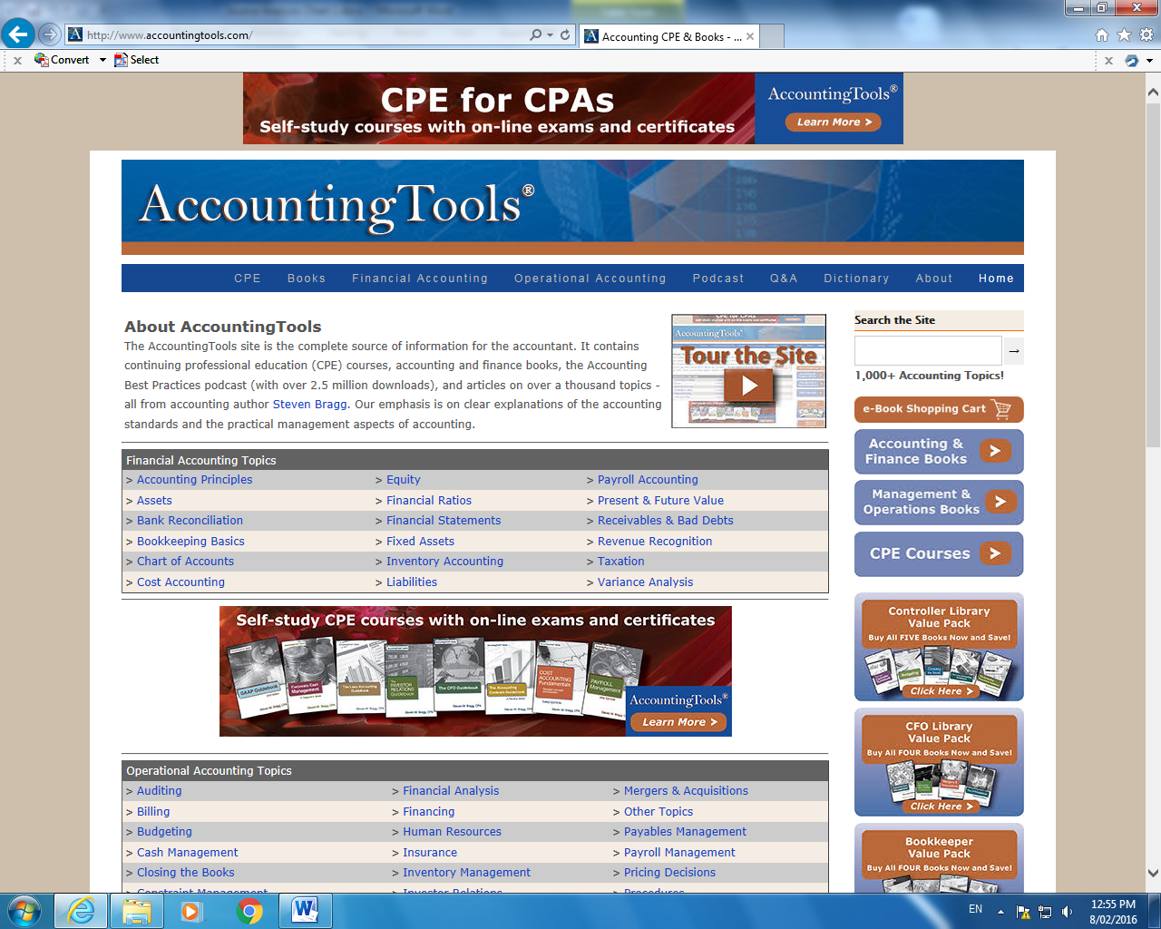  Bragg, S. (2015). Accounting CPE & Books – Accounting tools. (Online) Accounting Tools. Available at http://www.accountigntools.com  Accessed 10 May 2015  This was a great site for getting accounting information and how to conduct basic accounting operations. | - Reading and analyzing the website  - Questioning Accounting teacher  - Talking to business owners
 | TYPE OF SOURCE
Website – Accounting processes
Interview with Accounting Teacher
Interview with Business owner
KEY FINDINGS
What information have you gained? What new knowledge or ideas have you discovered?
- How to conduct a bank reconciliation
- You use your bank statement to conduct a bank reconciliation
- Any items that don’t appear on the statement need to be reconciled with businesses records
- If there is a difference between the bank statement and business records there is an error either by the business or the bank
- Errors can be easily overcome through checking records or contacting the bank
- Go through any extra random things on the banks statement and make sure you have them in your own records
VALIDITY
How relevant? How useful? How is it ‘fit for purpose’?
- The site is useful but I didn’t really understand a lot of the information initially as I haven’t done accounting. I need to talk to the accounting teacher about how to actually do them, and any templates
- I was a bit worried about the site being American and whether processes might be different to Australia
RELIABILITY
How accurate? How objective/biased? How trustworthy How credible? How current?
- Reliable – validated through discussion with teacher and business owners and accountants
- Worried if it were American that they would have different requirements to Australia
SKILLS AND KNOWLEDGE
Describe the type of research process undertaken and outline what skills and/or knowledge you developed.
- Reading – understanding about bank reconciliations and what they are. Developing skills and understanding in how to conduct one.
- I spoke with the Accounting teacher about how to do one, and she showed me a template that I can use. I tried doing one with her and was successful in doing it. I can understand the process and can now apply it to my business.
- I spoke with LOCAL BUSINESS OWNER about whether they think a bank reconciliation is relevant and they said they use them every month
EFFECTIVENESS
What feedback, opportunities, questions, challenges, problems did you encounter? How did you respond to, overcome, solve these?
How did you review and adjust the direction of your research in response?
- I didn’t understand the information at first so spoke with the accounting teacher and Mr Smith from the LOCAL GARDEN BUSINESS about bank reconciliations
- I was worried that I wouldn’t be able to do a bank reconciliation just from the information on the website, so asked the LOCAL BUSINESS if they really need to be done in one of my interviews with them.
CAPABILITY
How have you developed one or more of your Capabilities?
- I did not know how to conduct a bank reconciliation before, now I do.

INSERT BANK RECONCILIATION FROM PAGE 32 OF STUDENT DOCUMENT

