Who Am I?

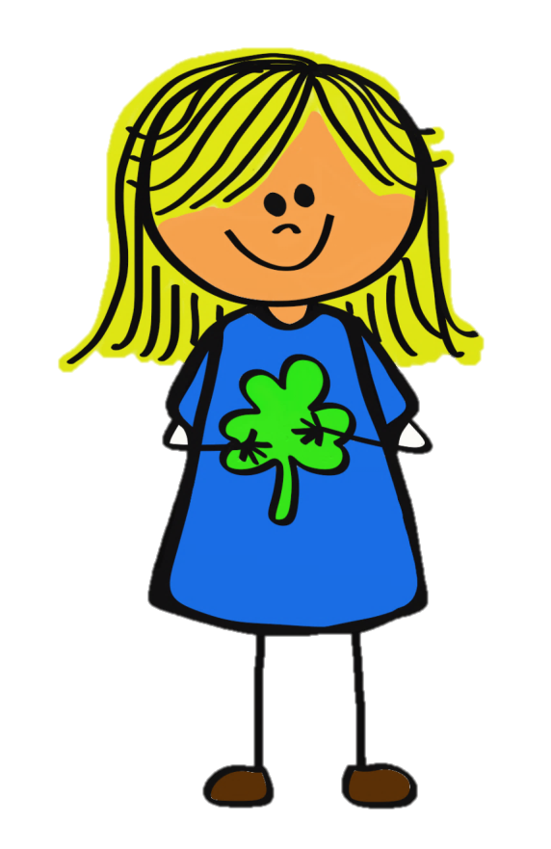

My Interests

Words that describe me

What I Value