Summary: What Have I Learned About Myself?
For each intelligence on the wheel below provide examples of how it applies to you:

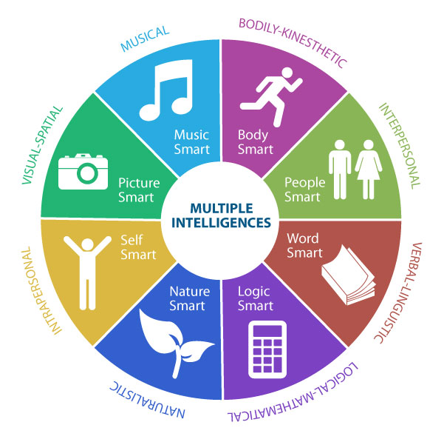

Summarise your personality strengths and weaknesses:

Summarise your learning style strengths and weaknesses:

