- Put these characteristics into order of importance, greatest to least and give a reason for each choice.
Trustworthiness
Respect
Responsibility
Fairness
Caring
Citizenship

- Give one way you are developing or each of these traits is being developed in your life – you need an example for each.

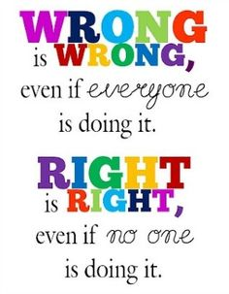

- Using the opposites of these traits, decide on un-ethical traits – list the names you have given them.

- Finally, give examples of unethical behaviour, matching all the categories you just came up with.

