Student Name: ____________________________

STAGE 2 ECONOMICS
Assessment task 6

2014

DETERMINATION OF PRICE AND OUTPUT

General instructions
- Working time – 1 hour
- Write using blue or black ink
- Answer all questions
- Write your name at the top

A few tips
- Remember to use economic terminology
- Draw and label diagrams correctly

/39

SHORT ANSWER and STIMULUS RESPONSE QUESTIONS

- Using appropriate economic concepts and principles answer the following questions.

- Consider the following information about the economy below
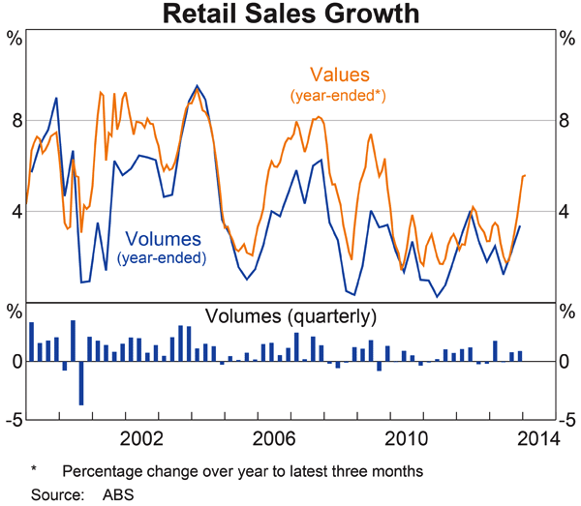
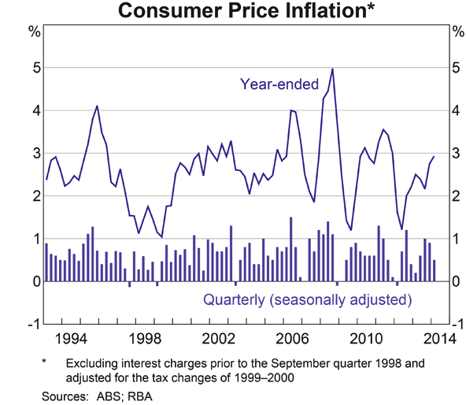

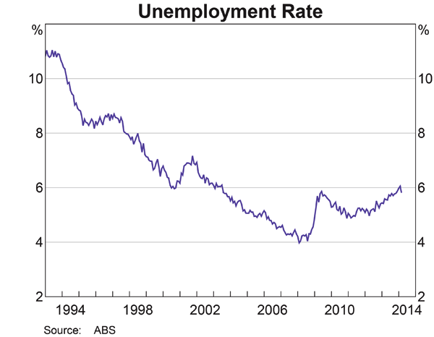
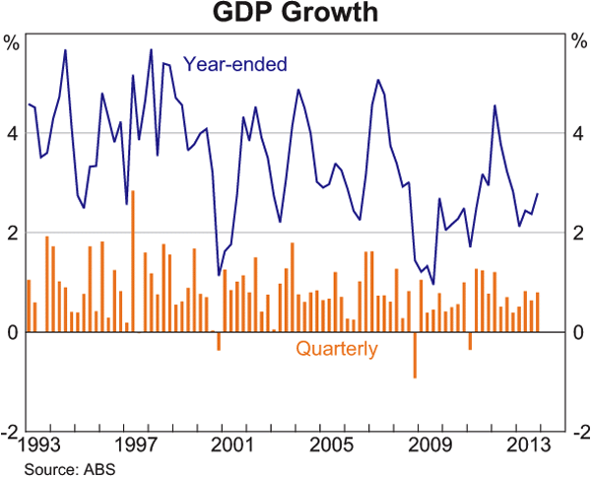
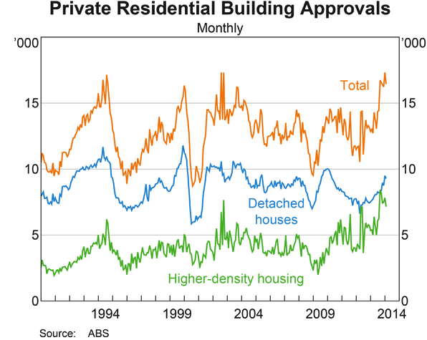
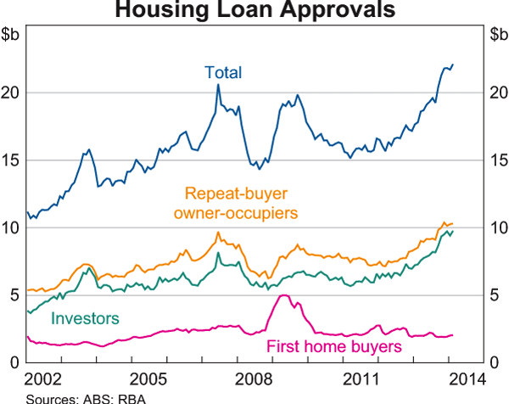
- Assume that this economy has a target rate for unemployment of 5%. Explain what is likely to be the economies stage of the business cycle in May 2014 with references to indicators. Use an AD/AS diagram to demonstrate this. (A&E)

(5 marks)

- Evaluate, using the above diagrams, why there may be downward pressure placed on the $A

(2 marks)

- Using the diagrams above, name one co-incident indicator

- Building approvals would be what kind of indicator?
(1 mark)

- How would the type of indicator mentioned in iv) be used in determining economic performance?

(2 marks)

- Explain why it is important to use a variety of indicators when determining the economic position of an economy.

(3 marks)

- What event occurred in 2008 to cause the spike in unemployment? (K&U)
(1 mark)

- What are the different types of economic indicators (leading, lagging and co-incident) likely to be showing with reference to the business cycle in March 2008. Use specific examples of these indicators (A&E)

(6 marks)

- Draw a new curve/s on the diagrams below to show the impact on the Australian economy of the following events. Outline the impact on price levels, economic growth and the level of unemployment. (K&U)

- Depreciation of the Australian Dollar

P
LAS
SAS
AD

Real GPP
Yf

(3 marks)

- Australian Federal Government decides to increase the minimum wage

P
LAS
SAS
AD

Real GPP
Yf

(3 marks)

(c) The government allows 20,000 new refugees access to Auatralia

P
LAS
SAS
AD

Real GPP
Yf

(3 marks)
3. Use the following stimulus material to answer the questions below

Refer to the following graphs which relate to the labour force over a period or time.

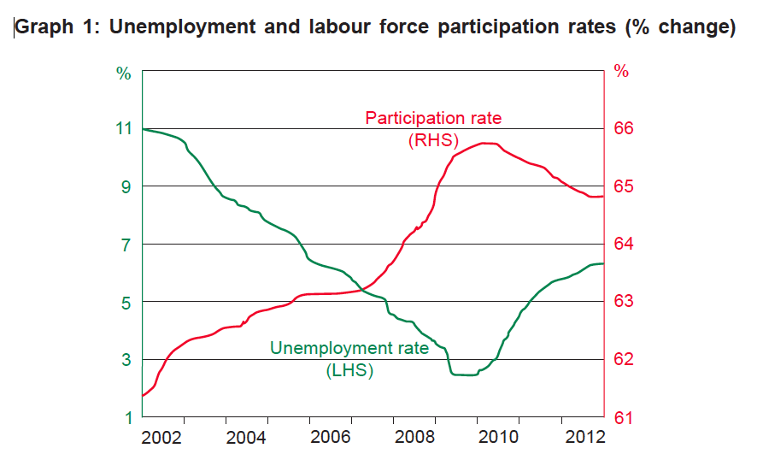

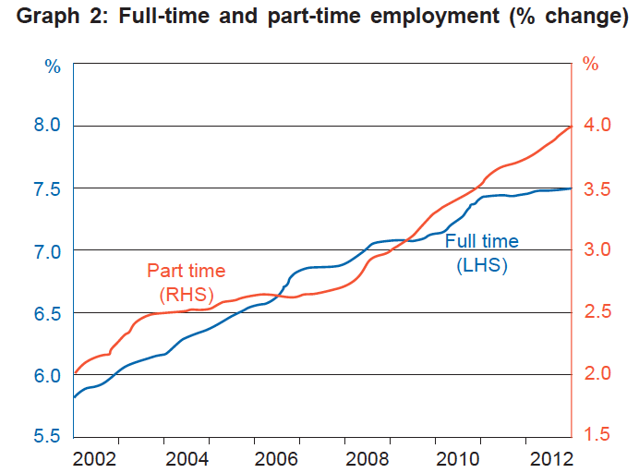

- State the relationship between the unemployment and labour force participation rates shown in graph 1
(1 mark)

- Identify one employment trend shown in graph 1
(1 mark)

- “The percentage change in part time employment is lower than the percentage change in full-time employment for the whole period between 2002 and 2012.” Explain how the data in graph 2 supports or contradicts this statement.

(2 marks)

- Define the term ‘hidden unemployment’

(1 mark)

- Describe how hidden unemployment may affect the unemployment rate

(2 marks)

- Define the term underemployment

(1 mark)

- Describe how underemployment may affect the unemployment rate

(2 marks)

Assessment

Learning Requirements | Assessment Design Criteria
1. know, understand, communicate, and apply economic concepts, principles, models, and skills  2. explain the role of economic systems in dealing with the economic problem of scarcity  3. evaluate the effects of interdependence on individuals, business, and governments locally, nationally, and globally  4. evaluate and explain the way in which economic decisions involve costs and benefits  5. critically analyse and evaluate economic issues and events (past and current) using economic models and the skills of economic inquiry  6. critically analyse and evaluate the impact of economic change locally, nationally, and globally. | Knowledge and Understanding  The specific features are as follows:  KU1 Knowledge, understanding, and application of economic concepts, principles, models, and skills.  KU2 Understanding of the role of economic systems in dealing with the economic problem of scarcity.  Analysis and Evaluation  The specific features are as follows:  AE1 Analysis and evaluation of economic issues and events (past and current) using economic models and the skills of economic inquiry.  AE2 Evaluation of the effects of interdependence on individuals, business, and government, locally, nationally, and globally.  AE3 Analysis and evaluation of the impact of economic change locally, nationally, and globally.  AE4 Evaluation of the way in which economic decisions involve costs and benefits.  Communication  The specific features are as follows:  C1 Communication of economic principles, models, and concepts.  C2 Use of economic terminology.

Assessment Criteria |  | Requirements |  | Grade
Knowledge and Understanding  KU1 Knowledge, understanding, and application of economic concepts, principles, models, and skills. |  | - Knowledge, Application and Understanding of Macroeconomics including: aggregate demand and supply, circular flow & macroeconomic objectives. |  | A, B, C, D, E  /20
Knowledge and Understanding Overall Grade | A+ | A | A- | B+ | B | B- | C+ | C | C- | D+ | D | D- | E+ | E | E-

Analysis and Evaluation  AE2 Evaluation of the effects of interdependence on individuals, business, and government, locally, nationally, and globally.  AE3 Analysis and evaluation of the impact of economic change locally, nationally, and globally. |  | - Appropriate use of specific economic concepts, models and principles |  | A, B, C, D, E  /26
Communication Overall Grade | A+ | A | A- | B+ | B | B- | C+ | C | C- | D+ | D | D- | E+ | E | E-

Communication  C1 Communication of economic principles, models and concepts  C2 Use of economic terminology. |  | - Appropriate use of specific economic concepts, models and principles throughout assessment task – marked holistically. |  | A, B, C, D, E
Communication Overall Grade | A+ | A | A- | B+ | B | B- | C+ | C | C- | D+ | D | D- | E+ | E | E-

 | On Balance Grade

Performance Standards for Stage 2 Economics

 | Knowledge and Understanding | Analysis and Evaluation | Communication
A | Comprehensive knowledge, in-depth understanding, and focused application of complex economic concepts, principles, models, and skills.  Comprehensive and well-informed understanding of the role of economic systems in dealing with the economic problem of scarcity. | Astute and logical analysis and evaluation of economic issues and events (past and current) using economic models and the skills of economic inquiry.  Perceptive evaluation of the effects of interdependence on individuals, business, and government locally, nationally, and globally.  Incisive analysis and evaluation of the impact of economic change locally, nationally, and globally.  Insightful and well-informed evaluation of the way in which economic decisions involve costs and benefits. | Sophisticated communication of economic principles and models, and complex concepts.  Consistent, clear, and appropriate use of correct economic terminology.
B | Some depth of knowledge and understanding, and focused application, of a variety of economic concepts, principles, models, and skills.  Well-informed understanding of the role of economic systems in dealing with the economic problem of scarcity. | Well-considered analysis and evaluation of economic issues and events (past and current) using economic models and the skills of economic inquiry.  Well-considered evaluation of the effects of interdependence on individuals, business, and government locally, nationally, and globally.  Well-informed analysis and evaluation of the impact of economic change locally, nationally, and globally.  Well-informed evaluation of the way in which economic decisions involve costs and benefits. | Clear and accurate communication of economic principles and models, and a variety of concepts.  Clear and appropriate use of economic terminology.
C | Considered knowledge and understanding, and competent application, of economic concepts, principles, models, and skills.  Informed understanding of the role of economic systems in dealing with the economic problem of scarcity. | Considered analysis and evaluation of economic issues and events (past and current) using economic models and the skills of economic inquiry.  Considered evaluation of the effects of interdependence on individuals, business, and government locally, nationally, and globally.  Informed analysis and evaluation of the impact of economic change locally, nationally, and globally.  Informed evaluation of the way in which economic decisions involve costs and benefits. | Competent communication of some economic principles, models, and concepts.  Appropriate use of economic terminology.
D | Superficial understanding and partial application of some basic economic concepts, principles, models, and skills.  Some recognition of the role of economic systems in dealing with the economic problem of scarcity. | Basic consideration and description of one or more economic issues and/or events (past and current) using some skills of economic inquiry.  Basic consideration and description of one or more of the effects of interdependence on individuals, business, and government locally, nationally, and globally.  Recognition of aspects of the impact of economic change locally, nationally, and globally.  Some awareness of the way in which economic decisions involve costs and benefits. | Communication of some basic economic principles, models, and concepts.  Some appropriate use of some economic terminology, with inconsistencies.
E | Identification and attempted application of one or more basic economic concepts, principles, models, or skills.  Limited recognition of the role of economic systems in dealing with the economic problem of scarcity. | Emerging awareness of one or more economic issues or events (past and current), with limited use of skills of economic inquiry.  Limited recognition of one or more of the effects of interdependence on individuals, business, and government locally, nationally, and globally.  Emerging recognition of an aspect of the impact of economic change locally, nationally, and globally.  Limited awareness of the way in which economic decisions involve costs and benefits. | Attempted communication of one or more simple economic principles, models, or concepts.  Limited use of economic terminology.

