MARKETS in ACTION
Market Mechanism, Oligopolistic Markets

TASK DESCRIPTION: Annotated Map and Podcast – Prices in Oligopolies
ASSESSMENT COMPONENT: Folio Task: Task 1
ASSESSMENT CRITERIA: Understanding U1, Application A1, A2 and A3, Analysis An1

Aim

To understand how Demand and Supply affect price changes and how market structure can affect these changes.

Task

Investigate the causes of price fluctuations within a Commodity market of your choice over the last 15 years. Determine the extent to which the Retail market structure of this commodity plays a role in influencing prices.

Task Details

Part A
You are to choose a Commodity market and research and assess the causes of pricing changes over the last 10 to 15 years.
- Price fluctuations should be presented as a graph.
- You must then identify and assess, using the market mechanism, the causes of the 4 most significant fluctuations in the market price. (The assessment of each fluctuation should include a definition, explanation, illustration and analysis of the identified factor).
  - It is expected that an annotated copy of one reference (most likely a news or journal article) be included for each of the 4 periods.
Part B
Record a 2.5 minute Podcast outlining the extent to which the prices are impacted by the structure and nature of competition in the market from Part A.
It is expected that the following elements will form the basis of your Podcast.
- Type of market structure
- Nature of the market
- Make-up of retail prices (E.g. factors of production, taxes etc…)
- Price change over time (including causes)
- Price variations across sellers and/or regions E.g. Rural vs Metro, State vs State
- Evidence of collusive behaviour, price leadership or interdependence in the industry

Task Presentation Examples

Part A
In no more than 500-words annotate the 4 sources of information and assess the causes of the 4 most significant price fluctuations.
The following may be used as a guide to the presentation of the assessing.
10-year chart of coffee prices for arabicas
Droughts throughout Brazil have resulted in significant destruction of crops. “January (2014) was the hottest month on record for parts of Brazil, and the drought was said to be the worst in 50 years. One estimate said 30% of the coffee crop may have been lost”.¹ This has resulted in a decrease in supply S to S₁
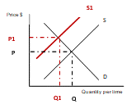
The resulting impact of the decrease in supply has been a 20% increase in prices from P to P_{1.}
- https://www.businessinsider.com.au/why-coffee-prices-are-surging-2014-2?r=US&IR=T

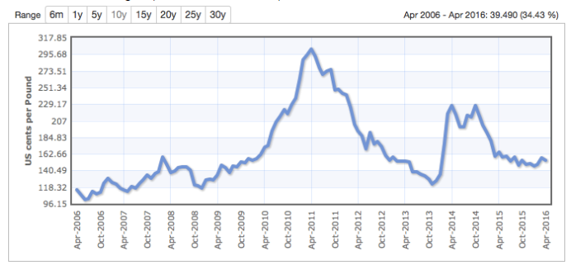

Source of Image: https://codyshirk.com/mmm-coffee-and-money/

Part B
You are to record a Podcast of no more than 2 and half minutes this will be posted to the Trove upload.

Any research findings included in Parts A and B must be appropriately referenced and a reference list is expected.

MARKETS in ACTION
Market Mechanism, Oligopolistic Markets

TASK DESCRIPTION: Annotated Map and Podcast – Prices in Oligopolies
ASSESSMENT COMPONENT: Folio Task: Task 2
ASSESSMENT CRITERIA: Understanding U1, Application A1, A2 and A3, Analysis An1

Assessment

STUDENT:

Criteria for Judging Performance | Requirements | Grade
Understanding  U1 Understanding of economic concepts, principles, and models in a variety of contexts. | - U1: Knowledge of the market mechanism and factors that determine prices within specific markets  Knowledge of price fluctuations in commodity markets. | A, B, C, D, E
UNDERSTANDING OVERALL MARK | A B C D E
Application  A1 Application of economic concepts, principles, and models in known and unknown contexts.  A2 Application of communication skills in an economic context.  A3 Application of economic thinking to construct arguments. | - A1 Application of market mechanism and market structures in price determination  Appropriate use of demand and supply model in the assessment of price fluctuations  - A2 Appropriate use of terminology such as Demand, Supply, Regulation, Taxes, Subsidy as well as the integration of quantitative and qualitative information.  Clearly and appropriately constructed written assessment and podcast incorporating use of economic terminology and models.  - A3: Reasoned explanation as to the causes of price fluctuations of the Commodity and the impact of the nature of competition in the retail market.  Clear and logical assessment of the determination of Prices in Part A and B | A, B, C, D, E  A, B, C, D, E  A, B, C, D, E
APPLICATION OVERALL MARK | A B C D E
Analysis  An1 Analysis of a range of economic data, models, and principles. | - An1: Analysis of the causes of price fluctuations through an annotated reference. Analysis of nature and structure of retail market and the influences on Price  Appropriate use of specific data, economic concepts and principles | A, B, C, D, E
ANALYSIS OVERALL MARK | A B C D E
 | Overall Grade

Performance Standards for Stage 1 Economics

- | Understanding | Application | Analysis
A | Perceptive understanding of economic concepts, principles, and models in a variety of contexts. | Highly effective application of economic concepts, principles, and models in known and unknown contexts.  Highly effective application of communication skills in an economic context.  Highly effective application of economic thinking to construct reasoned arguments. | Critical analysis of a range of economic data, models, and principles.  Critical analysis of the intended and unintended consequences of economic decisions.
B | Well-informed understanding of economic concepts, principles, and models in a variety of contexts. | Mostly effective application of economic concepts, principles, and models in known and unknown contexts.  Mostly effective application of communication skills in an economic context.  Mostly effective application of economic thinking to construct arguments with some reasoning. | Mostly critical analysis of a range of economic data, models, and principles.  Well-considered analysis of the intended and unintended consequences of economic decisions.
C | Competent understanding of economic concepts, principles, and models in a variety of contexts. | Competent application of economic concepts, principles, and models in known and unknown contexts.  Competent application of communication skills in an economic context.  Competent application of economic thinking to construct arguments. | Considered analysis of a range of economic data, models, and principles.  Considered analysis of the intended and unintended consequences of economic decisions.
D | Basic understanding of economic concepts, principles, and models in a context. | Basic application of economic concepts, principles, and models in a context.  Basic application of communication skills in an economic context.  Basic application of economic thinking to construct one or more arguments. | Description with basic analysis of economic data, models, and principles.  Description of one or more intended or unintended consequences of an economic decision.
E | Awareness of some economic concepts, principles or models. | Attempted application of economic concepts, principles, and models in a context.  Attempted application of communication skills in an economic context.  Attempted application of economic thinking to construct an argument. | Attempted description of some economic data, models, or principles.  Attempted description of one intended or unintended consequence of an economic decision.

